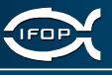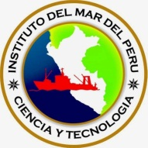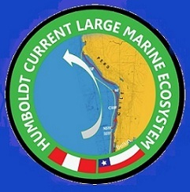
Humboldt Current Large Marine Ecosystem
Towards Ecosystem Based Management Chile – Peru
GEF- PIMS 4147
DRAFT Inception Report – April 2012
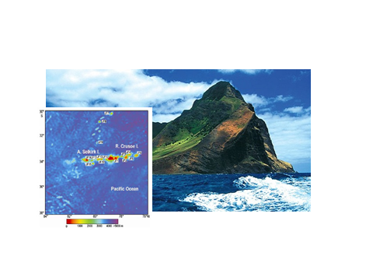
Isla Juan Fernandez Chile – Seamount pilot sites
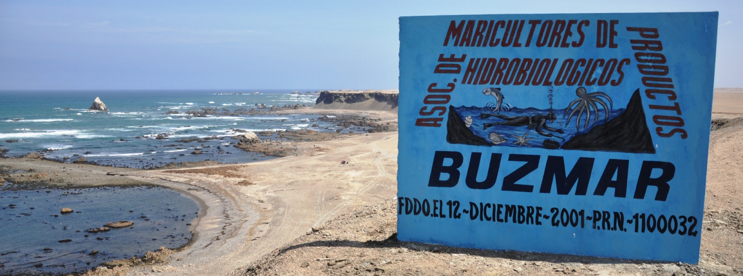
Pilot site, fisher associations for improved coastal resource management, Marcona, Ica Peru
Contents
Acronyms 3
Executive Summary 4
1. Introduction 7
1.1 Rationale for undertaking the Project 7
1.2 Objective and Outputs 9
2. Purpose of this inception report 9
2.1 Reasons for the slow start and resultant reduced spending rate 10
2.2 Project history and PDF phase achievements 12
2.3 Work-Plan development process 13
2.4 Logframe indicators 13
2.5 Regional Coordination Unit (RCU) functions 13
2.6 Support services and complementary responsibilities 14
2.7 Monitoring and Evaluation (M&E) work 14
2.8 Results from the inception workshop and pilot site field trip 14
2.9 List of reports to date 15
2.10 Proposed changes in the project’s work areas and / or modus operandi 15
IMARPE proposal to increase area covered by pilot sites: Paracas and Marcona 15
Chilean Pilot sites 16
Recommendations 17
Annex 1 Exchange of letters to update the ProDoc and correct article 302 17
Annex 2 Progress report elaborated by IFOP Chile. 17
Annex 3 TDA approved by Chile and Peru in 21st May 2003 See separate pdf file 24
Annex 4 SAP draft not approved 24
Annex 5 Logframe indicator matrix related to activities proposed 2012-2013 (early draft to be revised) 37
Annex 6 Management Effectiveness Tracking Tool: International Waters 44
Annex 7 Back to the Office Report (BTOR) SC field trip to Paracas 44
Annex 8 Chile-Peru Paracas meeting minute 61
Annex 9 Quarterly Operational Reports Q2 2011 to Q1 2012 64
Annex 10 POA 2012-2013 70
Annex 11 Financial management and procurement manuals 70
Annex 12 Financial report 83
Annex 13 Minutes from the preparatory 3rd and First Steering Committee meeting 4th May 2012 83

Acronyms
ANEPAP National Association of Artisanal Fishery Businesses, Peru
AWP Annual Work Plan
CPPS Permanent Commission for the South Pacific
DICAPI Maritime Authority of the Peruvian Navy
EBM Ecosystem-Based Management
EDA Ecosystem Diagnostic Analysis
ENSO El Niño- Southern Oscillation
GEF Global Environment Facility
GIS Geographic Information System
GoP Government of Peru
HCLME Humboldt Current Large Marine Ecosystem
HCS Humboldt Current System
IFOP Fisheries Development Institute, Chile
IMARPE Peruvian Sea Research Institute
IW International Waters
LME Large Marine Ecosystem
LNG Liquefied Natural Gas
METT Management Effectiveness Tracking Tool
MINAM Ministry of the Environment, Peru
MMA Ministry of the Environment, Chile
MPA Marine Protected Area
MSC Marine Stewardship Council
NGO Non-Governmental Organization
NIC National Intersectoral Committee
OMZ Oxygen Minimum Zone
PRODUCE Ministry of Production, Peru
PROFONANPE Peruvian Fund for Protected Areas
QOR Quarterly Operational Reports
RCU Regional Coordinating Unit
RNSIIPG Peruvian Guano Islands, Isles and Capes National Reserve
SAP Strategic Action Program
SC Steering Committee
SERNANP National Service of Protected Areas of Peru
SERNAPESCA National Fisheries Service, Chile
SNP Peruvian Fisheries Society
SPRFMO South Pacific Fisheries Management Organization
SUBPESCA Undersecretary of Fishing of the Ministry of Economy, Chile
TDA Transboundary Diagnostic Analysis also Transzonal Diagnostic Analysis
TG Technical Group
TNC The Nature Conservancy
TTT Technical Task Team
UNDP United Nations Development Program
UNOPS United Nations Office of Project Services
VMS Vessel Tracking System
WWF World Wildlife Fund

Executive Summary
After a long formation period since the Global Environment Facility (GEF) Humboldt Project Development Funds (PDF) precursor project finished in 2003 (2001-2003) the Full Size Project documents were signed by Chile on 15.07.2010 and Peru on 26.08.2010. PNUD and UNOPS signed on 26.08.2010 and 02.09.2010 respectively. The Full Scale Project was deemed to have formally started on the 01.04.2011 when the Regional Project Coordinator took up his post in Lima Peru and Project expenditure started. The 5-year Project end date is therefore considered to be 31.03.2016. The PDF-Block B project produced a Transboundary (Transzonal) Diagnostic Analysis (TDA) text which was approved in 2003. However the associated Strategic Action Programme (SAP) was not approved. Both documents will be updated during 2012-13 by using a range of analytical tools including Ecosystem Diagnosis and Risk assessments.
The current Full Scale Project inception period has been longer than normally contemplated as Peru held Presidential and Peruvian Congress elections during the period April to June 2011 (first round 10.04.2011 and subsequent decisive second round on 05.06.2011). The new President Ollanta Humala was sworn in on 28.07.2011 with new Ministers and other political appointments within Project counterpart organisations nominated and in place during the period August to September 2011. During the first year the Project’s Regional Coordination Unit (RCU) office has been set up within the UN compound in Lima, equipment (furniture and IT items) purchased and installed and the coordination team of three recruited: Michael J. Akester (Regional Project Coordinator = RPC); Mariano Gutierrez T. (Senior Project Officer = SPO) and Lenka Lazo L. (Financial and Administrative Assistant = FAA). This process was finalized on 02.11.2011 when the SPO took up his post. See also separate RCU report with comments on the first year of project work.
IFOP and IMARPE have convened National Intersectoral Committees (NIC) in Chile and Peru respectively with the first meetings held during the months of August and September 2011. Local Intersectoral Committee meetings have also been held in Paracas and Marcona, Ica Peru. The NIC working groups generated the annual work plan draft presented for approval on the 4th May 2012. Some of the activities exemplify the project’s multisectoral approach to Ecosystem Based Management (EBM) involving artisanal fishing associations, major industry, private biotech company, value addition, employment for women and invalids, biodiversity restoration and adaptation to climate change e.g. the work to produce macro-algae in Ica Province, Peru.
The HCLME was represented at the 6th GEF biennial International Waters Conference with a contribution to a National Oceanic and Atmospheric Administration (NOAA) book on ‘The Recovery and Development of Large Marine Ecosystems during Climate Change’. Mariano Gutierrez attended an Asia Pacific Economic Cooperation (APEC) – Large Marine Ecosystem Workshop on Marine Ecosystem Assessment and Management, Marine Resource Conservation Working Group (MRCWG) held in Seoul, Republic of Korea, January 4-5, 2012.
Visits by the Regional Project Coordinator have been made to Chile on four occasions and by the RCU team to all Peruvian pilot sites in Ica and Lambayeque (Islas Ballestas, Punta San Juan and Isla Lobos de Tierra). The Mayor of Marcona has formalised a Humboldt Project Intersectoral Committee in Marcona. Municipality funds have been assigned for baseline survey work. A baseline biodiversity survey has been completed at the Isla Lobos de Tierra site by the local IMARPE in Chiclayo. Pilot sites in Chile have not been visited.
Suggestions have been made by IMARPE to extend the area of Project activities in Paracas and Marcona to include the specific Guano Island and Capes mentioned in the Project Document plus the surrounding National Park land and sea areas. The intention being to ensure that a range of HCLME stakeholders are included: National Park administrators, tourism sector, artisanal fisherfolk, aquaculturists, waste management, industrial plants, marine transport, energy & mining and agriculture sectors would all be involved. The HCLME Project has a large number of partners in both Chile and Peru from both public and private sectors. There are also links with International NGOs including WWF and The Nature Conservancy Humboldt Project together with the Comisión Permanente del Pacífico Sur (CPPS).
The Steering Committee (SC) meeting and associated inception workshop scheduled for November 2011 had to be cancelled on the instructions of the Ministry of Foreign Affairs (RREE) – Peru pending the modification of article 302 in the Project Document where unintentional reference was made to a non-existent Standard Basic Agreement between UNDP and the Government of Peru (GoP). This was subsequently solved by means of an exchange of letters UNDP-GoP on the 28th February and 7th March 2012 (UNDP and RREE-Peru respectively see annex 1).
Training courses in Ecosystem Based Management have been delivered in both Chile and Peru (November 2011 and January 2012 respectively). The training was delivered with the intention of developing trainers.
During 2011 USD376,307 (20% allocated funds) were spent out of the allocated USD1.9 million although a fund adjustment was made in September 2011 to a revised USD545,000. The underspend is due to the delays in Project start-up referred to above. Funds unused in 2011 as well as funds allocated in 2010 have been reallocated for the period 2012-2015 as follows in table 1:
HCLME Budget USD | 2010 | 2011 | 2012 | 2013 | 2014 | 2015 | 2016 | Total/Balance
ProDoc Budget | 1,413,100 | 1,935,100 | 1,658,600 | 1,210,600 | 707,600 |  |  | 6,925,000
Annual Work Plan in Atlas |  | 376,307 | 1,453,575 | 1,995,249 | 1,549,934 | 1,549,934 |  | 6,925,000
Modified Budget and $ spent (red) |  | 376,307 | 235,430 |  |  |  |  | 611,737
Delivery Rate |  | 19.4%

Table 1 Expenditure during the first year of the project and fund redistribution over the 5-year project period.
Underspending continued during the first quarter of 2012 with only UD$167,777 spent. A 19-month work plan June 2012 – December 2013 is proposed. Many important coordination meetings have been held to establish partnerships both public and private with project stakeholders. Most of this work has taken place in Peru as the Regional Coordination Unit (RCU) is based in Lima. The possibility of the Project providing a grant on a 50:50 cost share basis for an EBM coordinating position within IFOP is being considered to assist with the implementation of GEF funded activities in Chile.
During 2011 the HCLME continued to cool bringing favourable conditions for the anchovy. However the deaths from unknown causes of a total of around 900 common and bottleneck dolphins in Northern Peru during two events in early 2012 demonstrate the importance of an EBM approach in determining the health of the Humboldt Current System (HCS) and its components. In April and May thousands of bird deaths in northern Peru suggest the possibility of sea temperature rise related to a forthcoming El Niño event and the displacement of anchovy from the warmer waters resulting in the reduction of food for seabirds.
Since the signing of the Project Document in 2010 Peru now has an additional 295,549ha of national parks under the National Reserve for the System of Islands, Isles and Guano Capes (RNSIIPG) with 140,833ha and San Fernando (154,716ha) Parks formed in 2011 (Fig 4 below). In Chile there is now a Legal Project awaiting approval to protect the sensitive seamount areas of special biodiverse interest (annex 2 shows work advances in Chile). Preparatory work for the Marine Stewardship Council (MSC) certification pre-assessment of an anchovy fishery in Ica Province continues to show promising results with links to the World Food Programme as well. Work advances carried out by the Regional Coordination Unit can be seen in a separate report.
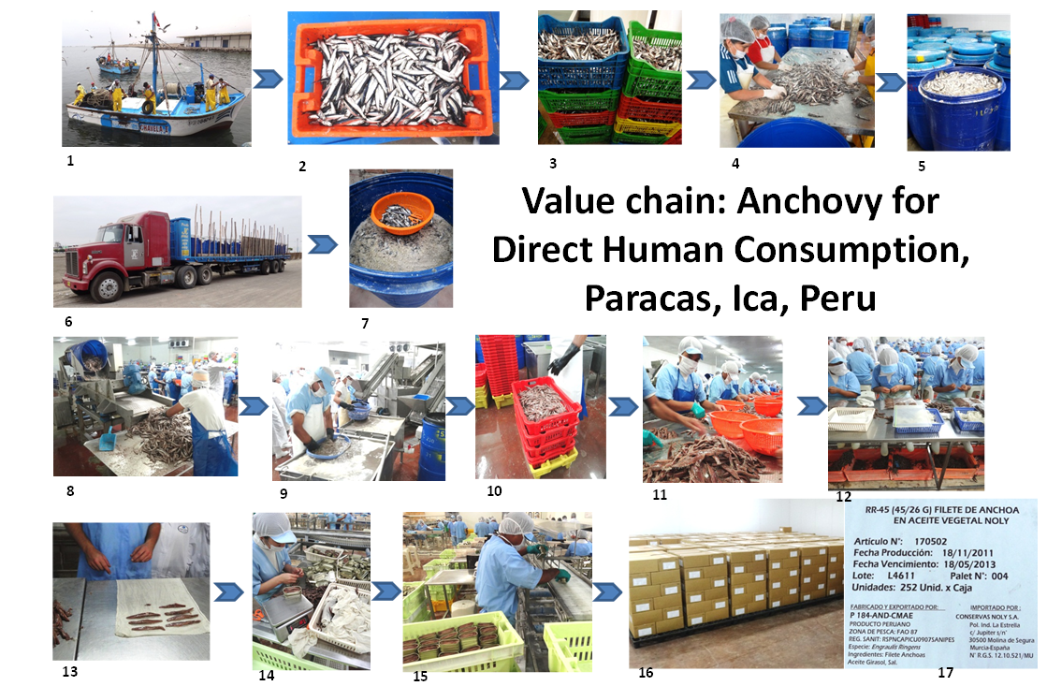
- Artisanal fishing boat registered to land anchovy for direct human consumption
- Anchovy caught during the night is landed at a registered landing site at La Puntilla, Paracas, Ica, Peru
- De-headed gutted anchovy draining after 12 hours in salt solution at a small associated processing plant
- Drained and salted anchovy are covered in salt crystal for curing in plastic drums
- Plastic drums containing salted anchovies. The fish lose water during the salting process
- After three months the salted anchovies are ready to be marketed as a salted fish in inland locations
The product can be purchased in any quantity required, a single fish from a small village store to a lorry load of several metric tonnes. The product is cheap at around USD1/kg. The same fish cured in salt are the start point for the salted anchovy fillet product sold in bottles and tines for around USD25/kg. Images 7 to 17 demonstrate this value addition process.
- A barrel of salted anchovy as the start point for a low cost anchovy food source or the luxury market. Some of the barrels come from a Marine Stewardship n(MSC) certified fishery in Argentina
- One of thousands of barrels is emptied in an EU certified plant. The following process is for export.
- The salted fish are soaked in warm water to remove the skin. Subsequently the fish are ‘filleted’ by hand
- Anchovy with the skin removed.
- Salted, skinned anchovy are trimmed prior to filleting
- The anchovy backbones are removed and the waste (under the work bench) is sent to produce fishmeal
- The anchovy fillets are packed in cloth and centrifuged to remove any excess water prior to canning
- Anchovy fillets are packed in tins at an accurate weight
- The canning process – tins with anchovy fillets have either olive or sunflower oil added prior to packing
- A warehouse filed with boxes packed with tinned or bottled anchovy fillets
- A product label for traceability purposes indicating the fishing ground reference point, production and expiry dates and destination. Each individual tin can be traced back to the boat that caught the fish, the area and date

Introduction

1.1 Rationale for undertaking the Project
The Humboldt Current transports vast quantities of cold water at surface speeds of up to 20cm . sec⁻¹ and sub-surface speeds of less than 10cm . sec⁻¹ equalling around 15 million cubic meters of water per second in a Northerly direction. At the same time water upwells from the ocean floor bringing with it important nutrients in the form of nitrates and phosphates used for primary production and the start of a food chain that leads to 20% of the world’s fish production coming from this system. There are three main upwelling systems: the Chilean Shelf Slope Front; The Nazca Front; and the Peruvian Upwelling Front (Table 2 & Fig 2).
Current | Width  ( km ) | Depth (m) | Velocity  ( cm/s) | Transport rate  ( 10⁶ m³/s )  Table 2 Humboldt Current dimension and speed
Humboldt | 1000km | 100m | 20 cm/s | 15 Sv
Sv = Sverdrup flow units: 1 Sv = indicates 1 million m³ water per second
The HCLME has an important cooling effect on the Western seaboard of South America. There is evidence of a cooling trend within the system, a phenomenon only seen in two of the world’s 64 LMEs (Humboldt and Californian).
Figure 2. Humboldt Current System area: 4,000km long and 1,000km wide, predominant salinity (ppt), water masses and currents along the Western coast of South America. Water masses are designated by colors: Surface Equatorial Waters (light red), Coastal Cold Waters (green) and Surface Subtropical Waters (light blue). The Main currents in the HCS are: Peru Oceanic Current (POC), Peru Coastal Current (PCC), Peru Chile Under Current (PCUC), Peru Chile Counter Current (PCCC), South Equatorial Under Current (SEUC) and South Equatorial Current (SEC). Adapted from Fuenzalida et al (2003) and Ayon et al (2008).
Source : Sustainability of the Humboldt Current LME. Serra R., M. Akester, M. Bouchon, M. Gutierrez, in ed.

Occasionally during warm tropical water intrusions at the Northern end of the current, El Niño events, there are dramatic changes to the nutrient availability from upwelling and subsequent primary and secondary productivity impacts. Marine bird populations have still not recovered from the last major heating event in 1997-1998. World climates are also impacted bringing a mix of drought and floods to different continents. A new die-off in April 2012 may herald a new ENSO event.
Biodiverse and productive with considerable natural and anthropogenic variation the Humboldt Current Large Marine Ecosystem (HCLME) is in need of important measures to recover damaged areas and protect sensitive systems form the negative impacts of further anthropogenic activity including climate change. Chile and Peru have therefore agreed to promote an Ecosystem Based Management (EBM) approach to the HCLME with the assistance of this Global Environment Facility (GEF) funded project.
The Humboldt LME project first phase, a GEF Project Development Fund (PDF-B) funded activity, produced a Transboundary (Transzonal) Diagnostic Analysis (TDA) approved in 2003 (annex 3) and a Strategic Action Programme (SAP) text that was not approved (annex 4). The current Full Project phase will update and seek full approval of these texts as part of the move towards EBM.
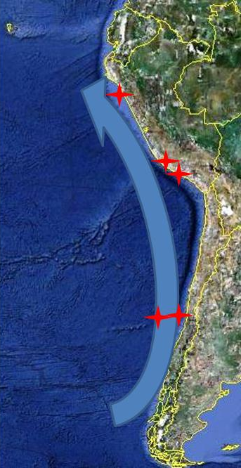
Figure 3
The HCLME on the Western coast of South America showing the five Project pilot sites (Islas Juan Fernandez and Bajo O’Higgins in Chile and Punta San Juan, Islas Ballestas and Isla Lobo de Tierra in Peru).
= HCLME Project Pilot sites

The Transzonal Diagnostic Analysis (TDA) approved in May 2003 by Chile and Peru generated information for the initial Strategic Action Programme (SAP) document. It collected in depth information related to the HCLME goods and services and identified problems together with their causes and impacts: environmental, economic and social - grouped under four main themes:
- The suboptimal exploitation of fisheries resources
- Insufficient understanding of the Humboldt Current System variability
- Threats to the HCLME biodiversity of relevance to the fisheries production and
- The situation related to the coastal habitat with impacts from land-based events
Over the last decade considerable advances have been made towards improving some aspects of all four aspects identified above. However many of the threats have increased due to land based and marine activities hence biodiversity degradation has continued in a number of areas therefore justifying the Project and its objectives.
Figure 4 Summary of the Project’s four expected results and the mix of central and field based activities designed to achieve the Project’s objective:
‘Ecosystem-based management in the HCLME is advanced through a coordinated framework that provides for improved governance and the sustainable use of living marine resources and services’

1.2 Objective and Outputs
The HCLME Project objective is:
“Ecosystem-based management in the HCLME is advanced through a coordinated framework that provides for improved governance and the sustainable use of living marine resources and services”.
To achieve the objective the project has four Outcomes (outlined in the figure below):
Outcome 1: Planning and policy instruments for EBM of the HCLME.
Outcome 2: Institutional capacities strengthened for SAP implementation and for up-scaling the results of pilot interventions to the systems level.
Outcome 3: Implementation of priority MPA & fisheries management tools provides knowledge of options for enhanced protection of HCLME and SAP implementation.
Outcome 4: Implementation of pilot MPAs underpins ecosystem conservation and resilience.

Purpose of this inception report
This report confirms the Project start date and provides information on work carried out during the inception period with an explanation as to why there has been a slow start. A fund distribution of the project 5-year period is also suggested. The final version of this report will also include minutes of the first HCLME Steering Committee (SC) meeting due to be held in Chile on the 3rd May 2012 and approval process for the work plan corresponding to an 19-month implementation period June 2012 to December 2013.
This report is designed to:
- Record the project start date and list activities carried out during the inception period (in this case a prolonged 12-month period). There is also an explanation as to why there have been considerable delays in reaching the first Steering Committee meeting stage;
- In this particular case outline the project history with reference to a previous Global Environment Facility (GEF) Project Development Fund (PDF) project and its outcome – Transzonal Diagnostic Analysis (TDA) document approved by the Governments of Chile and Peru and a draft Strategic Action Programme (SAP) document drawn up but not approved;
- Present the methodology used to draw up the first work-plan on the basis of the project's logframe matrix and include the plan itself. In this particular case explain why a 19-month work plan period is proposed;
- Include the logframe indicators in relation to the activities designed for the first implementation period;
- Outline the way the Regional Coordination Unit (RCU) functions together with focal point teams in IFOP-IMARPE and the two Ministries of the Environment Chile-Peru where GEF focal point staff are based;
- Outline the roles, support services and complementary responsibilities of UNDP-UNOPS and RCU staff vis à vis the project team Chile-Peru;
- Provide comments on the UNDP-GEF reporting and monitoring and evaluation (M&E) requirements including the Management Effectiveness Tracking Tool (METT) system;
- Outline the results from the inception workshop and pilot site field trip plus associated meetings held 17th and 18th November 201;
- List and annex reports delivered to date; and
- Record any proposed changes in the project’s work areas or modus operandi.

There are 13 annexes to this report:
- Exchange of letters UNDP-Ministry of Foreign Affairs Peru to solve legal problem (separate files)
- Report submitted by IFOP covering advances re project activities in 2011
- TDA approved 21st May 2003 during the GEF PDF-B phase
- SAP finalized in 2003 but not approved
- Logframe indicators for the period to 31.12.2013
- Management Effectiveness Tracking Tool (separate file)
- Back to the Office Report from field trip to Islas Ballestas pilot site Paracas November 2011
- Minute from the informal Chile-Peru meeting in Paracas
- Quarterly Operational Reports for the period 2011 to Q1 2012
- Approved work plan for the period June 2011 to December 2013
- Financial management and procurement guidelines
- Financial report
- Minutes from the 1st Steering Committee meeting held 4th May in Santiago, Chile.

2.1 Reasons for the slow start and resultant reduced spending rate

The Project started when the Regional Project Coordinator took up his post on 28th March 2011. As the Project is of 5-years duration the end date will be at the end of Q1 2016.
The current Full Scale Project inception period has been longer than normally contemplated as Peru held Presidential and Peruvian Congress elections during the period April to June 2011 (first round 10.04.2011 and subsequent decisive second round on 05.06.2011). The new President Ollanta Humala was sworn in on 28.07.2011 with new Ministers and other political appointments within Project counterpart organisations nominated and in place during the period August to September 2011. During the first year the Project Regional Coordination Unit office has been set up within the UN compound in Lima, equipment (furniture and IT items) purchased and installed and the coordination team of three recruited: Michael J. Akester (Regional Project Coordinator = RPC); Mariano Gutierrez T. (Senior Project Officer = SPO) and Lenka Lazo L. (Financial and Administrative Assistant = FAA). This process was finalized on 02.11.2011 when the SPO took up his post.
Having established the Project office in Lima the RPC visited Chile 10th to 17th May 2011. Key Chilean stakeholders noted that there had been a lack of information about the Project start-up and RCU team selection process. It was agreed that the deadline for the SPO position would be extended to allow more people to apply.
In close coordination with all Project counterparts in both Chile and Peru arrangements were made for a Project Inception workshop, Steering Committee meeting and pilot site visit 16th -18th November 2011. Steering Committee (SC) members were selected, flights and accommodation arranged for Chilean counterparts, field trip arrangements finalized and stakeholders invited to attend the workshop.
Immediately prior to the proposed Inception Workshop and first Steering Committee meeting planned for 17th November 2011, the Regional Coordination Unit (RCU) team requested a meeting with the new IMARPE Executive and Scientific Directors recently appointed to their positions within IMARPE. The purpose of the meeting was to provide a series of introductions to the new IMARPE leadership under the incoming Humala Government and to discuss the arrangements that had been made for the Inception Workshop, SC meeting and pilot site field trip.
The meeting in IMARPE was held on the 8th November, 8 days before the arranged series of inception meetings. On arrival the RCU team were informed that the new IMARPE Director Dr. Carlos Palomares, was not available and that a situation had developed that would delay the Inception and SC meetings.
The meeting continued with the IMARPE Scientific Director, IMARPE legal team, the IMARPE Project focal point team, RCU members and a Peruvian Ministry of Foreign Affairs representative: Ministra Elvira Velasquez.
Ministra Velasquez outlined a series of observations which in her view needed to be clarified before the inception workshop and other meetings could take place. These amounted to the fact that article 302 of the Project Document contained reference to an agreement between the UN and Government of Peru (GoP) that doesn’t exit and that the Peruvian Intersectoral and Steering Committee members needed to be confirmed via a Presidential Decree. As the work plan activities for 2012 had been identified by an Intersectoral Committee as yet not included in a Presidential Decree – their deliberations and activity selection work could not be endorsed by the SC which in turn needed to have its Peruvian members included in a Presidential Decree.
As Project funds had been committed, people had allocated their time to attend and Project ‘goodwill’ would be negatively impacted by a total cancellation, it was agreed to rename the Inception Workshop an ‘Information Workshop’ and to proceed with ‘informal meetings’ but not to hold a SC session to approve the 2012 work plan.
The legal situation was eventually solved after a series of high level meetings and an exchange of letters UNDP-GoP and GoP-UNDP dated 28th February and 7th March 2012 respectively (see annex 1). A series of Inter-Ministerial (PRODUCE, MINAM, Foreign Affairs Peru) meetings then took place to find a mechanism whereby the required Decree could be signed. Ministra Velasquez agreed that a Steering Committee meeting date could be set in agreement with members from UNDP, UNOPS, Chile and Peru. Dates for the SC meeting were set for the 3rd and 4th of May 2012 and 16-18th April for the necessary pre-cursor work plan development meetings between Chile and Peru (held in Lima).
During the entire period after the new Peruvian Government was installed (September 2011 to date) work on Project activities has continued in Peru at pilot sites and between the RCU with IMARPE focal point unit. This has resulted in a biodiversity baseline report for Isla Lobos de Tierra in Lambayeque Peru, a baseline biological and socioeconomic report for the Marcona area (funded by the Mayor’s office in Marcona) and a series of meetings organized by the General Director of Land Use Planning in the coastal zone – also in the Lambayeque area. In addition to this a networking meetings have progressed with public and private organisations leading to additional stakeholders being identified along with interesting EBM style activities.
EBM training courses were carried out in both Chile (November 2011) and Peru (January 2012). The training was designed to be used as a Trainer of Trainers course so as to allow follow-up training events at the project plot sites and with other stakeholders.
Whilst there has been positive progress in Peru, despite the fact that the delays related to the legal status of the Project initiated in Peru due to the error in the Project Document, the situation has not been the same in Chile where IFOP reports “almost zero” progress in some areas especially related to the pilot site which has not as yet been visited by the RCU team. Annex 2 lists advances in Chile during the first year. Delays are due to two main reasons:
- After an initial Intersectoral Committee meeting in September 2011 with a high level of interest raised – even demands for greater inclusion of additional groups – the events of November effectively stopped all potential follow-up activities as there was a total lack of information as to how and when (or even if) the impasse would be solved. Hence no follow-up meetings were held; and
- The Chilean counterpart funding is provided under a different mechanism to that of Peru. For example SUBPESCA had requested the Chilean Government to provide USD2 million for 2012 as part of their commitment to the project. The financial planning process requires a project expenditure plan delivered in August and approved in November for implementation in January of the following year subject to confirmation that the expenditure will in effect take place. As no SC work plan approval for 2012 had been attained SUBPESCA could not confirm that the expenditure would take place and funds were lost. Funds can be reapplied for with the obvious reservation that confidence in a commitment once defaulted will be reduced.

As a direct result 20% of the Project’s time has elapsed with only 6% of the overall funds spent. It is normal for the time-expenditure percentages to lag in a Project without heavy infrastructure and equipment purchases in the first year. However the second year is now also compromised with a possible 40% time and 25% expenditure rate predicted.
On the one hand funds have not been wasted and a lot has been achieved in one area but on the other hand valuable counterpart funds have at best been delayed, hopefully not lost in Chile. The following table outlines the original fund allocation calendar, a proposed adjustment and the actual situation at the end of may 2012.

2.2 Project history and PDF phase achievements
The GEF Project Development Funds (PDF) intervention delivered a TDA-SAP document that was partially approved (TDA only) by Chile and Peru in May 2003. This TDA document will now be analysed again and a series of activities involving Ecosystem Diagnostic Analysis and Risk Analysis tools will be used after training courses are delivered mid-2012 to ensure a common level of understanding.

2.3 Work-Plan development process
National Intersectoral Committees (NIC) were established in both Chile and Peru via coordination with the focal point entities in IFOP and IMARPE. Meetings were held in August and September 2011 and in Peru working groups devised a series of activities based on the Project Logframe matrix.
However the events described at 2.1 above resulted in a complete stoppage of work plan development processes with the Chilean NIC members as it was considered irresponsible to raise intervention hopes when the viability of the project was in question.
On the other hand in Peru the RCU team has had a series of meetings with a range of Project stakeholders to discuss the EBM strategies and possible activities and funding options. Whilst it has been frustrating not being able to confirm interventions and GEF funding lists have been drawn up and links made to a range of public and private initiatives related to Project objectives.
Project pilot sites have been visited in Peru. However it was not possible to visit the Chilean pilot site areas in the Islas Juan Fernandez in part due to the expense but also so as not to enter into discussions with the population regarding an intervention of unknown capability due to the uncertainties regarding the timing of work plan approval.
Draft work plans ready in November 2011 have been modified to adjust to the reality of a mid-2012 start date and the need to have a 19-month work plan with follow-on activities 2012-2013 identified. The final draft work plan 2012-13 can be seen at annex 10. Procurement manuals can be seen at annex 11 and the financial summary at annex 12.

2.4 Logframe indicators
Lograme indicators have been reviewed (see annex 5)

2.5 Regional Coordination Unit (RCU) functions
The RCU comprises three team members: Michael J. Akester (Regional Project Coordinator = RPC); Mariano Gutierrez T. (Senior Project Officer = SPO) and Lenka Lazo L. (Financial and Administrative Assistant = FAA). The unit has an office in the UN complex Lima. The recruitment process for office staff was completed on 2nd November 2011 when the SPO took up his post.
The RCU liaises with:
- The IFOP-IMARPE focal points
- The GEF focal points
- UNDP offices in New York, Panama, Lima and Santiago
- UNOPS Copenhagen and Lima
- Stakeholder groups in Chile and Peru and worldwide
Reporting is instigated by the RCU and involves Quarterly Operational Reports (QOR) and visit and meeting reports as and when they occur. In addition there will be an inception report, Project Implementation Reviews (PIR) plus mid-term and final evaluations. See also separate RCU report for the first year of operations.
The RCU also coordinates activity and fund identification work whilst informing the focal points in IFOP-IMARPE and GEF regarding progress and proposals.
Financial management of all GEF funding is coordinated by the RCU see annex 11 for Procurement guidelines.

2.6 Support services and complementary responsibilities
UNDP Panama and UNOPS Copenhagen have an overall supervisory role regarding Project implementation. UNDP offices in Lima and Santiago also have a monitoring role and support service in terms of issues that may arise during Project implementation e.g. the need to correct article 302 in the Project Document via an exchange of letters with the Government of Peru (GoP).
The RCU reports to UNDP and UNOPS with copies to the focal point entities in Chile and Peru.

2.7 Monitoring and Evaluation (M&E) work
M&E work follows reporting on the Logframe indicators and updated baseline information collected during the inception period. The Monitoring Effectiveness Tracking Tools (Biodiversity and International waters – see project document and annex 6) will be updated annually from 2013 onwards to view progress.

2.8 Results from the inception workshop and pilot site field trip
The inception workshop was renamed ‘Information workshop’ as explained at 2.1 above. The Project’s objectives were outlined – a process that had already been carried out at the NIC sessions in both Chile and Peru.
A field trip for SC members was carried out in Paracas, Ica, Peru with a visit by boat to the area around the Islas Ballestas national park within the RNSIIPG (see back to the office report – BTOR annex 7). SC members also visited an association of artisanal fisherfolk, transport owners and processing plants working towards sustainable fisheries development, improved incomes via value addition, and employment opportunities for women and improved nutrition in poor areas of Peru where fish is typically not available. The group also has a further value addition process whereby fish salted in small processing plants is then filleted and selected for bottling and canning for the lucrative anchovy markets in Europe, the USA and Japan. This double value addition has also promoted the possible Marine Stewardship Council (MSC) certification in order to further promote sustainable fisheries, a continued presence in the international market place and possible added value.
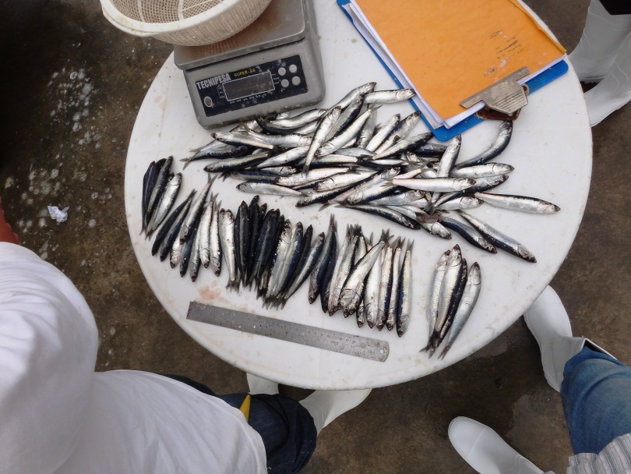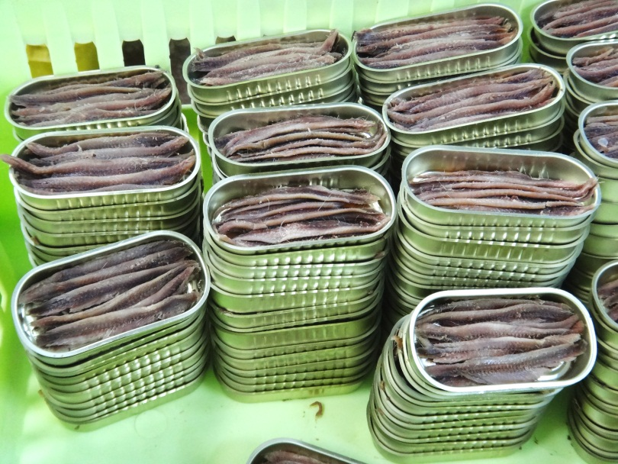
Fig 5 Anchovy size assessment at the landing site (left) and salted & fileted anchovies in tins to have olive oil added prior to packing and export to Europe, USA and Japan.
An informal meeting was also held with SC members Chile-Peru to air views about Project implementation (see annex 8).

2.9 List of reports to date
Meetings with IFOP and IMARPE have been minuted as has the Inception workshop as noted at 2.8. above. Similarly visits to pilot sites and the attendance of meetings have been documented via back to the office reports. As stated at 2.5 above QOR have been submitted and can be seen at annex 9. The approved POA 2012 – 2013 can be seen at annex 10 and the minutes from the first Project SC session at which the POA 2012-2013 was approved can be seen at annex 13. In May 2012 the Regional Coordination unit issued a report on start-up activities carried out during the first year (see separate report).

2.10 Proposed changes in the project’s work areas and / or modus operandi
Suggestions for minor adjustments to the project modus operandi include:
- A proposal from IMARPE to increase the area covered by two of the three pilot sites in Peru in Paracas and Marcona areas, (see Fig 6);
- A proposal for an EBM expert post to be created at IFOP initially funded by GEF for 30 months and then by IFOP until the end of the project and beyond;
- IFOP have also requested the new member of staff to be provided with operational fund advances to facilitate purchases made on a day-to-day basis in Chile;
- The use of a 19-month work plan June 2012 to December 2013 as the approved work plan will only start full implementation at the end of May / start of June 2012. The majority of activities started mid 2012 will continue throughout 2013
The project document recognises the need for additional funding to be identified as a means of ensuring the GEF contribution has the right balance of local funds. To achieve this the Regional Coordination unit has been and plans to continue to identify new Project partners. It is therefore proposed to ask the Steering Committee to endorse this approach under the observation that no agreements will be signed without seeking GEF-UNDP endorsement. The latter is important as there may be funding opportunities from entities that are often associated with malpractice in the form of damage to ecosystem properties and services, hence the EBM approach can be promoted via community work as outlined in the activity in Paracas activity 4.2.11 in the work plan at annex 10.
A list of activities carried out during the inception phase can be found in the Quarterly Operational Reports 2011-2012. These are annexed to this document so as not to repeat data contained therein (see annex 9).

IMARPE proposal to increase area covered by pilot sites: Paracas and Marcona
Figure 6 shows the full extent of the Peruvian Guano Islands, Isles and Capes National Reserve (RNSIIPG) and the two of the three pilot sites where it is proposed to expand the Project’s area of influence to include the activities going on in the area surrounding the Islas Ballestas and Punta San Juan pilot sites.
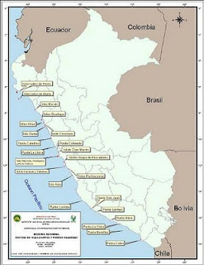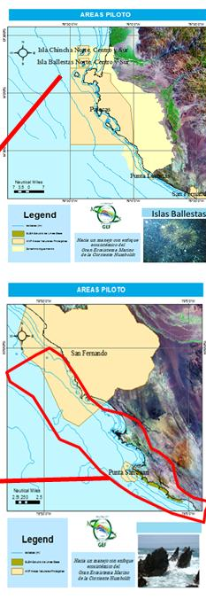
Figure 6
Map showing the 22 island and 11 capes that constitute the Peruvian Guano Islands, Isles and Capes National Reserve (RNSIIPG). There is a proposal from IMARPE to expand the area of influence covered by the project in both pilot sites in Ica. Islas Ballestas: expanded areas to include the Paracas National Park and an area to the South where Seabed Resource Management is being piloted. Punta San Juan: proposal to expand the zone of the project’s influence to include part of the new San Fernando National Park as well as an area to the South of the Punta San Juan where trials are being undertaken to re-establish macroalgae beds with associated improved biodiversity (see photo front page).

Islas Ballestas
Pta. San Juan

The IMARPE proposal involves including specific activities at the Ballestas and San Juan sites with SERNANP combined with a series of risk analyses based on activities in the surrounding area. The latter include: agriculture, tourism, transport (both land and marine), mining, energy (Liquefied Natural Gas LNG), Nitrate production, salt production, aquaculture, fishing, port development, urbanization and the possible impacts of climate change. The RCU team considers the proposal to be sound and recommends that it be accepted along with the integrated macro-algae production project – activity 4.2.11 in the work plan, annex 10.

Chilean Pilot sites
The Juan Fernandez Islands situated around 600km from the Chilean mainland and port of Valparaiso have as yet not visited by the RCU team due to the uncertainties outlined at 2.1 above.
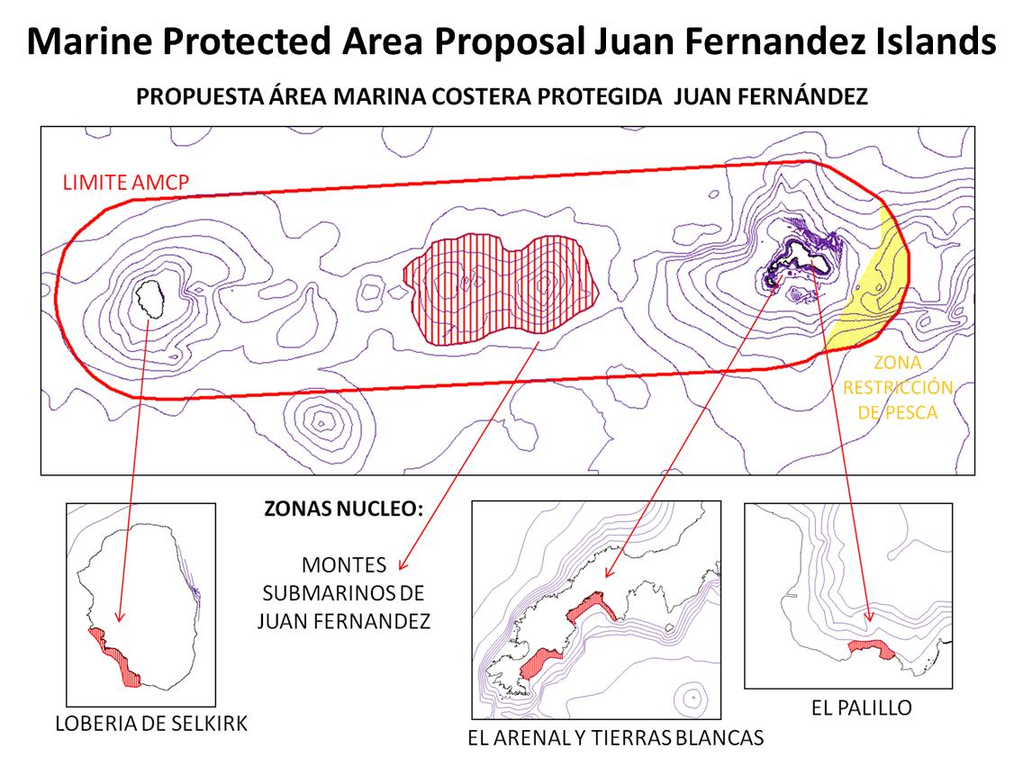
Figure 6 The Juan Fernandez Islands and associated seamount areas with proposal for a Marine Protected Area (area enclosed by red ellipse). Travel to the islands is difficult due to the distance and frequent strong winds. The survey work related to the seamounts is expensive. Work has already been carried out with remotely operated vehicles see: http://cpps.dyndns.info/cpps-docs-web/planaccion/biblioteca/pordinario/111.Biodiversidad%20de%20montes%20submarinos.pdf and http://oceana.org/es/sa/expediciones/salas-y-gomez/videos and http://oceana.org/sites/default/files/annual_report.pdf

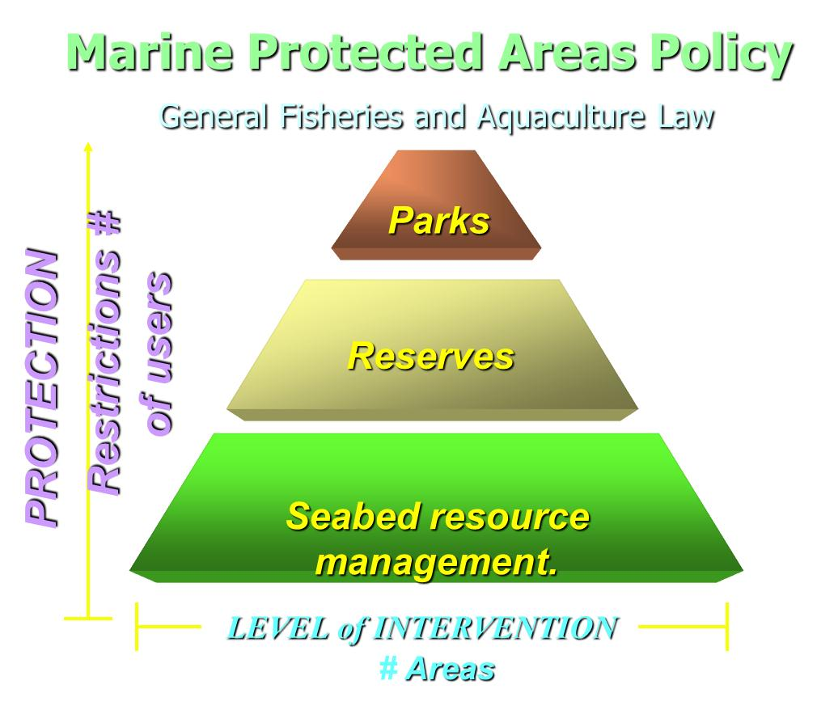
Figure 7
The Chilean Marine Protected Area policy includes different levels of protection with corresponding variations in the levels of intervention possible at the sites. Parks have the highest number of restrictions whilst Seabed Resource Management areas restrict access to those not assigned use of the resource but permit those with assigned user rights to manage the area under a management plan.
Data: Francisco Ponce, SUBPESCA, Chile

Recommendations
- IMARPE proposals for an expanded Project area of influence around the pilot sites should be accepted;
- The RCU will continue to identify new Project stakeholders and possible new interventions together with funding options in line with Project objectives. This should be coordinated with a single focal point team Chile-Peru;
- Once the 2012-13 work plan is approved the Project Focal point teams need to work as a combined unit and not, as at present, as two entities operating on their own. Related to this communication channels must be more open and rapid as the current trend for e-mail messages to be ignored leads to inefficiencies and misunderstandings. There is a proposal to purchase video-conference system for IFOP and IMARPE to improve day to day liaison re standardized fish stock assessment practices amongst other activities of EBM importance;
- The possibility of IFOP receiving a grant to cover 50% of the costs for a young EMB expert working full-time on project activities should be considered urgently as s/he would be able to assist with day-to-day EBM Project activities, networking with a wider range of stakeholders;
- Project management should liaise closely with other GEF funded projects and evaluate the possibility of cost free collaboration with other Marine Protected Area development projects outside the selected pilot sites e.g. the Chipana MPA site in Tarapaca Chile’
- A working group EDA-SAP Chile-Peru needs to be set up as soon as possible; and
- Consideration should be given to the development of a Humboldt Current Commission as the HCLME is the only LME worldwide without such a Commission.

Annex 1 Exchange of letters to update the ProDoc and correct article 302
See separate pdf files

Annex 2 Progress report elaborated by IFOP Chile.

INFORME DE AVANCE: ACTIVIDADES REALIZADAS A DICIEMBRE 2011

- Contexto

Dentro del marco del Programa de las Naciones Unidas para el Desarrollo se inicia la ejecución del proyecto denominado: “Hacia un Manejo con Enfoque Ecosistémico del Gran Ecosistema Marino de la Corriente de Humboldt”, donde el Instituto de Fomento Pesquero (IFOP) es la agencia de ejecución en Chile.

El proyecto tiene por objetivo: Avanzar hacia un manejo con enfoque ecosistémico en el Gran Ecosistema Marino de la Corriente Humboldt a través de un marco coordinado que fortalezca la gobernanza y el uso sostenible de los recursos marinos vivos y los servicios del ecosistema.

El presente informe tiene como objetivo dar a conocer aquellas actividades que se han ejecutado hasta la fecha y aquellas que se encuentran en proceso de desarrollo, para tal efecto se adjunta una tabla del Plan Operacional Anual para los años 2011 y 2012 (Tabla 1).

Además se enumeran actividades de carácter administrativo que se han realizado durante el presente año.

- Avances en la ejecución del proyecto por producto esperado

Producto 1.1:

Consiste en la realización de un Análisis Diagnóstico Ecosistémico (ADE) para lo cual es necesario crear un Grupo de Trabajo (GT) que involucre expertos de diversas disciplinas, éste grupo se ha generado con miembros del IFOP y de la Subsecretaría de Pesca (SUBPESCA) y se conformará completamente cuando se efectúen los cursos de capacitación correspondientes a este producto.

Por otra parte, es necesario realizar una revisión detalla de la información y datos biológicos, oceanográficos y pesqueros existentes, esta tarea está en sus inicios entre las cuales la actualización de la línea base para las principales pesquerías.

Para generar el ADE final, se deberá incluir un análisis de cadenas causales detallado con el fin de identificar las causas subyacentes y raíces así como las intervenciones objetivo a nivel regional que serán necesarias para hacerles frentes, para avanzar en este objetivo se diseña un cuestionario orientado a identificar las brechas del conocimiento y definir las problemáticas asociadas a las principales pesquerías que deben ser atendidas de manera urgente, dicho cuestionario es aplicado a sectorialistas de la Subsecretaría de Pesca e investigadores de IFOP.

Mediante las respuestas de los cuestionarios, se relevan “problemas” a diferentes escalas (a nivel internacional, nacional, regional y local) éstos se clasifican en 4 categorías: Manejo o Administración, Investigación, Toma de datos y Fiscalización y Control. Algunos de los problemas detectados se mencionan a continuación.

i) Manejo o Administración: en la administración de varias pesquerías se mencionan la falta de planes de manejo manifiestos, carencia de objetivos de manejo explícitos, además de dificultades en la asignación (fraccionamiento) de cuotas entre los usuarios esencialmente en el caso de que estas no estén fijadas por ley (artesanales e industriales), asignación espacial y temporal de las capturas o esfuerzo no concordante con la dinámica de los recursos. En pesquerías de peces pelágicos y demersales se espera avanzar hacia un manejo multiespecífico y abordar los problemas de sobreexplotación de algunos stocks. En este sentido, es necesario implementar estrategias para la reconstrucción de los stocks. También se indicaron problemas de manejo en especies transzonales y altamente migratorias o recursos pelágicos cuya administración debe considerar flotas foráneas fuera de la Zona Económica Exclusiva (ZEE), o requieren de un manejo conjunto con países limítrofes (especial atención requiere el manejo de recursos transfronterizos).

ii) Investigación: se establece en primera instancia que existen brechas del conocimiento, entre otras se menciona la necesidad de definir unidades poblacionales esto incide en la aplicación de medidas de administración tanto nacional como internacional, como la asignación de cuotas por países o regiones, etc. Por otra parte, indica que se deben medir los impactos de la pesca sobre el ecosistema, estimar a través de los niveles de captura el descarte en diferentes pesquerías y cuantificar el impacto del uso de de artes y sistemas de pesca que modifican los hábitat, principalmente en lugares que son importantes como zonas de reproducción de alimentación de juveniles y reclutas. También se indica la necesidad de generar mas indicadores independientes de la pesquería, particularmente los se relacionen con las variaciones de abundancia, como son el tamaño del stock desovante o la fortaleza de la clase anual o reclutamiento; mediante evaluaciones directas se requiere información que permita generar series de tiempo de información de huevos, larvas o prerreclutas que sean evaluados mediante cruceros de investigación. Referente a las pesquerías de pelágicos se necesita tener una mayor comprensión de fenómenos climático-oceanográficos que modifican la distribución espacial y la disponibilidad de los recursos. En los recursos hidrobiológicos explotados existe un escaso conocimiento de los procesos biológicos, fisiológicos, ecológicos que ocurren en los primeros estadios del ciclo vital, etc. Por otra parte se menciona la necesidad de analizar las estrategias de explotación y puntos biológicos de referencia de acuerdo con los parámetros de ciclo vital de las especies explotadas, etc.

iii) Toma de datos: se menciona la necesidad de mejorar la calidad de la información que se utiliza en la evaluación de stock, como es el chequeo de la información de entrada a los modelos.

iv) Fiscalización y Control: se mencionan los problemas de subreportes y descartes que alteran las estadísticas oficiales en las pesquerías nacionales, así como también la falta de mayor fiscalización en el control de cuota de las pesquerías administradas mediante esta medida de manejo. Además se señalan ciertas deficiencias en la fiscalización de vedas para diferentes recursos.

Curso: “Manejo con Enfoque Ecosistémico”
Durante los días 28 de noviembre y hasta el 02 de diciembre, en las dependencias del Hotel O’Higgins en Viña del Mar, se realiza la primera capacitación denominada “Fortalecimiento de capacidades en el Manejo con Enfoque Ecosistémico”.
Los objetivos del curso son los siguientes:
- Presentar los conceptos principales del Manejo con Enfoque Ecosistémico (MEE).
- Practicar el uso de herramientas de búsqueda de información científica y su aplicación al MEE.
- Facilitar el intercambio de experiencias en aspectos relacionados con el MEE.
- Facilitar la delineación de un marco de referencia para el MEE del Gran Ecosistema Marino de la Corriente de Humboldt (GEMCH).
La Dra. María Ángela Barbieri, Coordinadora Nacional del Proyecto, en la inauguración, realiza la presentación del proyecto GEF-Humboldt, expone los antecedentes y contexto, así mismo los resultados y logros esperados.
Al curso dictado por el Dr. Jeffrey Wielgus, asiste un total de 33 alumnos. Los participantes corresponden a profesionales de 10 instituciones públicas, privadas y universidades del país, entre ellas: Universidad Arturo Prat, Universidad Católica del Norte, Universidad de Valparaíso, Pontificia Universidad Católica de Valparaíso, Universidad de Concepción, Instituto de Investigación Pesquera (VIII Región), Ministerio del Medio Ambiente, Subsecretaría de Pesca, Instituto de Fomento Pesquero y se excusa de participar un miembro del Servicio Nacional de Pesca.
Los tópicos que componen el programa del curso son los siguientes
Día 1:
- Evaluación preliminar del conocimiento de los participantes
- Introducción al MEE
- Introducción a los Servicios Ecosistémicos
- Trabajo en grupos dirigido: Herramientas de búsqueda de información sobre Servicios Ecosistémicos (incluyendo el GEMCH)

Día 2:
- La base ecológica de los Servicios Ecosistémicos
- Amenazas a la resiliencia ecológica y la sostenibilidad

Día 3:
  - Aspectos sociales del uso de los recursos biológicos marinos

Día 4:
  - El Manejo con Enfoque Ecosistémico (MEE) y su aplicación a las pesquerías

Día 5:
  - Aplicación del MEE al GEMCH
El programa se efectúa a cabalidad y la metodología aplicada consta de 2 modalidades el primero de ellos corresponde a las clases magistrales dictadas por el profesor Wielgus y el segundo corresponde a trabajos grupales desarrollados por los alumnos de forma diaria, denominados “Práctica 1, 2, 3 y 4”.
Asimismo se realizan dos evaluaciones, la primera consiste en un cuestionario de diagnóstico, con preguntas de desarrollo al inicio del curso y un cuestionario de conocimientos al final de éste.
Al finalizar el curso, se realiza una evaluación al profesor por parte de los alumnos. La ceremonia de clausura, en la cual se realiza la entrega de certificados de aprobación del curso, fue presidida por el Director del Instituto de Fomento Pesquero, Sr. Jorge Antonio Toro Da’ Ponte, quien en su discurso destacó la importancia de la iniciativa, agradeció al Dr. Jeffrey Wielgus por su desempeño como profesor del curso y felicitó a los participantes por el compromiso y responsabilidad reflejado en el registro de asistencia.
Luego de la capacitación se recopila en un disco compacto las clases magistrales y diversos documentos de interés.
Producto 1.4:

Consiste en la ejecución de un Programa de Concienciación sobre Manejo con Enfoque Ecosistémico para tomadores de decisiones, sectores y grupos de usuarios de los recursos, para atender a este requerimiento se hace necesario diseñar herramientas y material de alcance público haciendo uso de publicaciones y métodos multimedia e integrando técnicas avanzadas con medios adecuados a las distintas comunidades, para ello se elabora una recopilación bibliográfica de material de alcance público y se monta en un disco compacto para su distribución, esto con la finalidad de tener un fácil acceso a información de interés que guarde relación con el enfoque ecosistémico.

De igual modo es necesario identificar, analizar y compartir las lecciones aprendidas que puedan beneficiar el diseño e implementación de proyectos futuros similares, dentro de este contexto se realizó, en las dependencias del IFOP un taller de difusión de la primera experiencia piloto en Chile de un Modelo para la Toma de Decisiones con Enfoque Ecosistémico en la Pesquerías de Algas Pardas, región de Coquimbo. Dicho proyecto se realizó con la participación de la Institucionalidad Pesquera (SUBPESCA, SERNAPESCA e IFOP) obteniéndose resultados construidos en forma conjunta, utilizando métodos basados en Enfoque de Trabajo Colaborativo.

Producto 2.1:

Contempla entre sus actividades iniciar el diseño del programa de seguimiento y monitoreo de las pesquerías y del Ecosistema Marino de Humboldt, para ello se encuentran en ejecución los proyectos de Método de Producción de Huevos (MPH), proyectos de seguimientos, en pesquerías de pelágicos en la zona norte, pelágico en la zona centro sur, pesquerías demersales, crustáceos y recursos altamente migratorios. Además se ejecutan evaluaciones hidroacústicas para los recursos anchoveta y sardina común en la zona centro sur, jurel zona norte y merluza común.

Producto 2.3:

Se plantea el requerimiento de herramientas de gobernanza de mercado desarrolladas para el manejo sustentable de pesquerías, para lo cual es necesario realizar un levantamiento de información de las diferentes alternativas de certificación disponibles en el mercado actual, incluyendo: el nivel de reconocimiento y valor, el criterio y estándares requeridos para la certificación y los costos y beneficios relativos (en términos de su potencial para mejorar el posicionamiento y la competitividad del producto en el mercado global), para el levantamiento de información en el área de certificación se realizó una charla en las dependencias del IFOP dictada por miembros de Marine Stewardship Coucil (MSC).

En la reunión se destacó el papel de las Instituciones gubernamentales en temas de certificación y se explica que el MSC es una organización mundial, independiente, sin ánimo de lucro, creada con el objetivo de encontrar una solución al problema de la sobreexplotación de los recursos pesqueros, su misión es contribuir a mejorar la salud de los océanos del mundo dando reconocimiento y recompensando las prácticas de pesca sostenibles e influyendo en la decisión de compra que hacen los consumidores, con el fin de transformar el mercado de productos del mar a un nivel sostenible.

Producto 2.4:

Pretende generar un programa de capacitación y apropiación para grupos de actores clave (pesquerías artesanales e industriales) implementado para aumentar el cumplimiento de los marcos regulatorios que sustentan el MEE, para lo cual es necesario generar la participación de los pescadores y la industria en el diseño e implementación del monitoreo en los sitios pilotos del proyecto de las AMP. Actualmente en Juan Fernández los pescadores están participando en el proceso de instauración de Áreas Marinas Protegidas.

Producto 3.1:

Hace referencia al desarrollo de una Legislación para la implementación de Áreas Marinas Protegidas para lo cual es necesario desarrollar los mecanismos legales necesarios para apoyar el establecimiento e implementación de áreas protegidas en áreas oceánicas, particularmente en hábitats priorizados, tales como los montes submarinos, con relación a esto se puede mencionar que hoy se encuentra en el Parlamento un Proyecto de Ley para la protección de Ecosistemas Marinos Vulnerables (EMV) y se está a la espera de los resultados del Ejecutivo. Dentro de este marco se realizaron indicaciones para el proyecto de ley de Ecosistemas Marinos Vulnerables (EMV) dado que había una gran diferencia entre la ONG Océano (quienes impulsaron esta iniciativa) y la Subsecretaría de Pesca, sin embargo se llegó a un texto consensuado. De aprobarse el proyecto la autoridad competente deberá identificar los diferentes ecosistemas para luego cerrarlos a las actividades pesqueras que los afecten; se prohibirá, en virtud del principio precautorio, la pesca con artes de fondos en las áreas donde existan montes submarinos mientras no se demuestre científicamente que la pesca no los afectará negativamente; se requerirá que el 100% de la flota arrastrera lleve observadores científicos a bordo para recolectar información sobre la presencia de EMV y se permitirá que las universidades, actores del sector pesquero artesanal e industrial y organizaciones de la sociedad civil puedan presentar evidencias sobre la existencia de estos ecosistemas y proponer su estudio, identificación y protección.

Producto 3.3:

Se pretende alcanzar un enfoque binacional de manejo coordinado piloto para el stock compartido de anchoveta, para el logro de este producto se ha dado inicio al proceso de identificación de los coordinadores nacionales del caso de estudio para comenzar a conformar los grupos de trabajo.

Producto 4.1:

Esta componente tiene relación con la implementación de manejo de Áreas Marinas Protegidas (AMPs) que sustentan la conservación y resiliencia del ecosistema. Se nombra como responsable al señor Francisco Ponce, designado por la Subsecretaría de Pesca para integrar el equipo del proyecto. Se ha revisado la información existente en cuanto a montes submarinos. Se han realizado diversas reuniones de trabajo y talleres, los cuales se detallan mas adelante en el listado de actividades. Se seleccionaron los montes F5, F6 y el Bajo O’Higgins. Con relación a las pesquerías de Juan Fernández, el año 2011 se licitó un proyecto para hacer un seguimiento a la actividad pesquera de Juan Fernández (principalmente: breca, bacalao de Juan Fernández y vidriola, además de la langosta de Juan Fernández y el cangrejo dorado).

En el Comité de Áreas Protegidas (AP) del Ministerio del Medio Ambiente se trabajó para determinar las características de las áreas marinas protegidas. Se identificó información considerada crítica para el establecimiento de AMPs. También se revisó el reglamento que señala reglas para establecer parques marinos en Juan Fernández y Bajo O’Higgins. Para las zonas costeras aun se está trabajando para la línea base.

Producto 4.3:

Pretende generar opciones de gestión para la conservación de cañones submarinos disponibles para Chile y Perú y actualmente se está en proceso de recopilación y análisis del conocimiento existentes en materias de cañones submarinos en el GEMCH y pronto se acordará la realización de un taller regional.

- Actividades administrativas realizadas durante el año 2011

- 30.03.11: reunión de coordinación con Raúl O'Ryan (PNUD) en Santiago.
- 12.04.11: taller Cambio Climático (recopilación de antecedentes) en Santiago.
- 15.04.11: reunión para la creación del Grupo de Trabajo (GT) para el ADE entre la Subsecretaría de pesca e IFOP.
- 25.04.11: reunión e inicio de trabajo del Análisis Diagnóstico Estratégico.
- 06.05.11: reunión de coordinación IFOP-GEF en Valparaíso.
- 10.05.11: reunión de coordinación del Núcleo Estratégico Interinstitucional (NEI-GEF) en Santiago.
- 12.05.11: reunión de coordinación NE-GEF en Santiago.
- 16.05.11: reunión Coordinador Regional Perú (M. Akester) con investigadores IFOP y Subpesca.
- 17.05.11: reunión de coordinación del Grupo de Trabajo (GT) del producto 4.1 “Dos Montes submarinos liderado por el Sr. Francisco Ponce.
- 01.06.11: reunión relacionada con el producto 2.3: “Certificación” con Rodrigo Polanco (MSC) en Santiago.
- 15-17.06.11: reunión del GT del producto 1.1: “ADE” en Valparaíso.
- 15.06.11: proceso Evaluación Postulante Senior Proyect (escrito) en Valparaíso.
- 11-22.07.11: proceso Evaluación Postulante Senior Proyect (oral) en Valparaíso.
- 04-07.07.11: reunión del GT del producto 1.1: “ADE” en Valparaíso.
- 27.07.11: reunión de coordinación de Áreas Marinas Protegidas: Montes Submarinos
- 27.08.11: reunión de trabajo del producto 4.3: “Cañones Submarinos”
- 19.08.11: reunión de coordinación Núcleo Estratégico- GEF en Santiago.
- 24.08.11: reunión de indicadores de gestión.
- 5-8.09.11: taller bilateral de gestión AMP-AMT, en Valparaíso. Expositor Francisco Ponce, asistentes: Wladimir Murillo y M. Ángela Barbieri.
- 5-8.09.11: Curso de Capacitación “software MARXAN” en Santiago. Asistente: Pablo Rojas.
- Octubre 2011: Comisión de Servicio. Solicitud del Sr. Rodolfo Serra para participar en GEF IW Conference in October in Dubrovnik, en Croacia.
- 12.09.11: taller de presentación proyecto GEF-Humboldt y Comité Intersectorial Nacional (CIN) en Viña del Mar.
- 13.09.11: Sergio Pino envía base de concursos de contratación de personal de IFOP a M. Akester para que UNOPS los sancione y apruebe que el Instituto realice el concurso.
- 13.09.11: reunión de coordinación PNUD en Santiago con R. O’Ryan; X. George-Nascimento; M. Akester y M. Ángela Barbieri.
- 14-15.09.11: reunión de coordinación en el marco del producto 1.4: “Programa de Concienciación sobre MEE para tomadores de decisiones, en Santiago. Asistentes: Layla Osman (TNC), M. Akester, M. Nilo (CPPS) y MA Barbieri.
- 20.09.11: reunión de trabajo sobre AMP: “Montes Submarinos” en Valparaíso.
- 22-23.09.11: reunión de trabajo: Cambio Climático (recopilación de antecedentes) en Valparaíso.
- 26.09.11: M. Akester envía bases del concurso para contratación de Investigador IFOP con el formato UNOPS y aprobadas.
- 29.09.11: presentación de los resultados de la experiencia piloto del Modelo de Toma de Decisiones con Enfoque Ecosistémico aplicado en la pesquería de algas pardas en la región de Coquimbo.
- 09.09.11: recepción de hoja de vida de los postulantes a entrenadores curso MEE.
- 03.10.11: reunión de coordinación Núcleo Estratégico de IFOP: aspectos administrativos en Valparaíso.
- 04.10.11: taller de Certificación, MSC y el papel del gobierno en Valparaíso.
- 07.10.11: reunión de coordinación Directivo IFOP-Subpesca en Valparaíso.
- 11.10.11: taller sobre: “La Gobernanza en Alta Mar”: Énfasis en el cumplimiento de las normas establecidas, expositores: Alistair Graham (Asesor de WWF Internacional); María Alicia Baltierra e Italo Campodónico, Subsecretaría de Pesca.
- 14.10.11: reunión grupo: Conservación y Biodiversidad; MMA-IFOP en Valparaíso.
- 14.10.11: reunión grupo: Montes Submarinos en Valparaíso.
- 24.10.11: entrevistas vía skype de entrenador experto en el Manejo con Enfoque Ecosistémico
- 25.10.11: reunión Cambio Climático en Valparaíso.
- 07.11.11: reunión Núcleo Estratégico en Valparaíso.
- 10.11.11: taller de Áreas Marinas Protegidas (Organizado por IFOP (proyecto GEF-Humboldt), APROPECH y U. de Valparaíso). Expositores: Sr. Francisco Ponce y Sr. Roberto De Andrade.
- 28.11-02.12: Curso: Fortalecimiento de capacidades en el Manejo con Enfoque Ecosistémico. Profesor: Dr. Jeffrey Wielgus, Hotel O’Higgins, Viña del Mar.

Annex 3 TDA approved by Chile and Peru in 21st May 2003 See separate pdf file
http://www.unido.org/fileadmin/user_media/Services/PSD/BEP/FORESIGHT/LA/Fishery/transboundary_diagnostic_analysis.pdf

Annex 4 SAP draft not approved

Los Gobiernos de Perú y Chile:

Con el objeto de promover el fortalecimiento de la cooperación regional para el manejo coordinado e integral, desarrollo sostenible y protección del Gran Ecosistema Marino de la Corriente de Humboldt;

En el marco de la declaración de la Conferencia Mundial de las Naciones Unidas sobre Medio Ambiente y Desarrollo celebrada en Río de Janeiro, Brasil, en 1992 (Declaración de Río);

Comprometidos a avanzar en los principios de la Declaración de la Cumbre Mundial sobre Desarrollo Sostenible de Johannesburgo del 2002 y su Plan de Aplicación y en particular al llamado para “estimular la aplicación, a mas tardar en el 2010, del enfoque basado en el ecosistema”, para “mantener o restaurar los niveles de las poblaciones de peces que puedan producir el rendimiento máximo sostenible con el objeto de alcanzar estas metas para los poblaciones pesqueras agotadas sobre una base urgente y tanto como sea posible no después del 2015”, para “la eliminación de las prácticas de pesca destructivas, el establecimiento de áreas marinas protegidas consistentes con la legislación internacional y basada en información científica, incluyendo las redes de trabajo representativas para el 2012” y el cierre de zonas en algunas épocas del año para la protección de los periodos y los lugares de cría y reproducción, “la integración de la ordenación de las zonas marinas y costeras en los sectores fundamentales”;

Tomando en cuenta las iniciativas regionales adoptadas en el marco de los trabajos de la Comisión Permanente del Pacífico Sur para promover el manejo sostenible y la protección de los recursos marinos vivos del ecosistema de la Corriente de Humboldt;

Reconociendo el carácter único del Gran Ecosistema Marino de la Corriente de Humboldt, su importancia primaria para la seguridad alimentaria mundial, particularmente la de Perú y Chile, su papel clave en el mantenimiento de la diversidad biológica marina y su importancia en relación al cambio climático.

Tomando nota del trabajo realizado para la adopción de La Convención Internacional para la Prevención de la Contaminación de Buques (MARPOL 73/78) y la Convención de Londres en Relación a la Contaminación por Petróleo y los Desechos en el Mar; el Acuerdo de las Naciones Unidas para la Implementación de las Provisiones de la Conferencia de las Naciones Unidas sobre el Derecho del Mar de l982, relativas a la Conservación y Manejo de las Poblaciones de Peces Transzonales y Poblaciones de Peces Altamente Migratorias; el Código de Conducta para la Pesca Responsable de la Organización de las Naciones Unidas para la Alimentación y la Agricultura; la Convención sobre Diversidad Biológica; El Acuerdo Marco de las Naciones Unidas sobre Cambio Climático; la Convención de Lima sobre la Protección del Medio Marino en el Pacífico Sudeste; el Programa de Acción Mundial para la Protección del Medio Ambiente Marino frente a las Actividades en Tierra; el Acuerdo Marco para la Conservación de los Recursos Vivos Marinos en la Alta Mar del Pacifico Sudeste y; otros instrumentos internacionales relacionados vigentes;

Concientes de la importancia de las iniciativas tomadas por las organizaciones gubernamentales y no gubernamentales respecto a la conservación de los recursos marinos vivos y la protección del medio del Gran Ecosistema Marino de la Corriente de Humboldt;

Preocupados por la naturaleza del manejo y de la necesidad de fortalecer la coordinación y conservación de los recursos marinos vivos de la Corriente de Humboldt como un ecosistema integral;

Convencidos de la urgente necesidad de tomar acciones concretas de manera individual y coordinada, en los niveles nacional y regional con el objeto de asegurar el manejo integral sostenible de los recursos marinos vivos y proteger el medio ambiente del Gran Ecosistema Marino de la Corriente de Humboldt;

Comprometidos en continuar con el fortalecimiento de sus capacidades para el desarrollo sostenible en los niveles nacional y regional;

Reconociendo la significativa contribución hecha a través del proceso de Análisis Diagnóstico Transzonal (ADT) integrando la información necesaria para la planeación de políticas en el Gran Ecosistema Marino de la Corriente de Humboldt;

Agradeciendo el apoyo del Fondo para el Medio Ambiente Mundial para facilitar el diálogo y análisis que sustentan el presente convenio;

Convienen en:

- Establecer el Programa de Acción Estratégico para el Manejo Coordinado e Integral, Desarrollo Sostenible y Protección del Gran Ecosistema Marino de la Corriente de Humboldt;

- Acordar los principios, políticas y acciones específicas contenidos en el Documento adjunto y sus Anexos, que forman parte del presente convenio;

Suscrito en...a los... días del mes de ... del año 2003.
Programa de Acción Estratégico para el Manejo Coordinado e Integral, Desarrollo Sostenible y Protección del Gran Ecosistema Marino de la Corriente de Humboldt.

I. El Desafío: El Manejo coordinado, integral y sostenible del Gran Ecosistema Marino de la Corriente de Humboldt.

1. El Gran Ecosistema Marino de la Corriente de Humboldt (GEMCH) es uno de los sistemas más productivos de nuestro planeta. Depende del fenómeno de surgencias que proveen de un abasto continuo de nutrientes hacia las aguas superficiales donde se desarrollan grandes poblaciones de fitoplancton. Estas poblaciones son la base de un ecosistema que tiene influencia en la vida marina a través de miles de kilómetros del Pacífico Sudeste. Estas también representan un 20% de la producción pesquera mundial. Esto constituye la mejor fuente de proteína en muchas partes del mundo y la clave económica y social para Perú y Chile. Sin embargo, algunos problemas transzonales afectan el uso sostenible del Gran Ecosistema Marino de la Corriente de Humboldt. Se han identificado cuatro problemas principales:

1 La explotación no-óptima de los recursos pesqueros del ecosistema de la corriente de Humboldt. Este problema pone en riesgo la sostenibilidad de las poblaciones de recursos vivos marinos y la seguridad alimentaria. Las causas principales de dicha situación, se refieren a los altos niveles de incertidumbre y variabilidad de las condiciones ambientales, oceanográficas y cambio climático y a su parcial conocimiento; a los limitados instrumentos de regulación; al incompleto conocimiento de la ecología y la dinámica de las poblaciones; a la insuficiente evaluación de los recursos y de su control.

2 Entendimiento insuficiente de la variabilidad del sistema en términos espacio temporales y de productividad biológica. El Gran Ecosistema Marino de la Corriente de Humboldt es un sistema altamente variable que sufre cambios dramáticos ocasionales como resultado de los eventos de El Niño-la Niña, asociados al Ciclo El Niño-Oscilación del Sur (ENOS). Adicionalmente, es posible que la variabilidad del sistema y los recursos naturales del Gran Ecosistema Marino de la Corriente de Humboldt puedan verse alterados como resultado del cambio climático. Estos cambios, son actualmente difíciles de pronosticar y afectan el manejo de las pesquerías, particularmente debido a la dificultad de distinguir entre la sobreexplotación y los eventos naturales o para obtener niveles de captura óptimos. Las causas principales del problema son la insuficiente capacidad e infraestructura en la región para el conocimiento de la variabilidad del ecosistema; la capacidad limitada para realizar cruceros y evaluaciones conjuntas, la integración parcial de los sistemas de información; y los reducidos mecanismos para la integración de resultados de estudios externos.

3 Amenazas a la biodiversidad del Ecosistema y que son relevantes a la producción pesquera. Las estrategias de manejo del ecosistema actuales brindan poca atención a la diversidad biológica. Además, existe un riesgo continuo por la introducción oportunista de especies mediante el transporte marítimo (incluyendo especies que representan un riesgo significativo para la salud humana y aquellos que pueden causar floraciones algales dañinas). Más allá de esto, existe una insuficiente información sobre la diversidad biológica del sistema y una incipiente aplicación del enfoque basado en el ecosistema.

4 Asuntos relativos al Hábitat Costero. Las zonas costeras del Gran Ecosistema Marino de la Corriente de Humboldt incluyen importantes hábitats que son parte del Gran Ecosistema y que brindan diversas facilidades, áreas de crianza, y otros valiosos bienes y servicios. Estos hábitats son susceptibles de alteraciones causadas por actividades humanas como, entre otras, la contaminación y el daño físico.

2. Teniendo en cuenta, que los problemas arriba mencionados obedecen, en parte, a las visiones parciales del valor del ecosistema y su contribución global y la percepción de la necesidad de maximizar la producción de corto plazo. Es necesario, por lo tanto, mejorar las capacidades regionales que permitan incorporar los conceptos de manejo integrado del ecosistema en Perú y Chile.

3. El presente Programa de Acción Estratégico se diseña para contribuir a la solución de los problemas transzonales identificados. Se construye sobre la base del Análisis de Diagnóstico Transzonal del Gran Ecosistema Marino de la Corriente de Humboldt e Informes Diagnósticos Nacionales que deben consultarse respecto a información mas detallada de los problemas, sus efectos y un análisis de sus causas.

II. Las Bases para la Acción Cooperativa: La acción cooperativa se desarrollará teniendo en cuenta los siguientes principios y enfoques, de conformidad con lo establecido en las respectivas legislaciones nacionales e instrumentos internacionales vigentes:

4. El del desarrollo sostenible tal como esta definido en la Cumbre Mundial sobre Desarrollo Sostenible, en el Plan de Aplicación de las Decisiones de la Cumbre Mundial sobre Desarrollo Sostenible y en la Declaración de Johannesburgo sobre Desarrollo Sostenible.

5. El del enfoque precautorio de conformidad con lo establecido en la Declaración de Río sobre el Medio Ambiente y el Desarrollo y en el Código de Conducta Para la Pesca Responsable de la FAO en 1995.

6. El del enfoque basado en el ecosistema, de conformidad con lo establecido en el Código de Conducta Para la Pesca Responsable de la FAO y lo establecido en la Declaración de la Conferencia de Reykiavik sobre la Pesca Responsable en el Ecosistema Marino (FAO, 2001)

Además, con la finalidad de fortalecer y complementar esta acción cooperativa, los países podrán entre otros promover:

7. La aplicación de una estrategia de manejo adaptativo.

8. El uso de tecnologías adecuadas limpias.

9. El uso de políticas e instrumentos económicos para impulsar el desarrollo sostenible

10. La utilización de Criterios Ambientales y relativos a la salud humana en aquellos aspectos que fueran relevantes para la aplicación del proyecto.

11. La participación del Sector Privado.

12. La Transparencia y participación pública en el desarrollo del Programa

Límites del Sistema

13. Aunque la influencia del Gran Ecosistema Marino de la Corriente de Humboldt cubre una vasta y variable área geográfica, los Estados signatarios acuerdan desarrollar el Programa, dentro de los siguientes limites:

Límite Norte: 4°de latitud Sur– Esta representa la frontera entre la Corriente de Humboldt y la Corriente Sur Ecuatorial.

Límite Sur: 41°30’ de latitud Sur– La bifurcación de la Corriente de Deriva del Oeste (frente a la costa de Chile) que genera la Corriente del Cabo de Hornos con dirección sur y la Corriente de Humboldt que asciende al norte.

Límite Este: La línea de influencia de mareas.

Límite Oeste: El límite Oeste del Gran Ecosistema Marino de la Corriente de Humboldt se encuentra provisionalmente localizado en la frontera externa del componente costero de la corriente dentro de los 90 W de longitud. Reconociendo información reciente que indica la existencia de una influencia importante de aguas afuera en la productividad y las pesquerías; las actividades de evaluación se ampliaran, en consecuencia, hasta el área de la frontera oeste del Acuerdo de Galápagos no excediendo el meridiano 120º de longitud oeste.

En la aplicación de este Programa y utilización de estos límites, los Estados signatarios tendrán en cuenta los intereses de otros estados, de conformidad con el derecho internacional vigente.

Arreglos Institucionales

14. El Convenio y su Programa se orientarán a promover el fortalecimiento de la cooperación regional para el manejo coordinado e integral, desarrollo sostenible y protección del Gran Ecosistema Marino de la Corriente de Humboldt. Los países identificaran los mecanismos de co-financiamiento para alcanzar este objetivo.

15. Para la implementación del Convenio y su Programa, los Estados signatarios convienen en establecer una estructura institucional que comprende:

- El Comité Ejecutivo del Convenio, el cual estará copresidido por los representantes del Instituto del Mar del Perú y del Instituto de Fomento Pesquero de Chile, respectivamente. Dicho Comité Ejecutivo estará integrado, además, por un representante de los correspondientes Ministerios de Relaciones Exteriores, que actuarán como covicepresidentes; por un representante del Consejo Nacional del Ambiente del Perú y uno de la Comisión Nacional del Medio Ambiente de Chile y; por un representante del Viceministerio de Pesquería del Perú y uno de la Subsecretaría de Pesca de Chile. También estará integrado por el representante de la ONUDI y por el Coordinador Regional, en calidad de asesores, con derecho a voz pero no a voto; el Coordinador Regional actuará como Secretario del Comité Ejecutivo.

- Una Unidad Coordinadora Regional del Programa, que estará a cargo del Coordinador Regional designado por la ONUDI en consulta con los estados miembros y los Coordinadores Nacionales designados por los países, quienes presidirán las Secciones Nacionales.

- Dos Secciones Nacionales, una por el Perú y otra por Chile, integrada por los representantes de los sectores e instituciones públicas y privadas que cada Estado signatario considere conveniente, cada una de las cuales estará presidida por el representante del Instituto del Mar del Perú y el Instituto de Fomento Pesquero de Chile, respectivamente.

16. El Comité Ejecutivo del Convenio será la máxima instancia de decisión del Convenio y su Programa y será el responsable de dictar las disposiciones de carácter político que orienten los trabajos. El Comité Ejecutivo del Convenio, a través de sus copresidentes, tendrá la representación institucional del Convenio y su Programa. Regulará y supervisará, asimismo, los trabajos de la Unidad Coordinadora Regional del Programa y la ejecución de los fondos y presupuestos asignados para la implementación del Programa. El Comité Ejecutivo del Convenio aprobará su Reglamento treinta días después de su instalación. La nómina de los integrantes de cada uno de los Estados signatarios al Comité Ejecutivo del Convenio será comunicada a la otra Parte y al representante de la ONUDI por la vía diplomática.

17. La Secciones Nacionales serán los entes operativos nacionales encargados de llevar adelante las acciones necesarias para facilitar la implementación del Programa. La composición de cada Sección Nacional será comunicada a la otra Parte y al representante de la ONUDI, por la vía diplomática. Cada Sección Nacional aprobará su propio Reglamento de organización y funciones. Los Presidentes de ambas Secciones Nacionales agotarán todos los esfuerzos necesarios para obtener la mayor armonización posible entre ambos Reglamentos, respetando las particularidades que la realidad de cada Sección Nacional pueda plantear.

18. Para su funcionamiento, la Unidad de Coordinación conjuntamente con las Secciones Nacionales establecerán, como mínimo, los siguientes Grupos de Trabajo:

- Grupo de Trabajo sobre Pesquerías;

- Grupo de Trabajo sobre Variabilidad Ambiental;

- Grupo de Trabajo sobre Biodiversidad y Salud del Ecosistema;

- Grupo de Trabajo sobre Información e Intercambio de Datos y;

- Grupo de Trabajo sobre Capacitación y Fortalecimiento Institucional.

Los Grupos de Trabajo arriba mencionados deberán quedar constituidos a más tardar sesenta días después de la instalación de la Unidad de Coordinación. De ser necesario, se podrán establecer otros Grupos de Trabajo. Los Grupos de Trabajo operarán a nivel binacional y nacional.

19. La Unidad Coordinadora Regional del Programa será la encargada de asegurar todas las previsiones de carácter administrativo, financiero y logístico que permitan al Comité Ejecutivo del Convenio, a la Unidad de Coordinación, Grupos de Trabajo y a las Secciones Nacionales desarrollar el Programa dentro de los plazos, metas y objetivos establecidos en el presente documento y, por el Comité Ejecutivo del Convenio. Entre otros:

- Coordinará y administrará el Programa y sus proyectos constituidos incluyendo la preparación de contratos, administración financiera y contabilidad, dando cuenta al Comité Ejecutivo del Convenio;

- Asegurará la operación y mantenimiento de las comunicaciones electrónicas (incluyendo el sitio web), con el propósito de facilitar la operación eficiente de la red de trabajo institucional del Convenio y su Programa y, resguardar y divulgar la información y productos de información;

- Apoyará los trabajos, organizando los talleres o conferencias necesarios y publicando los resultados de los estudios realizados;

- Brindará asesoramiento técnico a las Presidencias de las Secciones Nacionales, cuando así le sea requerido y actuará como Secretaría de los Grupos de Trabajo cuando estos sesionen a nivel binacional.
Programas de Acción Estratégico Nacionales

20. La Unidad de Coordinación conjuntamente con las Secciones Nacionales preparará para el 2004, un Programa de Acción Estratégico para el Gran Ecosistema Marino de la Corriente de Humboldt u otro documento correspondiente, el que debe presentar planes en detalle para la implementación nacional de este Programa de Acción Estratégico. Estos deberán incluir detalles de las responsabilidades y proyectos específicos tanto como sea posible.

Cooperación Ampliada

21. Perú y Chile, alentarán individual y conjuntamente la:

- Cooperación continua y ampliada con las otras organizaciones internacionales relevantes que trabajen dentro o en la región como las Agencias de las Naciones Unidas, la Comisión Permanente del Pacifico Sur, y otras organizaciones multilaterales involucradas.
- Cooperación de las Organizaciones No-Gubernamentales (ONG´s) especializadas debidamente registradas en cada país, que contribuyan al manejo integrado, desarrollo sostenible, utilización de los recursos marinos vivos y protección del Gran Ecosistema de la Corriente de Humboldt.
- Estrecha coordinación con la comunidad donante, incluidas las instituciones financieras multilaterales, las agencias de apoyo bilateral y fundaciones privadas, con el objeto de asegurar financiamiento para los proyectos y la identificación de políticas en el Programa de Acción Estratégico así como para ampliar el desarrollo de los Planes de Acción Estratégicos Nacionales de la Corriente de Humboldt.

III. Acciones de Política

22. En la formulación de las acciones de política propuestas, los Estados signatarios han seguido los principios del Desarrollo Sostenible, el enfoque precautorio y el enfoque basado en el ecosistema. Ha existido acuerdo en una visión de largo plazo del Gran Ecosistema Marino de la Corriente de Humboldt, una serie de Objetivos de Calidad de Ecosistema y diversos objetivos operacionales de apoyo de corto plazo y sus acciones correspondientes.

Las acciones propuestas para alcanzar los objetivos operacionales se presentan en forma tabular en el Anexo II. Los arreglos para el seguimiento y evaluación de la efectividad de esta estrategia se muestran en la Sección IV. La visión de largo plazo y los objetivos de calidad del ecosistema serán revisados a los diez años de iniciado este programa y los objetivos operacionales cada tres años mientras dure la aplicación del programa. Las revisiones “ad-hoc” podrán realizarse cuando los países lo consideren necesario. El proceso de revisión se basará en las evaluaciones regulares descritas en la Sección IV.

23. La visión de largo plazo es:

Un Gran Ecosistema Marino de la Corriente de Humboldt sostenible que pueda mantener la integridad biológica, producción pesquera y servicios del ecosistema para las actuales y futuras generaciones humanas

A. Enfrentando el problema de los recursos pesqueros no explotados óptimamente

24. El Objetivo de Calidad del Ecosistema (OCEco) para enfrentar este problema se define como:

Mantener los recursos pesqueros dentro de límites biológicos seguros así como el uso sostenible de todos los recursos explotados en el Gran Ecosistema Marino de la Corriente de Humboldt

Acciones Iniciales para alcanzar el Objetivo de Calidad del Ecosistema

25. El Comité Ejecutivo del Convenio promoverá la identificación de las mejoras necesarias para la aplicación del enfoque basado en el ecosistema. El Objetivo Operacional será identificar, para fines del 2005, las directrices que serán necesarias proponer a los Estados en los subsiguientes años de implementación del convenio para la aplicación del enfoque basado en el ecosistema.

26. El Comité Ejecutivo del Convenio, con el apoyo de los Grupos de Trabajo asistirá a las instancias nacionales en el mejoramiento de las capacidades existentes para el desarrollo y ordenamiento de las pesquerías de los recursos pesqueros en el Gran Ecosistema Marino de la Corriente de Humboldt. El Objetivo Operacional será diseñar y proponer los planes para el fortalecimiento de las capacidades destinadas al mejoramiento del desarrollo y ordenamiento de las pesquerías, para fines del 2005. En los años subsiguientes implementaran dichos planes.

27. El Comité Ejecutivo del Convenio asistirá a los países en el mejoramiento de su normatividad, cuando sea necesario, para evitar la presencia de la sobreinversión en pesquerías en la región. El Objetivo Operacional será revisar las regulaciones existentes y proponer las mejoras pertinentes para el 2006.

28. El Comité Ejecutivo del Convenio asistirá a los países al mejoramiento de sus procedimientos y al fortalecimiento de sus capacidades para el seguimiento y fiscalización de las actividades de pesca ilegal, no declarada y no reportada. El Objetivo Operacional será la presentación de propuestas de mejoras y fortalecimiento de capacidades para el 2005. Para el año 2008 se habrá verificado el fortalecimiento tangible de estas capacidades.

29. Mediante la cooperación con las instituciones gubernamentales y el sector privado, el Comité Ejecutivo del Convenio contribuirá a facilitar el establecimiento de un proceso piloto de “evaluación en tiempo real” de la distribución, biomasa, estructura y condiciones ambientales de las poblaciones de peces en el Gran Ecosistema Marino de la Corriente de Humboldt. El Objetivo Operacional será obtener el equipo necesario que permita el inicio de las operaciones piloto en el 2006 y la presentación de los primeros reportes de datos regulares en el 2007.

30. En cooperación con las instituciones gubernamentales competentes, el Comité Ejecutivo del Convenio establecerá una base de datos sobre los indicadores sociales y económicos, y brindara análisis continuos relativos a las causas sociales y económicas de los problemas ambientales que afectan al Gran Ecosistema Marino de la Corriente de Humboldt y de las posibles consecuencias sociales y económicas de las nuevas medidas propuestas. El Objetivo Operacional será el establecimiento de la base de datos inicial en el 2005, que permita producir los primeros análisis integrados en el 2008.

31. El Comité Ejecutivo del Convenio con el apoyo de los Grupos de Trabajo correspondientes, coordinará las evaluaciones conjuntas de las poblaciones de recursos pesqueros comunes mediante estudios simultáneos empleando, entre otros, plataformas de investigación cuya operación podrá ser financiadas por el programa cuando sea necesario. El Objetivo Operacional será el inicio de los cruceros de evaluación en el 2005, los cuales se continuaran sobre una base anual y, la producción de reportes regulares conjuntos a partir del 2006.

32. El Comité Ejecutivo del Convenio, con la asistencia de los Grupos de Trabajo correspondientes coordinara la realización de estudios para mejorar el conocimiento integral de los procesos de la dinámica de las principales poblaciones, del comportamiento entre especies y de la relación con los factores oceanográficos. El Objetivo Operacional será el inicio de una primera evaluación piloto de los procesos de la dinámica de las poblaciones y ecología en el 2006, para producir mayores resultados en el 2008.

33. El Comité Ejecutivo del Convenio promoverá la cooperación con organizaciones regionales e internacionales competentes con la finalidad de obtener oportunidades y brindar entrenamiento sobre la evaluación integral y manejo de las pesquerías con un enfoque basado en el ecosistema coordinando la realización de Talleres de entrenamiento en la región. El Objetivo Operacional será la capacitación en talleres de al menos 50 especialistas de la región hasta el 2007 y que otros 50 especialistas hayan recibido entrenamiento profesional y de postgrado sobre manejo integral y enfoque basado en el ecosistema para el 2008.

34. El Comité Ejecutivo del Convenio coordinara la realización de evaluaciones sobre la valorización económica y social del Gran Ecosistema Marino de la Corriente de Humboldt. Esto incluirá estudios del valor de los bienes y servicios del ecosistema, el valor como fuente de Seguridad Alimentaria y valores estéticos e intangibles. El objetivo operacional será el completar la primera evaluación económica y social en el 2007.

35. El Comité Ejecutivo del Convenio promoverá el establecimiento de programas para concienciar a la sociedad en relación a los beneficios de la aplicación del enfoque basado en el ecosistema en el Gran Ecosistema Marino de la Corriente de Humboldt, del enfoque precautorio (incluyendo su aplicación en pesquerías), del Código de Conducta para la Pesca Responsable (FAO) y de otros instrumentos destinados a asegurar la sostenibilidad del ecosistema y, la participación en la formulación de opinión que contribuya a los procesos de toma de decisiones. El objetivo operacional será el completar una campaña de información hacia la sociedad en particular las comunidades costeras de Perú y Chile, para el 2005.

B. Enfrentando el problema del entendimiento insuficiente de la variabilidad del sistema

36. El Objetivo de Calidad del Ecosistema para enfrentar este problema se define como:

Un Ecosistema saludable sustentado en el conocimiento mejorado de los efectos de la variabilidad ambiental en la producción biológica y en los recursos pesqueros; así como en la reducción de la incertidumbre en su gestión integrada.

Acciones iniciales para alcanzar el Objetivo de Calidad del Ecosistema

37. El Comité Ejecutivo del Convenio con el apoyo de los Grupos de Trabajo correspondientes, cooperara con los países en el diseño, equipamiento, consolidación de un sistema de monitoreo ambiental armonizado para el Gran Ecosistema Marino de la Corriente de Humboldt. El objetivo operacional para esta actividad será la identificación y prueba de un conjunto de indicadores sobre el estado del sistema para el 2006, que permita la elaboración de un primer informe sobre el estado del Gran Ecosistema Marino de la Corriente de Humboldt para el 2008.

38. El Comité Ejecutivo del Convenio promoverá cooperación con organizaciones regionales e internacionales competentes con la finalidad de identificar oportunidades y brindar entrenamiento para fortalecer la evaluación y generar índices y modelos que permitan entender y, eventualmente, pronosticar, los efectos de un ambiente físico cambiante en los recursos pesqueros. El objetivo operacional de esta actividad será la generación de Reportes evaluados por pares que demuestren inter alia, un conocimiento mejorado sobre la producción del ecosistema en un ambiente variable que contribuya a la reducción de la incertidumbre en el manejo pesquero. El primero de tales reportes deberá estar publicado en el 2007.

39. El Comité Ejecutivo del Convenio, con el apoyo de los Grupos de Trabajo correspondientes, coordinara evaluaciones para mejorar el entendimiento del impacto que la variabilidad Océano/Atmósfera tiene en los recursos pesqueros más importantes del Gran Ecosistema Marino de la Corriente de Humboldt. El objetivo será el facilitar la modelación predictiva de los efectos que el cambio ambiental tiene en la abundancia y la distribución de los recursos. El objetivo operacional será la generación de reportes evaluados por pares, que incorporen un mayor entendimiento del efecto de la variabilidad ambiental sobre los recursos pesqueros para el 2008.

40. El Comité Ejecutivo del Convenio promoverá el desarrollo y aplicación de modelos de evaluación de poblaciones que incorporen índices de variabilidad oceanográfica y climatológica. Estos modelos podrán ser utilizados con propósitos mas amplios de manejo ecosistémico, para apoyar decisiones hacia la utilización sostenible del Gran Ecosistema Marino de la Corriente de Humboldt. El Comité Ejecutivo del Convenio con el apoyo de sus Grupos de Trabajo asegurará el fortalecimiento de capacidades regionales de modelamiento. El Objetivo Operacional será disponer de modelos para los recursos pesqueros y el ecosistema en la región, propendiendo que para el 2008 las decisiones por parte de los países estén en condiciones de incorporar información disponible de la modelación predictiva.

41. El Comité Ejecutivo promoverá acciones para entender el rol de los ciclos biogeoquímicos del GEMCH en el cambio climático. El Objetivo Operacional inicial será la elaboración de un diagnóstico preliminar del rol de los ciclos, para fines de 2008.

42. El Comité Ejecutivo del Convenio promoverá el intercambio de información sobre el ambiente físico y biológico del Gran Ecosistema Marino de la Corriente de Humboldt, sus recursos pesqueros y su ecología. El trabajo se enfocará en el desarrollo de protocolos de intercambio de información y una base de datos común. Las bases de datos incluirán meta-datos de los datos existentes en Chile, Perú y fuera de la región y una biblioteca electrónica de productos. El Objetivo Operacional será contar con los protocolos de intercambio de información en el 2005 y el establecimiento de la base de datos del Comité Ejecutivo del Convenio en el 2007, los países deberían contar con el diseño de la biblioteca electrónica en el 2008.

43. El Comité Ejecutivo del Convenio promoverá mejoras en las capacidades de las instituciones nacionales relevantes en la relación entre los factores ambientales y los recursos pesqueros. El Objetivo Operacional es un incremento significativo de capacidades sobre la influencia del ambiente en las pesquerías en el 2007, demostrado por el número de especialistas capacitados, el incremento de su participación en simposios científicos, mejora potenciada de la tasa de publicaciones relevantes y menor utilización de expertos externos.

C. Enfrentando el problema de amenazas a la biodiversidad del Gran Ecosistema Marino de la Corriente de Humboldt relevantes a la producción pesquera.

44. Los Objetivos de Calidad del Ecosistema para enfrentar este problema se definen como:

Un nivel de diversidad biológica dentro del Gran Ecosistema Marino de la Corriente de Humboldt, que garantice la elasticidad, integridad y capacidad productiva del sistema

Acciones iniciales para alcanzar el Objetivo de Calidad del Ecosistema

45. El Comité Ejecutivo del Convenio promoverá la coordinación intersectorial y bilateral orientada a asegurar la conservación de la biodiversidad marina. El Objetivo Operacional será la creación del Grupo Nacional de Trabajo Intersectorial sobre biodiversidad marina y costera en Chile y en Perú en el 2005.

46. El Comité Ejecutivo del Convenio promoverá el intercambio de expertos nacionales para evaluar la información existente orientada al desarrollo de una línea de base sobre la biodiversidad del Gran Ecosistema Marino de la Corriente de Humboldt. El Objetivo Operacional será el contar con una propuesta para la elaboración de una base de datos en el 2006. En el 2008, se contará con un catastro sobre la biodiversidad en el Gran Ecosistema Marino de la Corriente de Humboldt.

47. El Comité Ejecutivo del Convenio apoyará el fortalecimiento y el mantenimiento de las capacidades humanas e institucionales en el campo de la biodiversidad marina. Se buscará capacitar especialistas en este campo en la región y reforzar los programas nacionales de entrenamiento. El Objetivo operacional a ser alcanzado en el 2007 será (i) haber realizado un numero significativo de talleres de capacitación en biodiversidad marina, (ii) haber incrementado las capacidades nacionales, los reportes de resultados relevantes y presentaciones en foros científicos nacionales e internacionales en el 2008.

48. El Comité Ejecutivo del Convenio, teniendo en cuenta los compromisos asumidos por Perú y Chile en el Protocolo para la Conservación y Administración de las Áreas Marinas y Costeras del Pacífico Sudeste, suscrito en Paipa, Colombia, el 21 de setiembre de 1989 y del cual ambos Estados signatarios son parte, identificarán las medidas y acciones que cada uno de ellos pueda aplicar en su territorio para asegurar la protección de la biodiversidad marina de manera apropiada y aplicable, como un medio para implementar el enfoque ecosistémico. Dichas medidas y acciones deberán promover la creación de áreas marinas protegidas para especies y hábitats frágiles y en peligro, la utilización de artes de pesca selectiva y regular la introducción de especies exóticas, cuyo establecimiento deberá ser coordinada por los Estados signatarios, a través del Comité Ejecutivo del Convenio, cuando éstas involucren recursos comunes. Asimismo, las acciones y medidas identificadas deberán facilitar la participación de los grupos de interés, así como apoyar a los Gobiernos en el cumplimiento de los compromisos de protección del ambiente marino asumidos durante la Cumbre Mundial sobre Desarrollo Sostenible de Johannesburgo de 2002.

El objetivo operacional será la identificación de medidas y acciones para el 2008, a fin que los respectivos Gobiernos puedan dar cumplimiento a las provisiones sobre el establecimiento de la red de áreas marinas protegidas resultantes de la Cumbre de Johannesburgo, promover el equipamiento de la flota pesquera con artes de pesca selectiva, que aseguren la baja captura incidental de especies amenazadas o en peligro y, el control y fiscalización de la introducción de especies exóticas.

49. El Comité Ejecutivo del Convenio promoverá la definición de un modelo conceptual de Áreas Marinas Protegidas para un ambiente marino de alta variabilidad tal como el Gran Ecosistema Marino de la Corriente de Humboldt. El Objetivo Operacional será la definición de un modelo conceptual piloto de AMP para el Gran Ecosistema Marino de la Corriente de Humboldt en el 2008.

50. El Comité Ejecutivo del Convenio impulsará y apoyará el desarrollo de un protocolo para el control y mitigación de la introducción de especies marinas exóticas en el Gran Ecosistema Marino de la Corriente de Humboldt y la participación de los países en las acciones de la Organización Marítima Internacional (como el Secretariado de la Convención MARPOL 73/78) para prevenir el transporte en aguas de lastre de especies marinas exóticas y su introducción en el Gran Ecosistema Marino de la Corriente de Humboldt. Los Objetivos Operacionales serán:

(a) Levantamiento de la información relevante sobre las especies exóticas para el 2006;
(b) La propuesta en el 2008 de un protocolo regional para el control y mitigación de la introducción de especies exóticas en el Gran Ecosistema Marino de la Corriente de Humboldt.

51. El Comité Ejecutivo del Convenio promoverá la realización de una campaña para mejorar la conciencia y las preocupaciones públicas sobre aspectos de la biodiversidad marina entre los Grupos de Interés y la sociedad en general para introducir conceptos de conservación de la biodiversidad entre los tomadores de decisiones a todos los niveles. El Objetivo Operacional será la conclusión exitosa de una campaña en los países en el 2007

D. Enfrentando los Asuntos relativos a los hábitats de la zona marino-costera

52. Los Objetivos de Calidad del Ecosistema para enfrentar este problema se definen como:

Hábitats de la zona marino-costera a lo largo del Gran Ecosistema Marino de la Corriente de Humboldt cuyo deterioro se ha prevenido efectivamente y que, las posibles áreas dañadas se encuentran en proceso de recuperación.

Acciones iniciales para alcanzar los Objetivos de Calidad del Ecosistema.

53. El Comité Ejecutivo del Convenio, promoverá la coordinación entre los Grupos de Interés involucrados en la conservación de los hábitats de la zona marino-costera. Los Objetivos Operacionales para esto serán:
(a) El establecimiento de mecanismos de coordinación nacional en el 2005.
(b) Propuestas nacionales armonizadas de perfeccionamiento de criterios de evaluaciones de impacto ambiental en el 2007.
(c) Propuesta armonizada de indicadores y estándares de calidad ambiental del hábitat en el 2008.
(d) Propuesta de procedimientos de vigilancia y control en el 2008.

54. El Comité Ejecutivo del Convenio promoverá el enfoque basado en el ecosistema en el diseño de estrategias para la conservación de los hábitats naturales en la zona costera, con énfasis en la recuperación de zonas afectadas. Estas estrategias serán probadas en dos sitios piloto demostrativos seleccionados para estos efectos. Los Objetivos Operacionales serán:
(a) Contar con una propuesta de estrategias y buenas prácticas de acuerdo al Código de Conducta para la Pesca Responsable (FAO) para el 2005.
(b) Realización de una Campaña de Difusión y sensibilización a las autoridades, y Grupos de Interés del enfoque basado en el ecosistema en el 2006, y
(c) La presentación del informe de estudios de caso en el 2008.
55. El Comité Ejecutivo del Convenio promoverá el fortalecimiento de las capacidades humanas para el desarrollo e implementación adecuada de planes y regulaciones para proteger los hábitats costeros en el marco del enfoque basado en el ecosistema. El Objetivo Operacional será el desarrollar un grupo operativo entrenado en conservación de habitats costero-marinos en distritos y municipalidades costeras piloto en el 2008.

IV Monitoreo y evaluación del programa de acción

56. Además de brindar información sobre el estado del sistema que apoyará su manejo mejorado (descrito en Sección III), el Comité Ejecutivo del Convenio desarrollará un programa de monitoreo y evaluación de este Programa de Acción Estratégico con tres niveles de información:

(a) Información sobre el estado del Gran Ecosistema Marino de la Corriente de Humboldt y el grado de alcance de los Objetivos de Calidad del Ecosistema, que deberá presentarse en los reportes del “Estado del Gran Ecosistema Marino de la Corriente de Humboldt” a publicarse cada cuatro años, comenzando en el 2005. Para este propósito, un conjunto de indicadores completo de apoyo a los Objetivos de Calidad del Ecosistema será desarrollado en el 2004. El primer reporte tendrá su base en información existente y servirá como información de línea de base. El reporte estará disponible al público.

(b) Información sobre el grado de alcance de los Objetivos Operacionales se presenta en la Sección III. Esto será producido anualmente y disponible al público siguiendo su revisión por el Comité Ejecutivo del Convenio.

(c) La información sobre la implementación de los proyectos o programas que apoyan el Programa de Acción Estratégico, se preparará de acuerdo con los requerimientos internos del Convenio y su Comité Ejecutivo del Convenio de acuerdo con las necesidades de los Gobiernos y Donantes. Esta información será de uso exclusivo por el Comité Ejecutivo del Convenio pero podrá ser liberada a consideración de los países.

V. Desarrollo de Capacidades

57. El desarrollo de la capacidad humana e infraestructura es un componente principal de este Programa de Acción Estratégico. Con el objeto de garantizar una coordinación adecuada entre los varios componentes del programa, el Comité Ejecutivo del Convenio creará un Grupo de Trabajo Ad Hoc para el entrenamiento y fortalecimiento de las capacidades. Este Grupo se vinculará con los otros Grupos de Trabajo con el objeto de desarrollar un programa anual prioritario para el fortalecimiento de las capacidades en la región; buscará el apoyo nacional y de donantes para su implementación; y dará seguimiento a sus alcances. Alentará actividades nuevas de fortalecimiento de capacidades para asegurar el apoyo eficiente para ellos.

VI Financiamiento del Programa de Acción Estratégico para el primer período de cinco años

58. El financiamiento para las acciones relativas al Programa de Acción Estratégico puede asegurarse desde fuentes nacionales, regionales e internacionales (como el Programa de Aguas Internacionales del Fondo para el Medio Ambiente Mundial) mediante financiamiento privado y público general o mediante la asignación de recursos económicos específicos, así como a través de donaciones y préstamos. Los proyectos específicos para el financiamiento internacional deberán prepararse para el financiamiento bilateral o multilateral. Deberán realizarse Conferencias de Donantes para asistir en este proceso durante cinco años, iniciando en el 2004.

59. Los arreglos de financiamiento específico para las políticas nacionales y medidas acordadas en este Programa de Acción Estratégico deben ser presentados en los Planes Nacionales de Acción Estratégicos del Gran Ecosistema Marino de la Corriente de Humboldt a ser adoptados por Perú y Chile.

60. Con el propósito de asistir a los gobiernos en la búsqueda de financiamiento de apoyo, deberá prepararse un presupuesto de costos y un plan financiero por el Comité Ejecutivo del Convenio, para las acciones específicas citadas en la Sección III. Estas examinarán los costos requeridos para las acciones nacionales y regionales y de los posibles beneficios a alcanzar en los niveles local, nacional, regional y global.

VII. Divulgación

61. El Comité Ejecutivo del Convenio deberá preparar un programa de difusión y consulta pública sobre el estado del Gran Ecosistema Marino de la Corriente de Humboldt y las acciones efectuadas para protegerlo con el objeto de mantener a los usuarios interesados y al público en general bien informado . Esto se desarrollará y presentará en la primera sesión del Comité Ejecutivo del Convenio. Las Organizaciones No-Gubernamentales (ONGs) constituidas y registradas podrán cooperar en este proceso consultivo y podrán estar presentes como observadores en el Comité Ejecutivo del Convenio cuando sea apropiado y así lo considere dicho Comité.

62. Se publicará una versión accesible, amigable y libre de términos técnicos de este Programa de Acción Estratégico en la región con el propósito de promoverlo ante los usuarios interesados y público en general.

VIII. Arreglos Para la Cooperación Futura

63. Posterior a la aprobación del Proyecto, los gobiernos deberán designar a los miembros del Comité Ejecutivo del Convenio con el objeto de garantizar su implementación. El Comité Ejecutivo del Convenio se reunirá a más tardar un mes después de la aprobación del financiamiento del proyecto con el objeto de desarrollar un plan de implementación y remitir las propuestas iniciales para el financiamiento de los Gobiernos y donantes.

Annex 5 Logframe indicator matrix related to activities proposed 2012-2013 (early draft to be revised)
 |  | GEF-Humboldt Project: 2012 baseline data with targets for year end and means of verification
Project Strategy | Indicators |  | Baseline Value 2012 | Activities Chile – Peru 2012-2013 | Targets at end of 2013 | Sources of verification | Assumptions
 |  | GOAL: A sustainably used and resilient HCLE that can maintain biological integrity and diversity and ecosystem services for current and future generations despite changing climatic and social pressures
OBJECTIVE:  Ecosystem-based management in the HCLME is advanced through a coordinated framework that provides for improved governance and the sustainable use of living marine resources and services | - Agreement on and understanding of the ecosystem-level issues of the HCLME as they relate to management of living marine resources (LMR) and biodiversity conservation. |  | Level of EMB understanding amongst project stakeholders is extremely varied. Those that depend upon the resource for their livelihoods are least aware of the concept, values, links to other sectors and the real risks. | Training courses at central and pilot site levels on EMB related to the Project objectives.  The courses at the central level will be designed to ‘train trainers’ who in turn will be responsible for organizing and or delivering further courses within their work places and with a wider range of stakeholder groups.  Activities in both Chile and Peru. Activity code:  Budget: $ | A dramatically increased awareness of the EBM concept and the value of the Ecosystem components. Associated risks are also identified and multisectoral agreements on how to mitigate the risks are listed at least in the pilot site areas in both countries: Juan Fernandez Islands (Chile) and the areas around the Peruvian National Park sites (Lobos de Tierra, Ballestas and San Juan | Meeting minutes  Back to the office reports  Training schedules and reports  Extension materials generated and distributed | Activities are accepted by the Steering Committee and distant pilot sites (Lobos de Tierra and Juan Fernandez Islands) can be visited together with local populations.  That the Ministries of Foreign Affairs in one or both countries do not permit work on fish stocks straddling the marine frontier.
 | - Increase in the % of fisheries management decisions that are based on integrated information on multi-specific criteria and multi-disciplinary parameters, including natural and ENSO-related variability |  | Both Chile and Peru use single stock criteria for fisheries management, responses to ENSO are not precautionary but reactive | Meetings, both face to face and virtual, between IFOP and IMARPE in Chile and Peru co-funded by HCLME.  Activity code:  Budget: $ | Work has resumed on the shared anchovy fishery and scientific data is shared between the two countries using multi-specific criteria & multi -disciplinary parameters | Coordinated data collection plans for the two countries
 | - Increased area of priority coastal, coastal-marine and marine habitats in Peru & Chile that are under some form of legal protection that contributes to biodiversity conservation. |  | The Peruvian Government Decree 024-2009 established a national Park covering 33 islands and capes and an area of 140,884ha  Chile had 10% of its territory under Marine Park protection by 2012. A national park network organization is to be established by 2015. | Training courses delivered to project stakeholders at central and Provincial levels, Chile and Peru. To be fully aware of the threats to coastal and marine habitats as a start point for legal protection and EBM systems in existing National Parks – Marine Protected Areas.  Activity Code:  Budget: $ | Risk analysis and draft TDA established covering pilot site areas in Peru with a general concept nationwide.  Baseline data for the Chilean Juan Fernandez Island pilot site completed. | SERNANP legal documents  NPAPS – MPA implementation strategies for each country
 | - Increase in the number of certifiable fisheries |  | The necessary conditions for certifying a fishery are not yet in place | - Activities in cooperation with WWF regional office Lima, MSC and SNP (Peru) re awareness raising about the Marine Stewardship Council (MSC) certification standard and recent Low Trophic Level requirements.  - Stakeholder meetings and e-mail exchanges together with WWF to list and rank possible fin and shellfish stocks as MSC certification options  Activity code:  Budget: $ | - Agreements with MSC, SNP and WWF as to the way forwards for the North Peru anchovy stock certification  - Fish and shellfish stocks with MSC certification possibilities identified in Chile and Peru | Project reports  MSC data
 | - % increased awareness in identified target groups, of the benefits of applying EBM |  | After training courses 2011 & early 2012 Chile-Peru, 70% of stakeholders with a biological or fisheries management background are aware of the EMB concept. However amongst other stakeholder groups at the Provincial level the level of awareness is <5% | EBM training courses held at a number of venues at both central and Provincial levels | 20% increase from the baseline value for each target group | Evaluation surveys at project start & end using agreed data on EBM definition
Outcome 1:  Planning and policy instruments for ecosystem-based management (EBM) of the HCLME are agreed and in place at regional and national levels | - A Strategic Action Plan process initiated via EMB awareness raising, Risk Analysis and Ecosystem Diagnostic Analysis (EDA) developed based on up- dated ecosystem information endorsed by both countries |  | A draft TDA-SAP document exists after a joint Chile-Peru activity early 2000s. 2003 TDA document approved. SAP not approved.  Limited understanding of EBM |  | Risk analysis process initiated at both national and provincial (pilot site) levels.  TDA document from 2003 revised and updated | Risk analysis documentation  Training course data  TDA documentation | The marine boarder dispute does not affect the binational dialogue process
 | - National Action Plans (NAPs) developed within the SAP framework and approved in each country |  | There are no national plans to prioritize actions for HCLM management.  Existing plans are sector based |  | NAP development process initiated for RNSIIPG in Peru  Seabed resource management experiences gathered in Chile for application in both Chile and Peru | NAP & legal documents
 | - % of the priority actions identified in plans that have secure financing:  (a) regional level in SAP  (b)national level in the NAP |  | (a) 0  (b) Peru =0  Chile =0 |  | (a)N/A in 2012  (b) Peru =10%  Chile =10% | NAPS & Public budget documents
 | - Existence of short, medium and long-term targets for marine & coastal habitat conservation |  | National protected area system strategies do not have specific targets for coastal marine conservation |  | Targets available at pilot site level in at least one of the areas in each country | Reports on habitat conservation from each country
 | - Number of sectors represented and level of officials that participate in the national inter-sectoral committees |  | At the Peruvian and Chilean National Intersectoral Committee meetings 29 and 17 stakeholders were identified respectively. |  | The numbers of sectors represented and levels when NIC are first formed, are maintained and strengthened throughout the project with a 10% increase in 2012: Peru & Chile | Minutes of the NIC meetings
Outcome 2:  Institutional capacities strengthened for SAP implementation and for up-scaling pilot interventions to the system level | - % of effective information exchanges in protocols defined within the framework of the Ecosystem Information System (EIS) |  | Currently, each government manages independent Geographical Information Systems (GIS) with limited information exchange. |  | 15% of protocols for information exchange are functioning at least at minimal levels | Examples of intersectoral data exchange | The will to share information between public institutions in public and private sectors at national and regional levels continues
 | - % of staff profiles and procedures that are aligned with EBM in key institutions (i.e., MME, MINAM, SUBPESCA, IFOP, IMARPE) |  | <10% of staff in IFOP, IMARPE have profiles aligned with needs for EBM |  | Staff profiles & procedures for EBM will be determined based on definitions and standards presented at the EBM training courses in 2011 and early 2012. | Capacity needs evaluations carried out on 2012 and repeated at the end of the project  Research plans
 | - Key institutions  (MINAM, MME, SUBPESCA, PRODUCE), have the capacities and internal processes to prioritize the creation of new MPAs and to manage them effectively. |  | No baseline established for institutional capacity scorecard values applied to relevant institutions on each country |  | Baseline established with institutional capacity scorecard values applied to relevant institutions on each country | Institutional capacity scorecard for MPA adapted from UNDP capacity scorecard
 | - Procedures defined and adopted to promote good fisheries practices and improve market competitiveness within the framework of the HCLME |  | There are incipient procedures for promoting good fisheries practices in relation to market competitiveness in each country. e.g. SPFRMO |  | At least one mechanism is adopted to promote good practices and improve market competitiveness within the framework of the HCLME | Project reports; legal documents and evaluations reports on impact of mechanisms
 | - Improved understanding of the benefits of ecosystem goods and services of artisanal fisher representatives that participate in fisheries fora  (as a proxy indicator of potential compliance with regulatory frameworks) |  | No baseline exists. It is evident that some fisher reps are aware of a range of ecosystem goods and services but do not have a clear holistic view. |  | Baseline level of understanding of ecosystem benefits in will be established in 2012 | Awareness evaluation survey applied at beginning and end of project
Outcome 3:  Implementation of priority MPA & fisheries management tools provides knowledge of options for enhanced protection of HCLME and SAP implementation | - Advances in adopting EBM for the shared anchovy stock as measured by the increase in agreed on and coordinated program of activities |  | For the last 2 years IFOP and IMARPE have not been exchanging information formally on stock evaluations and reproductive parameters for main pelagic commercial stocks |  | Data exchange re-established | Legal documents – IMARPE and IFOP procedures | The current commitment to international cooperation maintains at least the same level as project start  The Juan Fernandez Islands are accessible
 | - Adoption of coordinated management measures for the shared stock, such as closures, quotas and exclusion areas |  | Each country uses independent criteria for managing their part of the shared stock. |  | Under the SPRFMO scientific working group, countries use the same criteria for establishing TACs. Work towards closed season agreements | Project reports and legal documents
 | - Increase in hectares of the coastal-marine interface under improved management - measured by RNSIIPG Master Plan and the tools for monitoring and management effectiveness measurement |  | RNSIIPG was established in 2009 and came into force in 2010. Capes and islands of the guano systems are currently managed from an extractive perspective only targeting guano birds as conservation priorities worthy of protection. |  | RNSIIPG Management Plan process initiated at the three pilot sites in Peru  The GEF METT is used to establish initial baseline and target values and by end 2012 will have been updated. More specific M&E tools for marine areas are developed to measure management effectiveness gains | RNSIIPG Management Effectiveness monitoring system
 | - Identification of equivalency in conservation management options (PAs) for coastal and marine environments in both countries |  | Peru has no specific protected area categories for marine areas, but uses terrestrial categories, that follow a gradient from direct to indirect resource use – with no fully intangible protected areas.  Chile has three categories for marine areas (Marine Reserves, Marine Parks and MUMPAS).  These management schemes and categories are not equivalent for both countries |  | Protected Area resource use categories are established for at least one pilot area in Peru and a draft plan is available for the Juan Fernandez Islands. | SNAP & SINANPE documentation
 | - Number of best management practices developed in the project pilot sites that are up-scaled to other protected areas |  | 0 |  | a) Peru: initiate the process of management committee establishment with associated plans  b) Chile: Juan Fernandez Islands in the process of management option development | a) Management plans of the pilot sites  b) Project reports
Outcome 4:  Implementation of pilot MPAs that underpin ecosystem conservation and resilience | - Increase in management effectiveness of the pilot MPAs measured  a) in Peru with  - Management Plans  - b) with the Declaration of the area in Chile  c)Management effectiveness tracking tool (METT)  METT Poor= < 25%; Fair=26–50%:, Good= 51–76%:; Excellent= 77–100% |  | (a) 3 pilot areas in Peru do not have management plans; in Chile only specific fisheries (orange roughy) are currently managed in sea mounts  (b) METT values  Peru  Chile  Seamount 1& 2 METT 5/63 = 8% Poor |  | - Peru: Initiate management plan development at the 3 pilot sites  - Chile Ecosystem-based management strategy development initiated for Juan Fernandez Islands with relevant stakeholders  - METT values | GEF Management Effectiveness Tracking Tool (METT) applied at mid-term and end | Options pre-identified for financial sustainability of MPA prove to be effective
 | - Reduction in the incidence of illegal extractive activities in restricted areas established in the management plans of RNSIIPG pilot sites |  | No. of reports of illegal extractive activities will be measured |  | Initiate the process of pilot site zoning | Reports presented to local Peru port authorities (DICAPI) at each location
 | - % management costs of the pilot areas protected that have secure financing  - RNSIIPG pilots  - Seamounts |  | As the RNSIIPG have only recently been established and the Seamount MPA have not been established there are currently no specific management costs. |  | - The process of RNSIIPG pilots management cost estimation has been started and possible funding options from those that use the resource: AGRORURAL; Fisherfolk, Tourists etc. both public and private are identified.  - An analysis of Seamount management costs has been assessed for one site. | Pilot area management plan financial section and budget reports
 | - Ecosystem-based management strategy for sea canyons agreed on by the relevant stakeholders |  | No specific plans for sea canyons exist |  | Baseline data collected | Project reports
 | - Populations of flagship species at pilots |  | Population levels (distribution and abundance) not fully completed. |  | Identification of key biological indicator and flagship species carried out for three pilot sites in Peru and the Juan Fernandez Islands in Chile | Flagship species population censuses at project start & end

Annex 6 Management Effectiveness Tracking Tool: International Waters
See separate Excel file

Annex 7 Back to the Office Report (BTOR) SC field trip to Paracas

Michael Akester, Regional Project Coordinator: Back to the Office Report

Project area: | HCLME pilot site in Paracas
Visit to: | Pisco, Paracas & San Andres work areas including IMARPE Provincial office and & Anchovy processing plants
Visit dates: | 18th November 2011 (plus Minute from Humboldt Information meeting 17th)
Purpose: | - To demonstrate one of the Project’s pilot sites (Islas Ballestas) to members of the Humboldt Project Steering Committee  - Impact of tourism on sensitive biodiverse environments;  - Associated industries using the maritime environment mainly for transport: energy sector (Liquefied Petroleum Gas); salt production & export; fishing; guano extraction;  - To visit an initiative to add value to anchovy production and acquire a better understanding of the value chain process: Fishing Association for Direct Human Consumption processing plant belonging to the Compañía Americana de Conservas a Consorcio Group company http://www.grupoconsorcio.es/  - To visit the local IMARPE office in Paracas with members of a local stakeholder group and receive information on the proposed increase in the area of influence under the Humboldt Project to include the National Park and economic activities with an impact on the Islas Ballestas pilot site.
Travel Team | Humboldt Project Coordination Unit members: Michael Akester, MichaelA@unops.org ; Mariano Gutierrez, HCLME Project SPO MarianoG@unops.org : Lenka Lazo Finance and Administration Assistant;  Chilean delegation from IFOP, SUBPESCA, MINREL and MMA  IMARPE scientific Director and focal point person  RREE representative Peru  UNDP Regional Office Project Coordinator  UNOPS International Waters Cluster team
Name of person  Reporting | Michael Akester
Persons met: | Dr. Jorge Zeballos, Director IMARPE Paracas jzeballos@imarpe.gob.pe ; Pablo Echevarria, General Manager of Compañía Americana de Conservas pechevarria@grupoconsorcio.es Tel 994045090 Office 56 542603;  Mayor of Paracas Municipality  Head of SERNANP – Ica Province  Peruvian Navy Officers
Status and Issues | - The visit to the Islas Ballestas went well with a calm sea and good overall weather conditions (see photos annex A). En route the Paracas Bay scallop culture area was visible together with the San Martin port with a bulk salt carrier being loaded. The LPG platform was also seen. Guano was being harvested in the Ballestas and barges towed to the site for loading.  - The artisanal landing site at La Puntilla – Paracas was visited and the offloading of fresh anchovy observed. The fish was then to be transported to a small processing plant for the start of the partial conservation process using salt solutions (see previous BTOR 10th November).  - A processing plant owned by the Spanish Consorcio Group was visited. This plant receives salted anchovy from smaller plants in the Ica region and also from a fishery recently certified by the Marine Stewardship Council (MSC) in Argentina. The value addition process was explained by the plant manager Pablo Echevarria. Product samples were received – the tinned and bottled product is classified as a semi-conserved item that has not been pasteurized, hence it needs to be stored  - Pablo arranged an anchovy buffet at a local ‘Menu’ restaurant. Anchovy was used as the animal protein base for a range of typical Peruvian dishes.  - Local staff from the IMARPE Paracas office delivered presentations on the proposal to increase the Humboldt Project area of influence. The Ica SERNANP representatives also delivered a presentation as did Pablo Echevarria. One of the Humboldt project’s objectives is to increase the number of certified fisheries in the Project area. The possibility of certifying the Paracas Anchovy for Direct Human Consumption fishery is being considered by the Consorcio Group. The project would act as a facilitator creating links between certifiers and fisher associations. It will also help identify possible fisheries as being reasonable options for the certification process. Entities like MSC provide training courses free of charge http://www.msc.org/ . There will be a course in Uruguay in December 2011 and Lima January 2012.
Recommendations provided | As this field visit was part of what was intended to be an activity associated with the Steering Committee meeting, originally scheduled for the 17th November, there were no recommendations provided with the exception of the suggestion to Pablo Echevarria to consider MSC certification for the Paracas DHC Anchovy fishery undertaken by 60 licenced artisanal fishing boats.
Follow-up action: | - Project to facilitate possible MSC certification of the Paracas DHC Anchovy fishery and arrange a meeting between DHC fishery leaders and Patricia Majluf + forward MSC training course data- Uruguay December 2011. Action Humboldt Project Coordination Office.  - Ensure follow-up to the UNDP Res Rep’s letter of 15th November regarding the change to article 302 in the Project ProDoc (see meeting Minute annex B). Action MJA.  - Finalize unofficial combined annual work plan draft week 48 Action Humboldt Project Coordination Office  - Discus with PNUD Res Rep the possibility of holding an Anchovy food fair to raise awareness amongst decision makers about the advantages of salted anchovy as a healthy high protein food for all social levels. Action MJA
Copied to | IMARPE, Compañía Americana de Conservas, IFOP, Min of Production-Peru, UNDP (Panama, Lima & Santiago), UNOPS (Copenhagen).

Two annexes: 1) Photo document illustrating aspects of the field visit and 2) Minute from the ‘Information’ meeting and subsequent informal meetings in Lima and Paracas.

Annex A HCLME Project Information Meeting and fieldtrip to Paracas November 2011

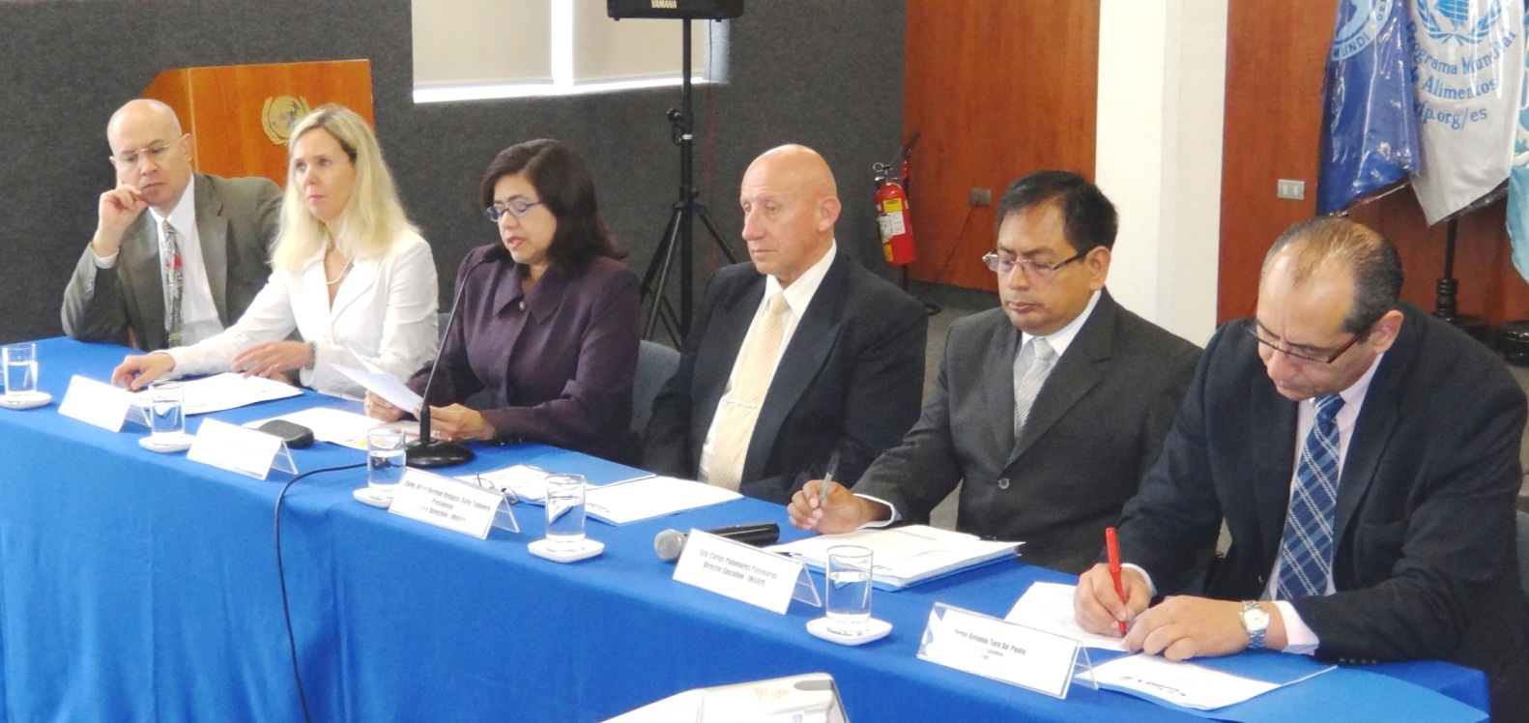
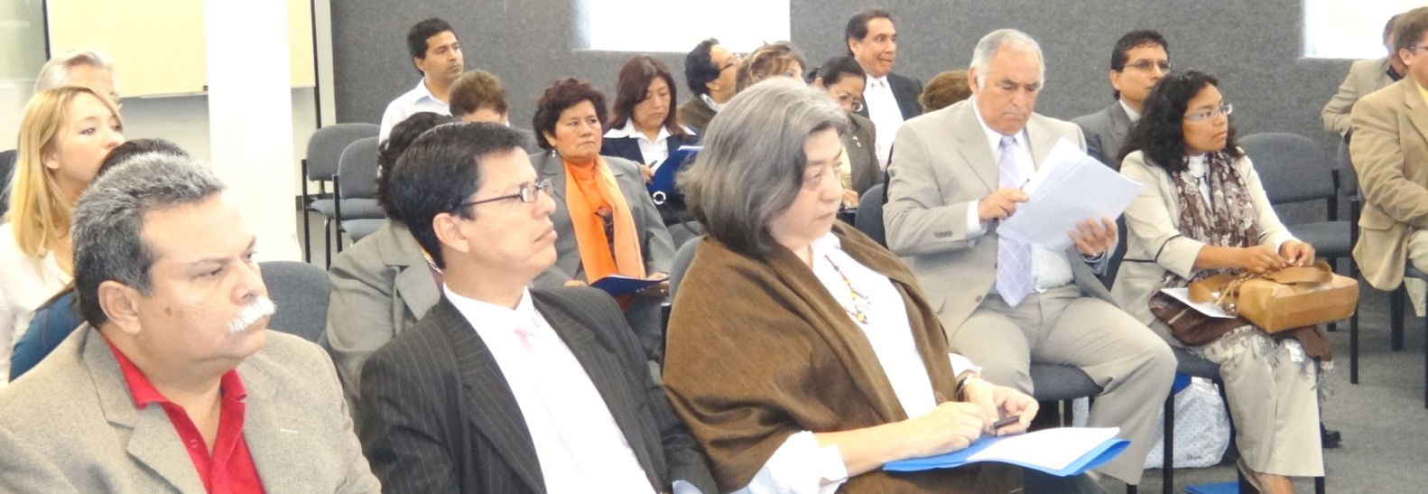
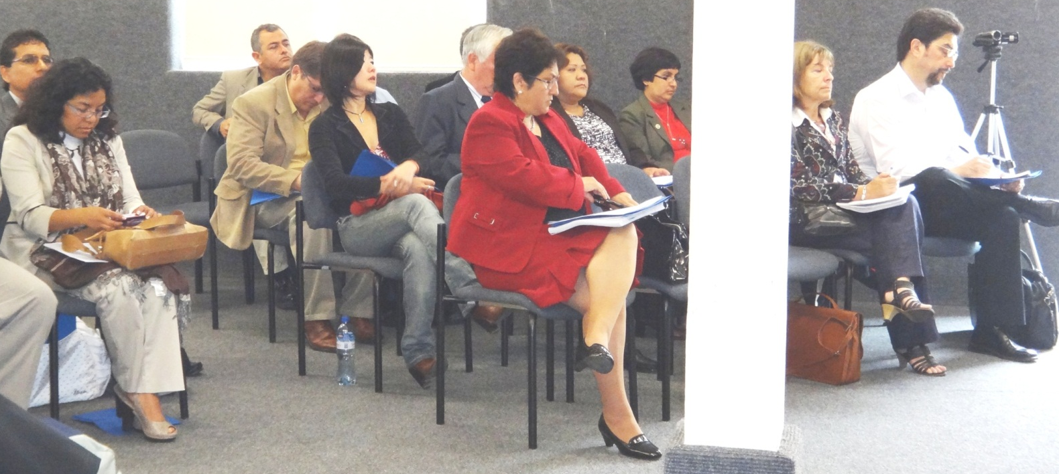
Guests of honour and participants at the HCLME Information meeting: during Rebeca Arias’ (UN Res. Rep.) welcome speech
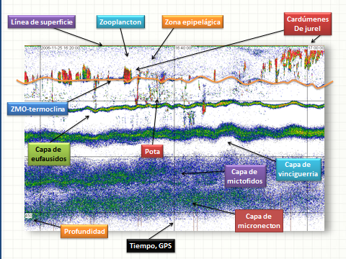
Use of sonar data for marine ecosystem health monitoring (Mariano Gutierrez)
Chilean Austral University studies regarding the Humboldt Current flow data for Chile and Southern Peru showing: a) summer and b) winter rapid flow in an area of approximately 400km width (red orange and yellow tones).

Over an area of 15 degrees of longitude, about 1,300km (each degree varies in distance from around 80km at 40ºS to around 110km at 15ºS), the Humboldt Current moves a mass of water Northwards at an average speed of 20cm/sec.

This is the equivalent of about 15 million cubic meters of water per second which in turn equates to around 70 times the discharge rate of the Amazon River system.

However it is the associated upwelling systems close to the Chilean and Peruvian coastlines that generate the dramatic productivity as nutrients are brought to the surface thus stimulating primary productivity.

Humboldt Current flow data at the start of the Current in the South-eastern area of the Pacific. http://www.biologiamarina.uach.cl/jgarces/Papers/Satellite_altimetry_reveal_jet-like_dynamics_Humboldt_Current.pdf

Chilean pilot sites

Peruvian Pilot sites
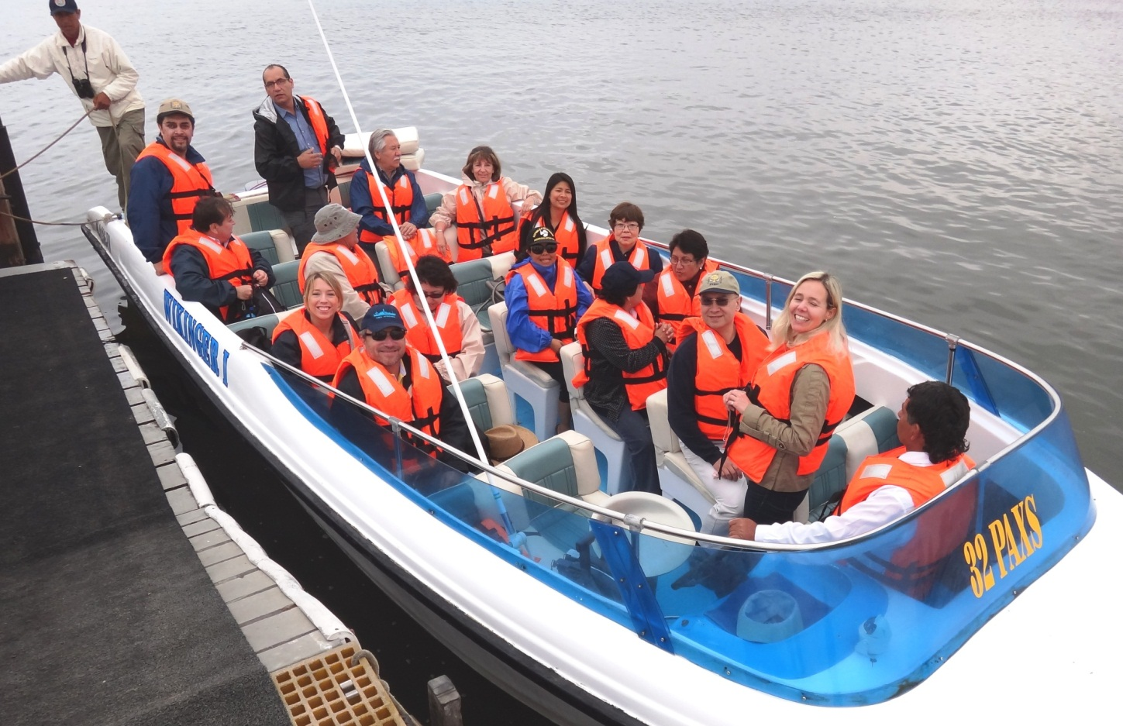
Boat trip to the Islas Ballestas HCLME Pilot site Northwest of Paracas
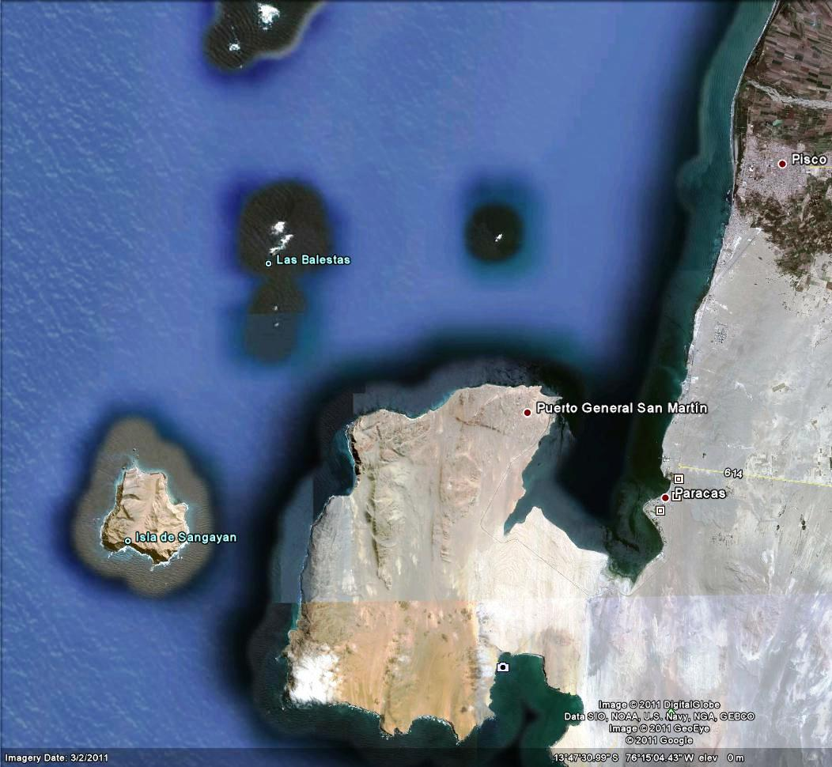
- Pisco
- San Andres (Direct Human Consumption [DHC] of Anchovy) processing plant base
- Islas Ballestas
- Liquid Gas terminal
- San Martin Port
- Landing site DHC
- Scallop aquaculture area
- Paracas
- Eco-Hotel Hilton Double Tree
- National Park

Map of the Paracas Bay, Islas Ballestas, range of economic activities using the marine environment and National Park
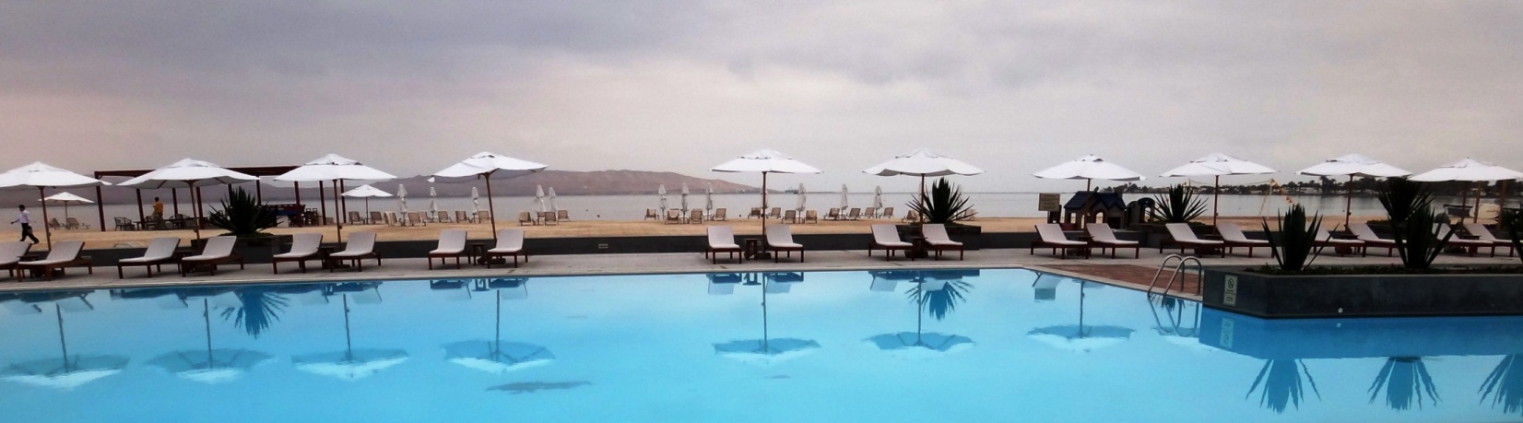
Eco-Hotel in Paracas at dawn: Paracas bay in the background. Part of the bay belongs to the National Park (map above).
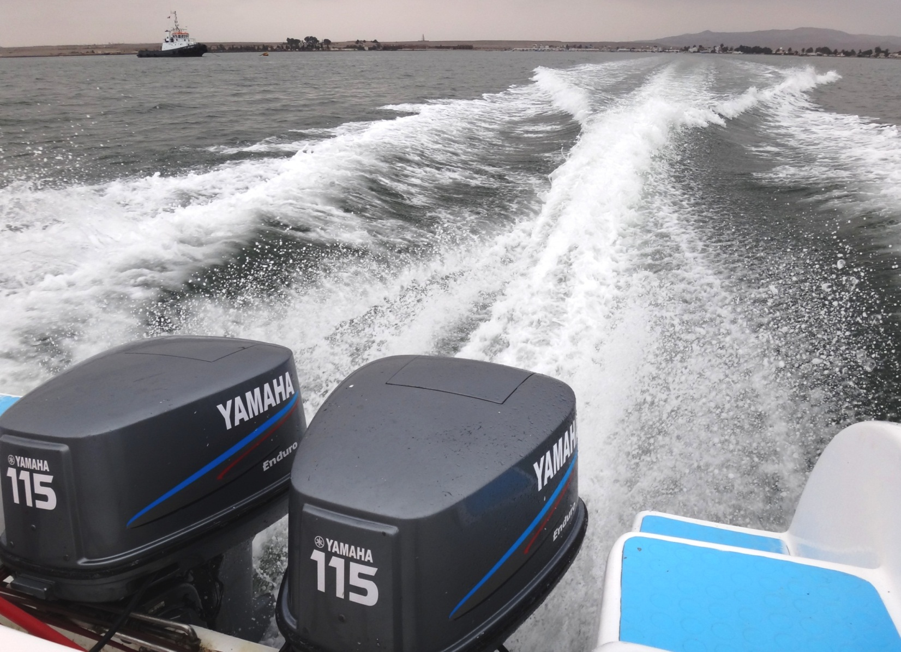
Leaving Paracas for Islas Ballestas at 35knots. Tourism plays an important part in generating employment and income but also poses a threat to ecosystem’s wellbeing in terms of propeller damage to marine reptiles and mammals, noise and pollution generation. The Islas Ballestas are sometimes referred to as the alternative to the Galapagos Islands in that the Islands are bio-diverse, interesting and easier to access. It should be mentioned that the Government of Ecuador has recently passed new regulations restricting the access of tourists to a number of attractions like the Hammerhead shark gathering area. The HCLME Project will help SENANP and others to come up with similar management master plans in order to protect the rich flora and fauna of the country’s national parks.
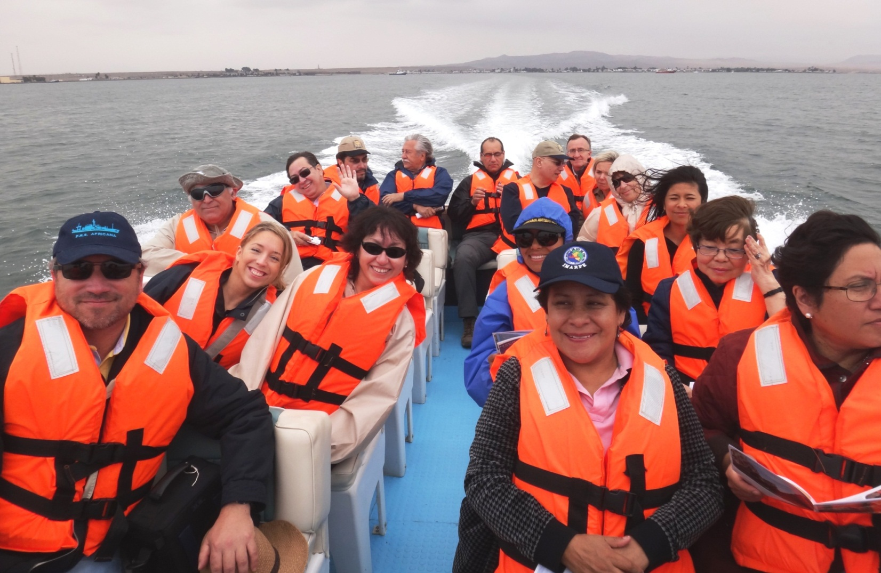
HCLME teams from Chile, Peru, Panama and Copenhagen travelling to the Ballestas Islands pilot site in Ica Province, Peru
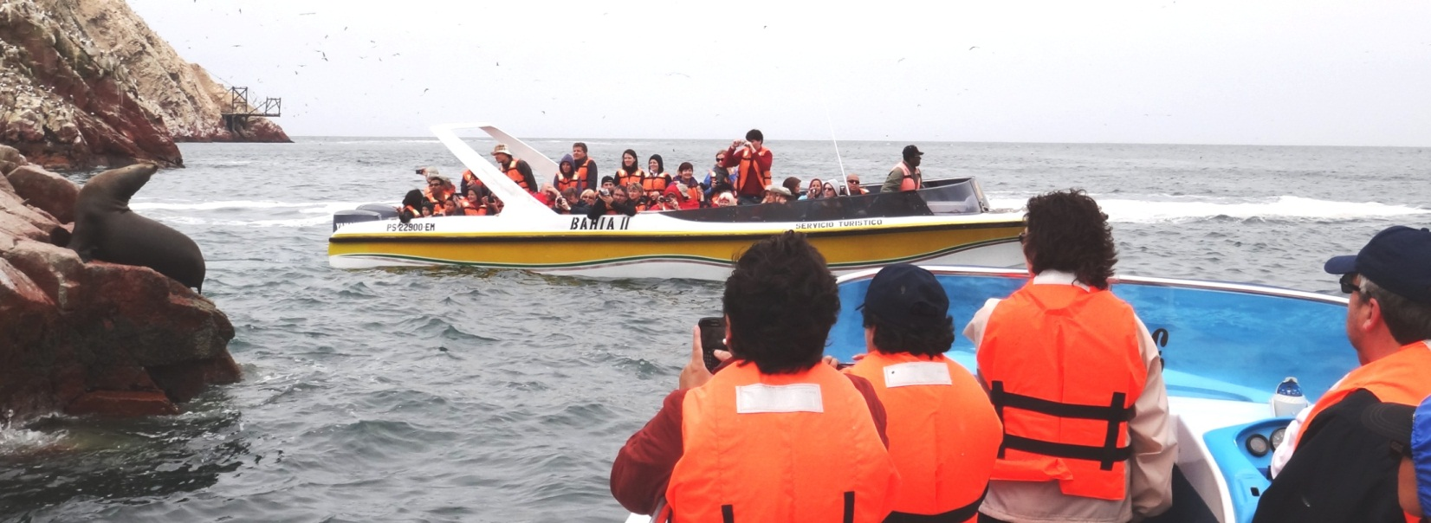
During the summer months (November to March) a large number of boats visit the Ballestas Islands
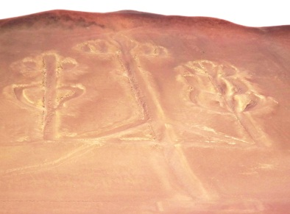
The Paracas candelabla or cactus symbol is carved in the rock and dates back many centuries. Some say it represents the lightning rod or staff of the god Viracocha, who was worshipped throughout South America. Others say it is a Masonic symbol and yet others that it is a navigation mark placed by pirates. The Paracas cloth is a burial winding cloth dating back almost 2,000 years and was found in tombs cut into the rock.

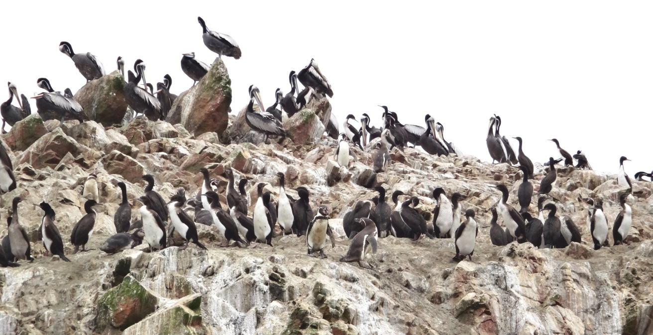
The Ballestas Islands are Guano harvesting areas. Guano (bird excrement) builds up over years and is harvested for use as a fertilizer for organic food production. Currently the Peruvian Agriculture Ministry has the responsibility for controlling guano harvesting – allowed on a one year in seven cycle.
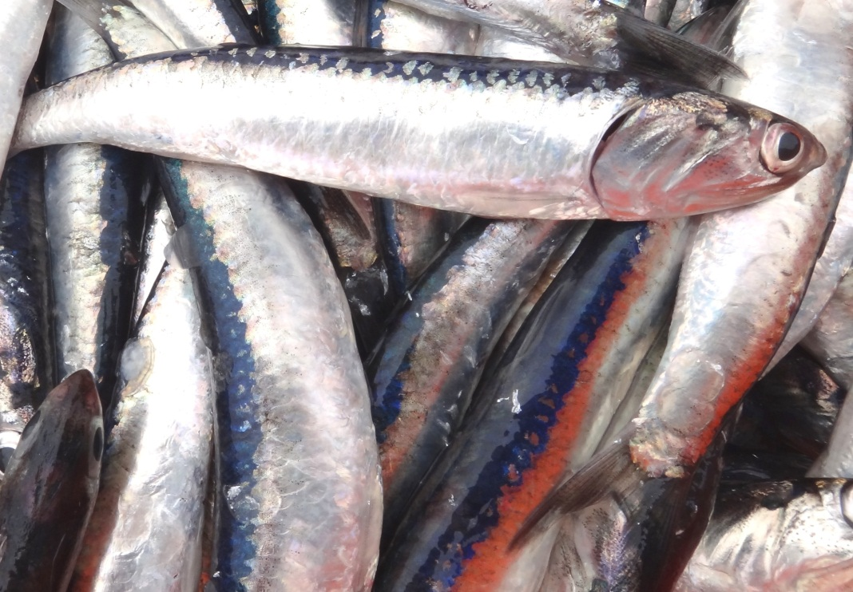
The start point for guano is the seabird’s diet – mainly pelagic fish like the anchovy pictured above. Today anchovy are harvested by the millions of tonnes to produce fishmeal for animal feed ingredients (for salmon, pig, chicken eggs amongst others). If too many fish are harvested for fishmeal the wildlife, part of Peru’s rich biodiversity is damaged. Apart from the ecological damage, the tourist industry would suffer as marine birds and mammals, dependent on fish populations, move away or die off. The bird populations have yet to recover from the dramatic sea temperature warming event (El Niño) of 1997-1998. Currently the Peruvian Marine Fisheries Institute (IMARPE) is keeping a close control on anchovy fishing by industrial boats. The artisanal fishing fleet has no quota and as such can fish to its full capability. There is an increasing drive towards fishing anchovy for direct human consumption i.e. not indirect consumption via pork meat, chicken eggs, salmon and a huge number of other fish produced under aquaculture conditions, hence the importance of the direct human anchovy consumption promotion (see below).
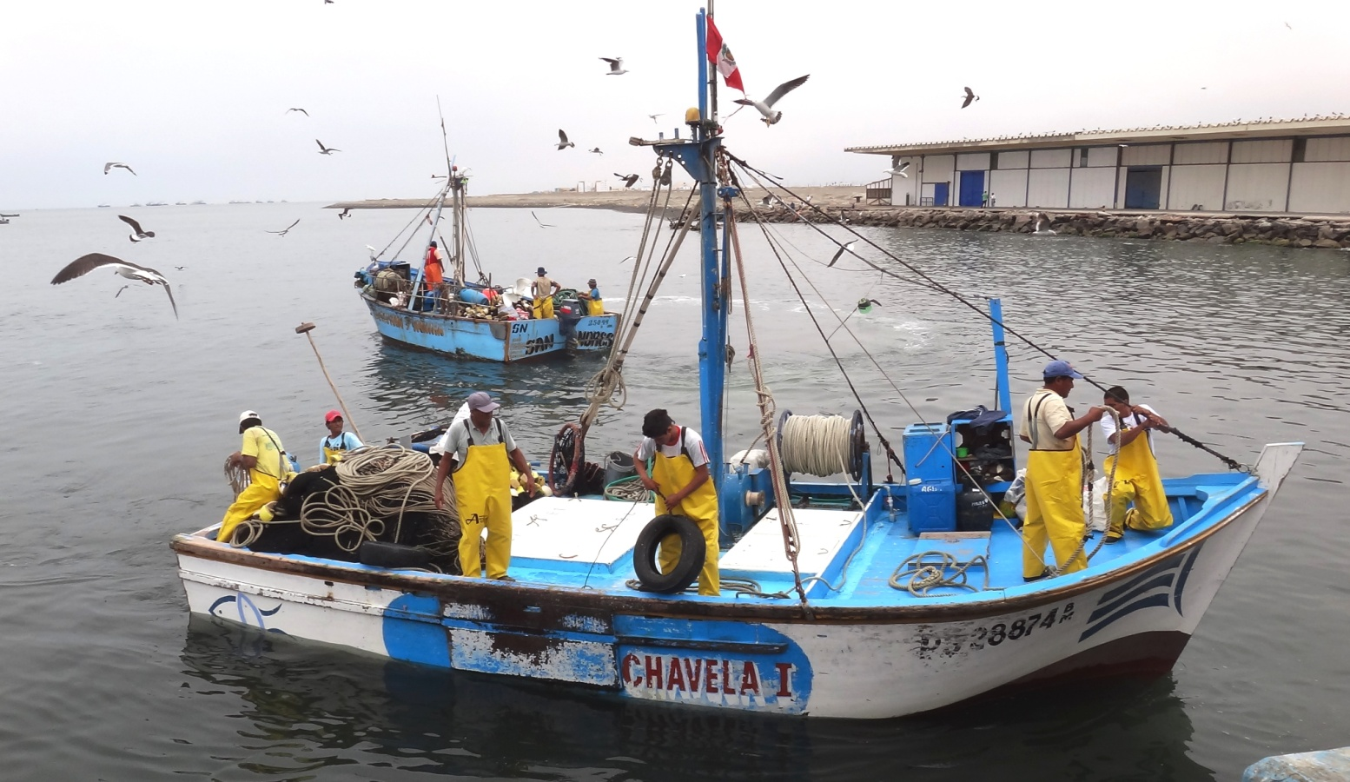
An artisanal fishing boat with around 5 tonnes of anchovy onboard ready to be unloaded as part of the direct human consumption of anchovy work. Six crew, an outboard engine, no shelter and all the work carried out by hand. Fishing takes place from around midnight to offloading at 10am.
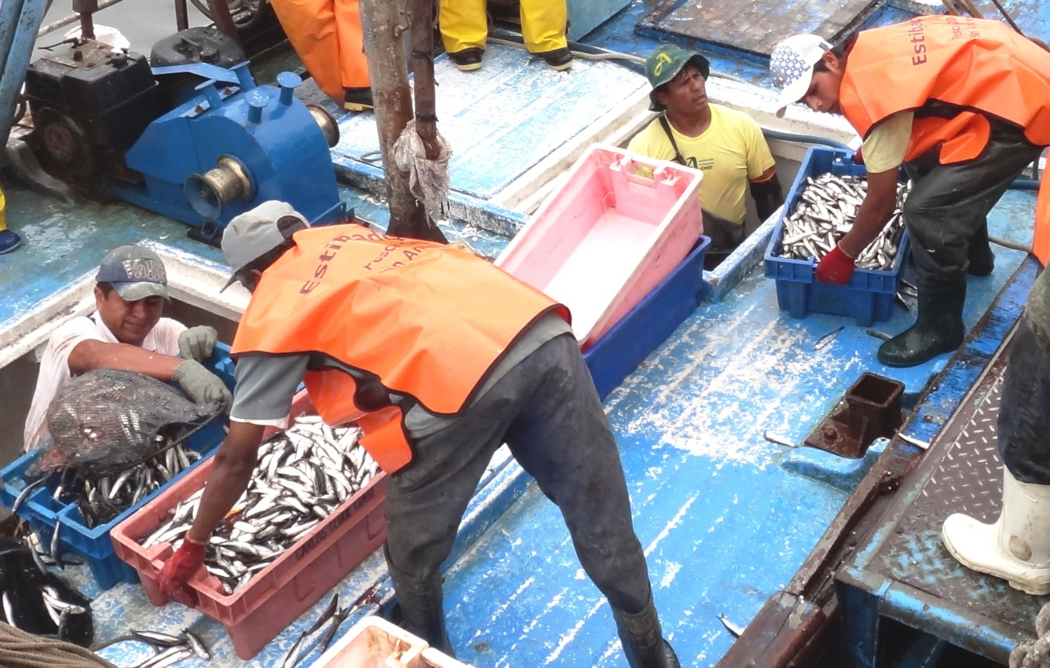
Offloading anchovy destined for direct human consumption under the control, supervision and support of the Association of Associations for the Direct Human Consumption (DHC) of Anchovy. The aim is to harvest a lower volume per trip and ensure improved quality for the dual option DHC processing sequences: A) Transport to plant, de-heading & gutting, salting and curing in salt. Followed by: B) Transport of salted fish to markets all over Peru or value addition via filleting and packing in tins or bottles for export markets.
- Artisanal fishing boat registered to land anchovy for direct human consumption
- Anchovy caught during the night is landed at a registered landing site at La Puntilla, Paracas, Ica, Peru
- De-headed gutted anchovy draining after 12 hours in salt solution at a small associated processing plant
- Drained and salted anchovy are covered in salt crystal for curing in plastic drums
- Plastic drums containing salted anchovies. The fish lose water during the salting process
- After three months the salted anchovies are ready to be marketed as a salted fish in inland locations
The product can be purchased in any quantity required, a single fish from a small village store to a lorry load of several metric tonnes. The product is cheap at around USD1/kg. The same fish cured in salt are the start point for the salted anchovy fillet product sold in bottles and tines for around USD25/kg. Images 7 to 17 demonstrate this value addition process.
- A barrel of salted anchovy as the start point for a low cost anchovy food source or the luxury market. Some of the barrels come from a Marine Stewardship n(MSC) certified fishery in Argentina
- One of thousands of barrels is emptied in an EU certified plant. The following process is for export.
- The salted fish are soaked in warm water to remove the skin. Subsequently the fish are ‘filleted’ by hand
- Anchovy with the skin removed.
- Salted, skinned anchovy are trimmed prior to filleting
- The anchovy backbones are removed and the waste (under the work bench) is sent to produce fishmeal
- The anchovy fillets are packed in cloth and centrifuged to remove any excess water prior to canning
- Anchovy fillets are packed in tins at an accurate weight
- The canning process – tins with anchovy fillets have either olive or sunflower oil added prior to packing
- A warehouse filed with boxes packed with tinned or bottled anchovy fillets
- A product label for traceability purposes indicating the fishing ground reference point, production and expiry dates and destination. Each individual tin can be traced back to the boat that caught the fish the area and date

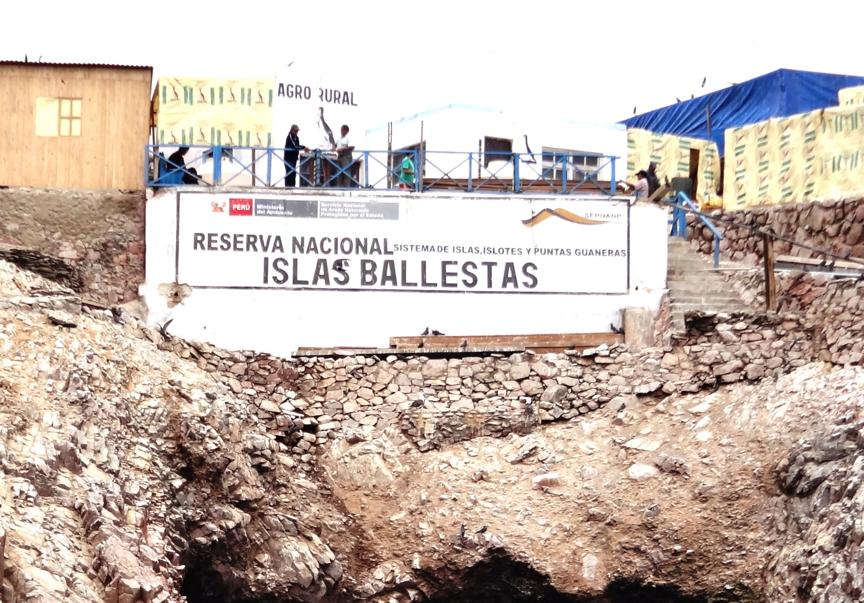
Ministry of Agriculture (AGRORURAL) installations, Islas Ballestas. SERNANP (Servicio Nacional de Areas Natuales Protegidas) http://www.sernanp.gob.pe/sernanp/ : within the Ministry of Agriculture, is empowered under the Ministry of the Environment (MINAM) Decree 024-2009 to supervise and manage natural recourses found inside the Peruvian Guano Islands, Isles and Capes National Reserves (RNSIIPG). This includes aquatic and land based resources: plant and animal wildlife in both forest and sea including their products and by-products (guano extraction is managed by AGRORURAL under SERNANP supervision). SERNANP also has to be consulted and give a positive opinion before natural recourse management planes can be approved.
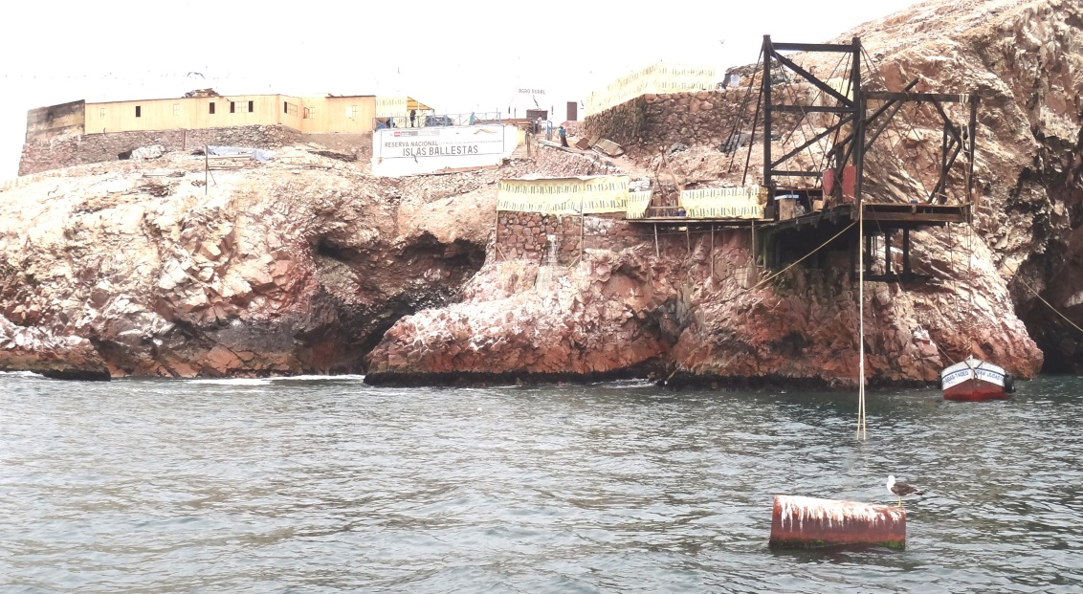
Guano is collected, placed in sacks and transferred to barges from this collection point on the islands. The arid climate with little or no rainfall ensures the high nitrate content of the guano as there is no leaching by rainfall. The product is used for organic agricultural product farming and as a lawn fertilizer.
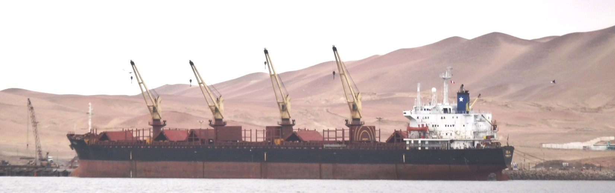
San Martin Port, Paracas Bay: a bulk carrier ship loading salt from the Salinas de Otuma in the area (satellite image below). The salt crystals are bulk exported to the USA and Canada where it is used in the winter months to stop ice forming on roads and pathways.
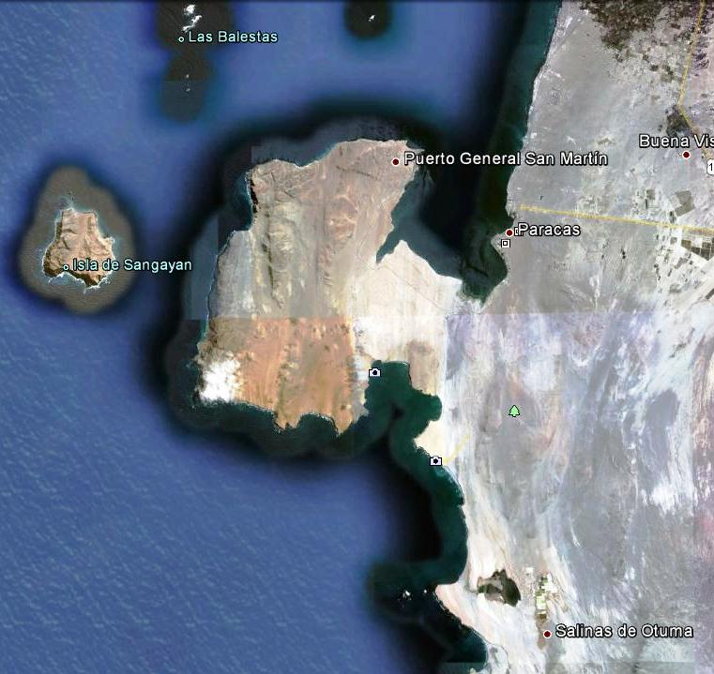
- Islas Ballestas

- Paracas

- Salinas de Otuma

Salt water flows to the salt pan evaporation areas inland in the desert where the strong sunlight evaporates the water

For data relating to gas pipelines and projects plus their potential negative impacts on the Paracas National Park see: http://www.paracas.com/actividades-economicas/gas-de-camisea/

How does the GEF-Humboldt Project relate to the above mentioned descriptions and observations?

The project will promote a holistic approach to maintaining the health of the Humboldt Current Large Marine Ecosystem following five basic steps as identified by IUCN and as described in the Project Document.

1) Determining main stakeholders and defining ecosystem areas, leading to the Transzonal Diagnostic Analysis-Strategic Action Programme (TDA-SAP) development process with a wide range of stakeholders; 2) Characterizing the Ecosystem structure and function, and setting in place mechanisms to manage and monitor it (the use of the Management Effectiveness Tracking Tool [METT] annex VI in the ProDoc; 3) Identifying and placing a value on the important economic issues that will affect the ecosystem and its inhabitants (some aspects highlighted above in the photos relating to the visit but there are many more); 4) Determining the likely impact of the ecosystem on adjacent ecosystems (the Sea-Land interface including integrated coastal zone planning and management aspects together with land based impacts from beyond the coastal zone e.g. gas pipelines from the Cusco area, irrigation water use, mining waste, deforestation in areas with watersheds draining to the West; and 5) Deciding on long-term goals and flexible ways of reaching them (the Strategic Action Programme towards EBM).

Peru is currently enjoying good economic growth from a range of sectors: fishing, mining, tourism, hydrocarbon exploitation, textiles, agriculture and food processing. The current need is to ensure economic, social and environmental sustainability by reducing the risks these activities may present. The activities from each sector have an impact on the same sector and others, for example excessive fishing activities have an impact on the abundance of fish and shellfish which in turn have an impact on the range of wildlife in an area as food becomes scarce. Once animals migrate to look for food or die off there will be less for tourists to see which in turn impacts the hotel, transport and restaurant industries. Similarly contamination from mining or marine transport activities may cause a decline in marine life with negative environmental and socio-economic consequences. Hence the Ecosystem Based Management (EBM) aim to promote the health of the whole ecosystem before any specific sector or sub-sector needs.

In many respects Peru and neighbouring Chile are dependent on the Pacific Ocean as it helps to regulate the climate, provides precipitation in the Andes for coastal and inland areas alike, absorbs excessive carbon dioxide and brings a mixture of economic and recreational activities.

Annex B Information meeting minute.

It was not possible to hold the intended Humboldt Project Inception Workshop followed by a Steering Committee meeting due to comments from the Peruvian Ministry of Foreign Affairs (RREE) about the ‘legality’ of the Humboldt Project Document approved by GEF and signed by the Governments of Peru and Chile.

This question was based on an observation that article 302 in Chapter 5 (Legal Context) had an error. The latter was reference to a Standard Basic Agreement between UNDP and the Government of Peru dated 24th May 1993; however there is no such agreement but an earlier accord for Technical Assistance signed on 30th March 1956 and a legislative resolution # 13706 approved this on the 15th September 1961. A letter was sent by UNDP on 15th November acknowledging the error in the document signed by both parties and offering to correct the article by an exchange of letters.

A second objection raised by the RREE related to the fact that the ‘illegality’ of the project document meant that it would not be possible to legalize the National Intersectoral Committee - Peru (NIC) or the Project Steering Committee delegation from Peru. As the NIC is the stakeholder group with the responsibility of designing and prioritizing activities in accordance with current HCLME EBM needs, it was deemed that the draft 2012 work plan, a product of many days’ work by the NIC-Peru, could not be submitted for approval.

It is assumed that when this current impasse is solved, the product of the original Peruvian NIC deliberations from two major meetings and subsequent inter-project work can still be used.

17th November 2011 Morning ‘Information’ meeting (would have been the Inception Workshop)

This session was opened by Rebeca Arias the UN Resident Representative with delegates from Chile and Peru in attendance. Rebeca made reference to the Project start date in April 2011, the strong economic climate in Chile and Peru due mainly on the dependence on non-renewable and renewable natural resources including those related to the HCLME, hence the need to promote the EBM concept to ensure ecosystem health now and in the future. She also underlined the fact that Chile and Peru have been working closely together for decades sharing scientific data relating to the services delivered by the HCLME including pelagic fisheries especially that of the anchovy stocks. Climate change aspects were also referred to including the need for UNDP projects to promote adaptive and where possible mitigation strategies.

The executive Directors of IMARPE and IFOP also made opening remarks in which references were made to the importance of the Project in terms of the sustainable use of renewable natural resources and the services offered by the HCMLE. Reference was also made to the need to adapt to climate change scenarios and to jointly study these. The need for combined economic analyses was also called for within the Project context.

In total 62 representatives from a total of 28 different entities representing government, NGO, private sector and university groups were present at the meeting.

There were four presentations: two from the Humboldt Project Coordination office and one each from Chile and Peru with data about the Project’s pilot sites. The Peruvian Ministry of Foreign Affairs has requested copies of the presentations prior to endorsing their release to all the participants as promised during the meeting.

Questions from participants included: the number of endemic species in the seamount areas in Chile; how project resources will be assigned; how the general public will be encouraged to voice their opinions related to the EMB approach in their areas; access to data from other LME projects around the world; why only three pilot sites chosen in Peru; fish stock certification; how were local intersectoral committees established; how will access to finfish and shellfish stocks be assigned to fishing communities. It was noted that additional co-funding should be actively sought from Regional Governments and private sector alike.

17th November 2011 Afternoon ‘Question and Answer’ meeting with UNDP and UNOPS (would have been the Project Steering Committee meeting to approve the 2012 annual work plan).

Apologies were received from James Leslie, UNDP Peru, as he had to attend another urgent meeting.

Jose Vicente Troya, UNDP Regional Office in Panama, opened the session with comments related to the need to react and adapt to the current situation and if necessary introduce operational changes.

Jorge Valenzuela from the MFA Chile asked how the situation had occurred and noted that Chile needed to be officially informed about the current problem. Michelle Graco from IMARPE outlined the good progress to date via the IMARPE focal point coordination up to the point of the very recent (8th November) MFA-Peru observation and action.

Elvira Velasquez, MFA-Peru, explained that the error in the project document needed to be corrected as it is the legal framework for the project. She asked if Chile agreed to the reference made to the Bio-Diversity accord referred to in article 302 in the Project Document. In reply Joge Valenzuela MFA-Chile stated that the Document had been signed by both MFA Ministers, hence Chile is in agreement with the signed document.

Katrin Lichtenberg, UNOPS International Waters Cluster Director, asked how long it will take to correct article 302 in the ProDoc as the Project has a lot to do in a short time; lost time also means a waste of limited project funds.

Michael Akester suggested that as the Project Document identifies a set of basic activities to achieve the desired Project Outputs and a budget allocation already exists this could be approved and adopted now for the first 6-months of 2012 further to an update with more specific activities and minor modifications as soon as the current ‘legal’ problem is solved. Michelle Graco, IMARPE, elaborated on this point.

Elvira Velasquez stated that until the administrative problems were solved it would not be possible to approve a work plan as the Peruvian Steering Committee members could not be formally assigned. She expected a suggested solution to the legal aspects would be forthcoming on Friday 25th November. A tentative meeting between Agencia Peruana de Cooperación Internacional (APCI) and IMARPE was scheduled for Wednesday 23rd November.

The meeting closed at 14.30hrs with many questions unanswered but with the expectation that the legal issue would be solved on Friday 25th November (see footnote one).

Would be Project Steering Committee members from Chile and Peru then travelled to Paracas in preparation for a day long field visit to one of the Peruvian pilot sites – Islas Ballestas on the 18th November (field trip report above).

Annex 8 Chile-Peru Paracas meeting minute
Minuta – Taller Informativo 17 de Noviembre del 2011
Primera parte: Presentación y palabras del panel
1. Se inicia con palabras introductorias de la Rep. De las Naciones Unidas para el Perú, Rebeca Arias, discurso en la que remarca una de las prioridades del período 2012-2016 que se enfocan en el desarrollo sostenible y cambio climático.
2. El Director Ejecutivo del IMARPE Eco. Carlos Palomares, menciona que los proyectos están vinculados con los esfuerzos de los científicos en un plano binacional. Ambas naciones, Perú y Chile deben aunar esfuerzos para hacer frente al cambio climático y a las actividades del hombre que puedan afectar al ecosistema. Puntualiza que esta reunión va a sentar las bases que nos ayudarán a plantar los lineamientos para operar el proyecto.
3. Sr. Jorge Toro, Director Ejecutivo del IFOP, aclara que se tiene que cambiar el paradigma del manejo de los recursos, siendo un gran desafío para poder conservar los diversos servicios ecosistemicos que brinda la gran corriente. El proyecto en conjunto tiene un desafío de largo plazo, en el cual se ira avanzado con el enfoque ecosistemico , especialmente en el aspecto de gobernanza.

Segunda Parte: Presentaciones según agenda entregada.
Tercera Parte : Ronda de preguntas y comentarios
• Dr. Albertina Kameya al Dr. Francisco Ponce : ¿Qué porcentaje por especies de peces estan habitando en las montanas submarinas?. El Dr. Ponce contesta que exactamente no tienen los porcentajes de especies habitadas en los montes. Lo que si quiere señalar es que se quiere acoplar la estrategia de gobierno para la zona con los objetivos del proyecto.
• Dr. José Troya a José Zavala: ¿ Cual es el mecanismo de asignación de recursos para el trabajo con los comités locales?¿Que mecanismos existen que aseguren la participación? Transferencias de recursos a actores locales, como?. Dr. Zavala contesta que el proyecto en su presupuesto plantea recursos para los trabajos con los comités locales y también las aportaciones de contrapartidas. En los sitios pilotos, si hay recursos adicionales de otros proyectos que van en curso que se han identificado y pueden aportar al trabajo de los comités.
• Asociación Oannes a expositores: ¿Cual va a ser la estrategia de la ciudadanía con cara al proyecto? ¿cómo plantear el mapa de actores?
Michael J. Akester comenta que la CPPS tiene un proyecto de monitorear el estado de salud de la corriente de Humboldt. Nuestro proyecto tiene que establecer su propia comisión de ¨HCLM¨ para vigilar las actividades sobre la HCLME.
José Zavala subraya que hay que entender que el proyecto es un proceso, que servirá como un catalizador de los objetivos del proyecto. Abordar el tema de los sitios pilotos, en Perú y Chile es vital el tema de la participación de actores vinculados a los recursos. Se deben considerar las lecciones aprendidas de las zonas piloto. Existen experiencias en Punta San Juan, experiencias avanzadas en Is. Ballestas. También existen experiencias SERNANP en temas de ordenamiento territorial. Los pescadores pueden estar entrelazados con el tema de turismo. El objetivo es realmente ambicioso, irá de menos a más.
Francisco Ponce: Este proyecto está inserto en actividades que el país ya está realizando en el borde costero. Cada una de las regiones que tienen borde costero está realizando la zonificación de los recursos participativo que está funcionando muy bien. Cada una de las RMP tienen una mesa de trabajo publico privado, que generan las practicas de gestión para con esas zonas.
Mariano Gutierrez: Sobre la participación del mapa de actores, remarca institutos como el IRD y adscribir actividades de ellos.
• MA.Barbieri hace una acotación: En Chile sí se efectuó una pesquería en los montes submarinos y existe interés de pescadores de la zona de detener la presión en esa zona. Se tienen 108 montes submarinos
• Auditorio pregunta a F. Ponce : ¿Cómo se han asignado las marcas en Is. Juan Fernández?. Ponce responde, es un sistema desarrollado por los pescadores de la zona. Esas marcas se heredan de padres a hijos. Cada familia tiene un sistema de marcas, se hereda y se respetan entre ellos. Es una forma muy particular de trabajar. Por ejemplo, comunidades de las Quenches, trabajan el borde costero, un grupo de rocas pertenecen a la familia trabajando solo dentro de sus espacios. Son formas ancestrales, distintas formas de ver el mundo. Tiene su propia cosmovisión.
• E.barriga – Imarpe consulta sobre las expectativas de éxito de las experiencias aplicadas al proyecto ?. El panel le contesta que IW learn tienen información de basta experiencia buenas y malas relacionadas al manejo con enfoque ecosistemico y es un activo muy importante del proyecto.
• Lilian Ayala , APeco : quisiera saber si coordinan actividades previas con gobiernos regionales/ MINAM ? ¿Por qué no se escogió a una isla netamente guanera?. José Zavala contesta, hay coordinaciones de estrategias con el MINAM y manejo integrado de zonas costeras, así también con el SERNANP. Existen otras experiencias de trabajos locales. Se está en etapa de planeamiento.
• Kerstin de Planeta Océano pregunta al panel, ¿ cómo se va a ser para replicar las experiencias en ambos países?. Mariano Gutiérrez le comenta que a medida que va adquiriendo experiencia con los sitos pilotos, estas se replicarían. Sr. Akester indica que el resultado 3 apoya a la iniciativa de escalar a mayor medida en todos los demás sitios.
• Arturo de SEDEPESCA, consulta sobre el tema de pesquerías certificables. Nos dice que cuenten con ellos para esta actividad. A que nivel se estaría viendo el tema de pesquerías certificables?. Mariano Gutierrez dice que el tema de certificación de sesgo, los mecanismos están disponibles que hay que conocer bien, por ejemplo el de Marine Stewarship Council, se acerca más al manejo con enfoque ecosistemico. Entender como funcionan es muy importante. MSC tendrá un taller en Lima, el próximo enero 2012. Es un tema que se va a promover. En Chile, Francisco Ponce indica que hay una aspiración de una pesquería en Is. Juan Fernández.
• Elisa Goya, Imarpe consulta sobre el estado en que están los comités ? Como van a estar estructurado la coordinación?. Sr. Akester indica que los comités intersectoriales necesitan su formalización, con apoyo de la Cancillería. Promoción de MOU por ejemplo con TNC. Por ejemplo en la Municipalidad de Marcona se institucionalizo un comité de trabajo del proyecto para su zona. Llama a usar los comités ya existentes no crear más.
• Patricia Majluf pregunta sobre las marcas, tienen algún mecanismo legal que les asegure esa propiedad? Existe una concesión distinta a la ancestral?. Francisco Ponce dice que se está en el plan de manejo de la langosta que si va a estar legalizado. Así de esta forma las marcas estarían legalizadas de manera indirecta.
• Marco Espino,IMARPE pregunta : Cual es la perspectiva al tratamiento del gran ecositema de la Corriente de Humboldt? Mariano Gutierrez contesta que se proponen a iniciar los trabajos con los pilotos. P.Majluf adiciona, indicando que los pilotos tienen más enfoque de preservación de las AMP, ya que se escogieron por la gran diversidad biológica y por las amenazas que presentan. Rodolfo Serra puntualiza que el Plan de diagnostico transfronterizo será abordado la perspectiva del manejo con ecosistémico.
Cuarta parte: Palabras de Cierre

Michael J. Akester: Se debe de tener un plan de trabajo Anual de la parte ecosistemica, PAE, Diagnostico transfronterizo coordinado. Durante del 2012 va a ver trabajo de acercamiento a los certificadores. Trabajos con los MSC. Existen experiencias de certificación de machas en Europa que son rentables. Asegurar que estamos trabajando sobre bases firmes y conformar planes de trabajos formales por las contrapartes. Buscar nexos con proyectos actuales como Profonanpe,TNC etc y así fortalecer las alianzas de proyecto.
___________________________________***************_______________________________

Día 17 de Noviembre : Reunión Informal 1:00 PM – 3:00 PM

Palabras de José Troya: Comenta sobre las responsabilidades con la que siente con el manejo adaptativo del PNUD para con sus clientes, los estados de Perú y Chile en este caso. Existen limitaciones las cuales se pueden tratar con cirugía mayor, esas transformaciones se pueden dar en consulta con PNUD y GEF. Estructura de toma de decisiones considera a los Comité directivo nacional, en cual las partes involucradas tienen la responsabilidad por velar por las hojas de ruta. De acuerdo a los ToR UNOPS tiene un rol de observador.
Los Comités Intersectoriales nacionales, tienen roles de asegurar la ejecución de actividades para así se den de la manera más adecuada posible. Estos comités son entes públicos que tienen diferentes roles, ejecutores, de beneficiados y otras veces como responsables finales. El rol de co - dirección lo lleva la Unid. Regional y el principal rol lo tiene las contrapartes.
• Jorge Toro : Le preocupa el tema de la aprobación de las actividades. IFOP tiene todas las ganas y de que se dé una trabajo en conjunto con Perú y Chile.
MJA. Hay dos 2 borradores de plan de trabajo que se tienen que entrelazar. Hay actividades conjuntas y otras apartes. El problema es que al día de hoy, el plan de trabajo no tiene como andar. ¿Podemos hacer actividades? Piensa que si, establecer Plan de trabajo para los 3 primeros meses.
• Raul O´Ryan : Cancillería precise que se necesita hacer y así continuar con el proyecto.
• J.Valenzuela: Nosotros tenemos todos los vistos para trabajar, hace el comentario que el PNUD podría apoyarnos con cancillería.
• Valenzuela : Cancillería chilena no tienen información formal por parte de cancillería sobre el petitorio de cancillería de Perú sobre el tema de la formalización/visos
• Velasquez : Si lo van a hacer. Existe una deficiencia legal en el documento. Se había considerado un acuerdo del 1993 con el PNUD el cual no existe hasta el momento. Quedaría corregir la cita. El proyecto no se inserta en un acuerdo específico, el cual está siendo estudiado por el despacho legal de la ministra Velasquez. Si es que no existe ese componente administrativo tiene que estar avalado por las autoridades competentes peruanas. Dado que el proyecto compromete presupuesto nacional/ recursos nacionales, tienen que tener bases legales.
• Jorge Valenzuela: los miembros del Comité directiva en Chile ya están institucionalizados por el refrenamiento del ProDoc.
E. Velasquez responde que esas institucionalización no han podido avanzar porque hay una deficiencia por subsanar. Ellos están estudiando de manera interna como subsanar este vicio.
• Katrin Lichtenberg: desea saber el tiempo que se tomara en corregir, porque ya hay gastos en marcha. Cual es margen de tiempo para solucionar?
E. Velasquez Espera para el próximo viernes 25, tener un informe de la oficina legal sobre la normativa y presentando las soluciones propuestas. Luego subsanar los vicios, encontrar una solución al marco normativo y los plazos para el CIN

Annex 9 Quarterly Operational Reports Q2 2011 to Q1 2012
Humboldt Current Large Marine Ecosystem – Towards Ecosystem Based Management - Project ID 76126
Quarterly Operating Report (QOR) as at 30.06.2011 = first 3 months of operation.

- Actual Project start date (first expenditure) April 2011.
- The Regional Project Coordinator (MJA) arrived at post 31.03.2011 after training at UNOPS Copenhagen.
- MJA organized the hiring of the Project’s Financial & Administrative Assistant (LLL) at post 18.05.2011 and selection process for the Senior Project Officer (tests and interviews to be finalized end July).
- The project rents an office in the UN compound Lima and this will be fully equipped by end July 2011.
- MJA has visited most of the project stakeholders based in Lima, Santiago and Valparaiso. He has yet to visit the pilot sites and has not yet met with fisherfolk associations.
- The National Intersectoral Committees are being established to prioritize 2011 and 2012 HCLME work plan activities with GEF and national funding.
- Links have been established with The Nature Conservancy in Peru – another Humboldt Project - Manager Mr. Fernando Ghersi fghersi@tnc.org , the Centre for Environmental Sustainability at Cayetano Heredia University in Peru pmajluf@csa-upch.org and a JICA project to promote direct human consumption of anchovy.
- The project has had several working sessions with most of the IMARPE staff in Lima and in late June was shown a proposal to expand the pilot site areas in two of the three national parks included in the project (Islas Ballestas & Punto San Juan both in Ica province, Peru). The proposal allows for genuine ecosystem based management work to start in that mining, urban, tourism and aquaculture areas are to be included in the pilot.
- The inception workshop and first steering committee meeting (combined) are delayed. Chile (IFOP) has requested a 30.11.2011 date.

Delivery rate: | Very slow due to start-up and presidential elections Peru
Budget expenditures to date | USD 99,036.56 (20% of planned Q2 2011)
Delivery rate (budget expenditure/annual budget) | 99,036.56 / 1,935.100.02 = 5% over the full year.

1. Inicio del proyecto (primer gasto) abril de 2011.
2. El Coordinador Regional del Proyecto (MJA) llegó a su puesto de 31/03/2011, después de recibir entrenamiento en UNOPS Copenhague.
3. MJA organizó la contratación de Asistente de Finanzas y Administración del Proyecto (LLL) en el puesto desde 18/05/2011 y el proceso de selección para el Senior Project Officer (pruebas e entrevistas terminarán a fines de julio).
4. El proyecto alquila una oficina en el complejo de la ONU en Lima y estará totalmente equipada a finales de julio 2011.
5. MJA ha visitado la mayoría de los participantes del proyecto en Lima, Santiago y Valparaíso. El todavía no ha visitado los sitios piloto y aún no se ha reunido con asociaciones de pescadores.
6. Los comités intersectoriales nacionales están en el proceso de establecimiento para dar prioridad a la formación de planes de trabajo 2011 y 2012 del Proyecto HCLME con fondos FMAM (GEF) y nacionales (Chile y Perú).
7. Se ha establecido vínculos con The Nature Conservancy en el Perú - Gerente del otro Proyecto Humboldt - Sr. Fernando Ghersi fghersi@tnc.org , el Centro para la Sostenibilidad Ambiental de la Universidad Cayetano Heredia de Perú pmajluf@csa-upch.org y un proyecto JICA promoviendo el consumo directo de anchoveta.
8. El proyecto ha tenido varias reuniones de trabajo con la mayoría del personal de IMARPE en Lima. A fines de junio IMARPE mostró una propuesta para ampliar las áreas de sitios pilotos en dos de los tres parques nacionales incluidos en el proyecto (Islas Ballestas y Punto San Juan, ambos en la Provincia de Ica, Perú). La propuesta permite una verdadera gestión de trabajo basado en el ecosistema: incluye la minería, sitios urbanos, el turismo, la pesca y la acuicultura como áreas dentro del proyecto piloto.
9. El Taller de Iniciación del Proyecto y del Comité Directiva (combinados) están postergados. Chile (IFOP) ha pedido la fecha del 30.11.2011.

Gastos presupuestales a la fecha | USD 99,036.56 (20% del programado Q2 2011)
Tasa de desembolsos (Delivery rate): (gastos presupuestales/presupuesto anual) | 99,036.56 / 1,935.100.02 = 5% anual

Humboldt Current Large Marine Ecosystem – Towards Ecosystem Based Management - Project ID 76126. Quarterly Operating Report (QOR) Q4

- On 09.08.2011 the Regional Coordination Unit moved into the definitive Project offices within the UN compound, Lima Peru. New IT equipment and furniture was installed.
- First field visit took place week 33 to Paracas and Marcona (see back to office
report).
- The first National Intersectoral Committee (NIC) meeting in Peru held 8th August and in Chile 12th September. Second meeting Peru 28.09.2011 to define 2012 work plan.
- MJA attended both Chilean NIC and Comisión Permanente Pacifico Sur (CPPS) UNEP-UNESCO-IOC Ocean Health ‘evaluation of evaluations’ meeting (week 37)
- 15th – 20th October, Regional Project Coordinator MJA and Rodolfo Serra (IFOP) attended the 6th GEF Biennial International Waters Conference in Croatia. Documents were presented on Variability of Humboldt Current Biomass Yields during Climate Change (will form a chapter in a forthcoming NOAA publication).
- Workshop held in Arequipa co-funded by Humboldt Project & The Nature Conservancy (TNC): Use of Protected Areas on the Land-Sea Interface as a method of adaptation to Climate Change (details in separate report).
- Senior Project Officer position filled 02.11.2011: Mariano Gutierrez (MGT) selected
- Inception workshop and Steering Committee meeting planned for 17th and 18th November were stopped by the Peruvian Ministry of Foreign Affairs (RREE-P) representative Elvira Velasquez R. on the basis of an incorrect reference at article 302 in the signed and approved Project Document (signed by the Ministers from the respective Chilean and Peruvian Ministries of Foreign Affairs). The RREE-P argument being: ProDoc faulty; the setting up of NICs is therefore questionable as this needs a ‘Decreto Supremo’; NIC developed 2012 work plan (WP) hence WP can’t be submitted, Steering Committee (SC) also has to be set up by a ‘Decreto Supremo’. As air tickets, hotels and field trip to the Islas Ballestas had all been booked in advance (expenditure committed) meetings were held but without the presentation of a 2012 WP and hence no SC approval of said plans.
- 15.11.2011 the UN Resident Representative in Peru, Rebeca Arias, sent a letter to the Deputy Minister MFA-P outlining how article 302 could be corrected as quickly as possible via a simple exchange of letters.
- From 28th November to 2nd December the project gave an Ecosystem Based Management training course in Vina del Mar, Chile (see separate report).
- 01.12.2011 MJA along with PNUD Programme Officials met with General Secretary RREE-P to agree on the need to modify Article 302 via a simple exchange of letters and underline the fact that as the Humboldt Project is directly implemented by PNUD there is no need for Presidential Decrees to set up the NIC & SC. This was agreed verbally.
- 10.12.2011 the Peruvian Head of Cabinet resigned and a new appointment was made by the President the next day. The new Ministers include Lino Ginocchio (agriculture), Luis Peirano (culture), Manuel Pulgar Vidal (environment), Jorge Merino (energy and mines), Ana Jara (women's affairs), Juan José Jiménez (justice), Alberto Otárola (defence), José Urquizo (production), José Villena (labour) and Daniel Lozada (interior).
Delivery rate: | Slow due to start-up, presidential elections (June) & government reshuffle (Dec) Peru
Budget expenditures to date | USD 376,307.44 (69% of planned 2011)
Delivery rate (budget expenditure/annual budget) | 376,307.44 /  545,000  (original budget 1,935.100.02) = 69% over the full year.

Gran Ecosistema Marino de la Corriente de Humboldt – Hacia un manejo con enfoque ecosistémico
- Proyecto ID 76126. Reporte Operacional Trimestral (QOR) Q4

- El 09.08.2011 la Unidad Coordinadora Regional se instaló en su oficina definitiva.
- Primer viaje a campo semana 33 a Paracas y Marcona sitios pilotos de Ica Perú – ver reporte ‘vuelta a la oficina’.
- La primera reunión del Comité Intersectorial Nacional (CIN) Perú 8.08.2011 y Chile 12.09.2011. Segunda reunión CIN-Perú 28.09.2011 para definir Plan Operativo Anual 2012.
- MJA asistió al CIN-Chile y reunión del Comisión Permanente del Pacifico Sur (CPPS) reunión de evaluación de evaluaciones sobre el estado de salud de la zona Océano Pacifico Sureste (semana 37).
- Entre 15 a 20 de Octubre MJA y Rodolfo Serra (IFOP) asistieron a la Conferencia GEF IWC6. Hicieron presentaciones sobre la variabilidad de biomasa en el HCLME durante el Cambio Climático. Los datos van a formar un capitulo en un libro de la NOAA.
- Taller co-financiado por el proyecto Humboldt y el Nature Conservancy en Arequipa sobre el uso de áreas protegidas en la zona del interface mar-tierra como método de adaptar a eventos provocados por el cambio climático (reporte separado).
- Puesto de Senior Project Officer ofrecido (y aceptado) al Dr. Mariano Gutiérrez (MGT) 02.11.2011.
- Taller de incepción y del Comité Directivo programado para las fechas 17 y 18 de noviembre fueron paralizadas por una acción de un funcionario (Sra. Elvira Velásquez) del Ministerio de Relaciones Exteriores del Perú en base a una referencia errónea en el articulo 302 del documento del proyecto firmado aprobado por Chile – Perú. El argumento del RREE-P es: Documento del Proyecto tiene un error por lo tanto no se puede establecer el CIN dado que se requiere un Decreto Supremo; los planes de trabajo 2012 fueron desarrollados por integrantes del CIN por lo tanto no pueden ser entregados; el Comité Directivo (CD) también debe estar formalizado a través de un Decreto Supremo. Dado que boletos de avión, hoteles y salida al campo a un sitio piloto Islas Ballestas habían sido pagados / reservados se llevo a cabo una reunión sin la presentación del plan de trabajo 2012. No era posible conseguir la aprobación del CD.
- El 15.11.2011 la representante de la ONU en el Perú, Sra. Rebeca Arias, envió una carta al Vice-ministro RREE-P sugiriendo que el artículo 302 podría ser corregido lo antes posible por medio de un simple intercambio de cartas.
- Durante 28 de noviembre al 02 de diciembre de 2011 el Proyecto dicto un curso de capacitación sobre el Manejo con Enfoque Ecosistémico en Vina del Mar, Chile (ver reporte separado).
- El 01.12.2011 MJA, junto con Oficiales del Programa PNUD, tuvieron una reunión con el Secretario General del RREE-P para hacer un acuerdo sobre la forma de corregir el artículo 302 por medio del intercambio de cartas y para subrayar el hecho que el proyecto esta implementado directamente por PNUD no hay necesidad de Decretos Supremos para formalizar los CIN y CD. Hubo un acuerdo verbal al respecto.
- El 10.12.2011 el Jefe del Gabinete Peruano renunció a su puesto y al día siguiente el Presidente nombró un remplazo. Nuevos Ministros incluyeron: Lino Ginocchio (Agricultura), Luis Peirano (Cultura), Manuel Pulgar Vidal (Medio Ambiente), Jorge Merino (Energía y Minas), Ana Jara (Asuntos de la Mujer), Juan José Jiménez (Justicia), Alberto Otárola (Defensa), José Urquizo (Producción), José Villena (Trabajo) and Daniel Lozada (Interior).
Tasa de entrega: | Lento debido a elecciones (Junio) y cambios políticos en el Perú (Diciembre).
Gastos presupuestales a la fecha | USD 376,307.44 (69% presupuestado 2011)
Tasa de desembolsos: (gastos presupuestales/presupuesto anual) | 376,307.44 /  545,000  (presupuesto original 1,935.100.02) = 69% del año completo.

Humboldt Current Large Marine Ecosystem – Towards Ecosystem Based Management - Project ID 76126. Quarterly Operating Report (QOR) Q1 2012
- Reporting period: 01.01.2012 to 31.03.2012
- Senior Project Officer (SPO) Mariano Gutierrez presented a document entitled ‘Assessment of changing states and biomass yields in the Humboldt Current LME’ at the Marine Resource Conservation Working Group (MRCWG), Seoul, Republic of Korea, January 4-5, 2012 (see separate report)
- EBM training course was delivered to stakeholders in Lima (see separate reports)
- Follow-up core group EBM training of trainers group meeting (15.01.2012 see separate report)
- Regional Project Coordinator (RPC) Michael Akester attended a South Pacific Regional Fisheries Management Organization (SPREFMO) meeting in Santiago Chile 29 Jan to 4 Feb 2012. Meetings were also held with IFOP, SUBPESCA, MMA, MINREL and PNUD-Chile (see separate report)
- 06 to 10 February 2012 visit to most northerly project pilot site in Peru: Isla Lobos de Tierra (see separate report)
- In response to a request from the Ministry of Foreign Affairs Peru (RREE-Peru) a letter dated 28th February 2012 was sent by the UNDP-Peru to correct the error in the Project Document (article 302 – see earlier reporting). RREE-Peru responded on the 7th March agreeing to the proposed change. Letters were sent to the Ministry of Foreign Affairs Chile (MINREL) outlining the changes made in the documentation (see back to the office report from RPC visit to Chile item 8 below)
- RPC attended a Project Coordination meeting in IFOP, Valparaiso 21st March (MMA, SUBPESCA & IFOP attended) and also delivered a presentation on 23rd March 2012 on the development of Peruvian and Vietnamese Marine Protected Areas (MPA), and comments on the proposal to establish an MPA in Tarapaca the most Northern Region in Chile. The possibility of synergy with the Humboldt Project re MPA establishment in Peru and Chile was discussed
- Several important meetings were held at the Regional Coordination Unit (RCU) Offices and within stakeholder agency offices:
- National Park Islands (RNSIIPG – Peru) zoning and the need for good underwater photos and archeological data
- Coastal zone planning (Planning Department MINAM-Peru)
- Synergistic links to proposed GEF projects in Peru (RNSIIPG and Adaptation to Climate Change) – meetings at PROFONANPE and with MINAM)
- The Nature Conservancy: activities with CPPS, WWF and others
- WWF: MSC certification work in partnership with GEF-HCLME
- Nitratos: Private company with Peru and Chile investment: will uses sea water for cooling purposes
- MSC: certification and the possibility of Northern-Central Anchovy stock certification whole/partial
- SERNANP: meetings to coordinate work at the pilot sites and the need to create a RNSIIPG master plan
- Work with a range of stakeholders in MINAM to develop a new Biodiversity Protection Action Plan
- Finance & Admin Assistant Lenka Lazo participated in a Skype-Conference with CPPS & TNC (Ecuador, Peru, Chile) to finalize plans for a Seabed Resource Management workshop to be held in Valdivia Chile Q4 2012
- Preparatory work for the Peruvian inputs to the Rio+20 event in Brazil
- Meeting with UN Volunteers to look into the possibility of the HCLME Project finding co-funding for UNVs at each pilot site
- 28.03.2012 meeting with the World Food Programme regarding the promotion of processed anchovy as an animal protein source in isolated areas.
- Visits to popular kitchens in Lima where direct human consumption of anchovy was being promoted by the Consorcio group working with the Project in Pisco
- Dates set for a combined Chile-Peru work plan development workshop 16-18 April 2012. Also the first project Steering Committee meeting has been set for 3rd May in IFOP, Valparaiso, Chile
Delivery rate: | Slow: complications related to the Project Document text
Budget expenditures to date | USD 68,331.23 (4.12% of planned 2012)
Delivery rate (budget expenditure/annual budget) | 68,331.23 / 1’658,600 = 4.12%  (Pro-Doc budget for year 3)

Gran Ecosistema Marino de la Corriente de Humboldt – Hacia un manejo con enfoque ecosistémico
- Proyecto ID 76126. Reporte Operacional Trimestral (QOR) Q1 2012
- Período cubierto por este reporte: 01/01/2012 al 31/03/2012
- Senior Project Officer (SPO) Mariano Gutiérrez presentó un documento titulado "Evaluación de los estados cambiantes y los rendimientos de biomasa en la corriente de Humboldt LME” en la reunión del Grupo de Trabajo sobre Conservación de Recursos Marinos, en Seúl, República de Corea, enero 4-5, 2012 (ver informe por separado)
- Curso de capacitación MEE fue dictado a los participantes en Lima (ver informes por separado)
- Seguimiento con el grupo núcleo MEE formación de formadores reunión del grupo (15/01/2012 ver informe separado)
- Coordinador Regional del Proyecto (RPC) asistió a una reunión de la Organización Regional de Ordenamiento Pesquero del Pacifico Sur (OROP), celebrada en Santiago de Chile 29 enero-4 febrero 2012. También se celebraron reuniones con el IFOP, SUBPESCA, MMA, MINREL y el PNUD-Chile (ver informe por separado)
- 06 al 10 febrero, 2012 visita al sitio piloto del proyecto de más al norte en el Perú: Isla Lobos de Tierra (ver informe por separado)
- En respuesta a una petición del Ministerio de Relaciones Exteriores de Perú (RREE-Perú) una carta de fecha 28 de febrero 2012 fue enviado por el PNUD-Perú para corregir el error en el documento del proyecto (artículo 302 - véase el informe anterior). RREE-Perú respondió el 7 de marzo aceptando el cambio propuesto. Se enviaron cartas al Ministerio de Relaciones Exteriores de Chile (MINREL) que describe los cambios realizados en la documentación (ver informe de la visita del RPC a Chile en el tema 8 abajo)
- RPC asistió a una reunión de coordinación del proyecto en el IFOP, Valparaíso, 21 de marzo (MMA, SUBPESCA y IFOP asistieron) el también hizo una presentación el 23 de marzo de 2012 sobre el desarrollo de los Áreas Marinas Protegidas (AMP) en el Perú y Vietnam. Hizo comentarios sobre la propuesta de establecer un área marina protegida en la Región de Tarapacá, zona norte de Chile. La posibilidad de sinergia con el Proyecto Humboldt sobre el establecimiento de las AMP en el Perú y Chile fue conversado.
- Varias reuniones importantes se llevaron a cabo en la Unidad de Coordinación Regional (UCR) dentro de las oficinas y de las oficinas de otros entidades:
- Sobre el Parque Nacional Islas (RNSIIPG - Perú) la zonificación y la necesidad de buenas fotos bajo el agua y los datos arqueológicos
- Planificación de las zonas costeras (Departamento de Planificación MINAM-Perú)
- los vínculos sinérgicos a las propuestas de los proyectos del FMAM en el Perú (RNSIIPG y Adaptación al Cambio Climático) - Reuniones de PROFONANPE y con MINAM)
- TNC: las actividades con la CPPS, WWF y otras organizaciones
- WWF: trabajo la certificación del MSC, en colaboración con el FMAM-HCLME
- Nitratos: Empresa privada con inversiones Perú y de Chile se utiliza agua de mar para la enfriar
- MSC: la certificación de la pesquería norte-centro de anchoveta completa o parcial
- SERNANP: reuniones para coordinar el trabajo en los sitios pilotos y la necesidad de formar un plan de acción para el manejo del RNSIIPG.
- Colaborar con MINAM para desarrollar una nueva Plan de Acción de la Biodiversidad
- Asistente Finanzas y Administración Lenka Lazo participó en una conferencia Skype con la CPPS y TNC (Ecuador, Perú, Chile) para finalizar los planes para un taller de Gestión de Recursos Marinos que se celebrará en Valdivia Chile Q4 2012
- Trabajos preparativos para la contribución de Perú al evento Rio+20 en Brasil
- Reunión con el líder de los Voluntarios de la ONU sobre la posibilidad que el Proyecto HCLME puede buscar cofinanciamiento para voluntarios en cada sitio piloto.
- 28.03.2012 reunión con el Programa Mundial de Alimento sobre la promoción de anchoveta procesada como fuente de proteína animal en zonas aisladas.
- Visitas a cocinas populares en Lima donde el grupo Consorcio de Pisco estaban promoviendo el consumo humano directo de la anchoveta.
- Fechas reuniones establecidas: Chile-Perú 16-18 abril y Comité Directiva 3 de Mayo 2012
Tasa de entrega: | Lento: complicaciones relacionado con el texto del Proyecto
Gastos presupuestales a la fecha | USD 68,331.23 (4.12% presupuestado 2012)
Tasa de desembolsos: (gastos presupuestales/presupuesto anual) | 68,331.23 / 1’658,600 = 4.12%  (Presupuesto del año 3 del Pro-Doc)

Annex 10 POA 2012-2013

Annex 11 Financial management and procurement manuals
Manual Operativo: Reclutamiento de Consultores / HHRR
Pasos a seguir:

- Armar los Términos de Referencia del curso/ servicio(TdR)
- Verificar si hay un Roster Profile con las características del personal a necesitar, si lo hubiera escoger de este roster y proseguir con el proceso competitivo.
- En caso no hubiera un Roster profile para nuestra necesidad, crear el Anuncio de Vacante (VA).
- Colgar en el sitio Web el VA. Este debe permanecer abierto al menos 1 semana.
- Recepcionar los Curriculum Vitae y los P11.
- Armar el “long list” con todos los candidatos recibidos, luego crear el “short list” con los candidatos que cumplan con los requerimientos solicitados en los TdR y el VA.
- Se forma el panel de entrevistadores. La mayoría debe ser UNOPS. Este panel debe ser el responsable de diseñar el Grid de Entrevistas (adjunto).
- Se escoge a una terna de 3 candidatos del Shortlist que mayor satisfagan los niveles técnicos requeridos de acuerdo al TdR , calificaciones académicas, experiencia e idioma.
- Enviar las invitaciones de entrevista a la terna de entrevistados.
- Coordinar las entrevistas respectivas. Los candidatos serán evaluados por la habilidad demostrada en responder satisfactoriamente a las preguntas, luego de cada entrevista el Panel dará la puntuación respectiva. Al término de las entrevistas, se elabora la Minuta de entrevista. (adjunto). En el caso que es un trabajo de consultor se debe elegir la persona o compañía técnicamente calificada que ofrece el costo menor.
- El candidato con la mejor oferta y más técnicamente aceptable podrá ser elegido.
- Se procede a contactar al candidato elegido y luego a coordinar detalles logísticos de acuerdo a la situación.

** Por cualquier servicio de consultoría de menos de 2500USD, recolectar 3 cotizaciones (si no se pudiera, sustentar debidamente), la mejor propuesta gana. No es necesario entrevistas.

Caso de Estudio :

Se tiene la necesidad de contratar a un consultor para dictar un curso sobre Biodiversidad Marina. Se necesita que tenga mas de 10 años de experiencia relevante y alto nivel académico. ¿Ahora, como procedemos?

- Reunir al UCR y las contrapartes para armar/ actualizar los TdR del curso. De acuerdo a estos términos armamos en conjunto el Anuncio de la Vacante (VA).
- Difundir el aviso por los medios pertinentes.
- Recepcionar los CV’s y P11. Comenzar a crear el Long List y short list (UCR) y difundirlos entre los interesados para sus comentarios.
- Del shortlist determinado por las partes, procedemos a elegir 3 mejores candidatos, los mas altamente calificados tecnicamente según sus experiencias detalladas en su hoja de vida.
- La UCR procede a invitar a los seleccionados a una entrevista, y seguidamente coordina con los interesados el diseño del Grid de Entrevistas.
- A los 3 participantes se les aplica las preguntas diseñadas, luego se califican de acuerdo al Grid y se ponderan los resultados. La UCR realizara la minuta de entrevistas.
- Se procede a escoger al que mejor oferta ofrece y al mismo tiempo técnicamente capaz de realizar las labores de acuerdo a los TdR.

Acronimos:
TdR : Terminos de Referencia
VA: Anuncio de Vacante
P11: formulario de las NN.UU para postulación a puestos en el Sistema.
UCR: Unidad Coordinadora Regional
Manual Operativo - Adquisiciones
- Compras por debajo de 2500 USD – Categoría Shopping

- ¿Que es “shopping”?
Es un proceso no formal de comparación de precios entre potenciales proveedores.

- ¿Cuando usar Shopping?
Solo deben ser usados por compras menores a 2500 USD, por los siguientes tipos de productos:
- Bienes y servicios fácilmente disponibles en el mercado
- Materias primas con especificaciones estándar
- Trabajos y servicios simples
Ejemplos de lo arriba mencionado: tickets de viaje, equipamiento de oficina y suministros, computadoras, pequeños servicios de consultoría (donde contratas a una compañía), pequeños trabajos en la oficina.

- ¿Cómo hacer shopping?

- De acuerdo a las actividades aprobadas en nuestro Plan de Trabajo, definir qué es lo que necesitamos, como y cuando. Una vez clara la necesidad comunicar la necesidad a UCR (Unidad Coordinadora Regional) y así conseguir la aprobación. (Contacto Vía Email)
- Con la aprobación de compra, conseguir en el mercado al menos 3 cotizaciones por el bien o servicio a necesitar. Se puede tener cotizaciones por escrito (vía email es aceptable). En caso de no conseguir las 3 cotizaciones, dar el sustento debido.
Con la identificación del mejor proveedor en base al mejor valor obtenido por el dinero a pagar (incluyendo aspectos como duración de garantía, servicios post venta etc.) se procede a registrar al proveedor a l sistema de UNOPS.
- UCR necesitará el nombre completo de la Cía. persona, RUT, dirección, Teléfono, cuenta bancaria (a nombre de la Cía. ó persona – en caso de tenerla) y correo electrónico para poder registrarlo en el sistema. La aprobación del proveedor en el sistema toma alrededor de 24-48 horas.
- UCR crea la Orden de Compra y se la envía al proveedor para su atención.
- El usuario (IFOP) deberá confirmar a la UCR la recepción satisfactoria de los bienes/servicios para proseguir con la orden de pago al proveedor. El usuario deberá enviar a la UCR la factura y demás documentos de recepción pertinentes vía electrónica. Nota : la factura debe estar a nombre de “ UNOPS”. En caso el proveedor no pueda entregarnos factura, podrá emitirnos una boleta, junto con un “Request for payment” (adjunto modelo).
- UCR procesa el pago ya sea vía transferencia bancaria ó cheque (UNDP), proceso que toma de 10 a 15 días.

- Compras desde 2500 USD a 5000 USD - Request for quotation
1. En este tipo de proceso adquirimos bienes, trabajos ó Servicios usados cuando el requerimiento es claro y específico.
2. Se prosigue con un proceso competitivo en el cual varias firmas son invitadas a cotizar, de este proceso obtenemos como mínimo 3 cotizaciones de distintos proveedores. Si hubiera menos, razones válidas tendrán que ser registradas para los archivos. Las propuestas tienen un plazo de recepción de al menos 10 dias. UNOPS evalúa las cotizaciones sobre la base del mejor valor relación calidad precio de las ofertas propuestas.
- 3. Una vez que tenemos escogido al proveedor, se le registra en el sistema , la UCR procede a crear un “Award” y Contrato de Orden de Compra, el cual debe estar firmado por el proveedor y PA (Procurement Authority) antes de la entrega del bien ó servicio.
- 4. Si el valor acumulado de los presentes y futuros requerimientos por un mismo proveedor sobrepasa los 50,000 USD en un año se deberá escalar a un proceso formal de solicitud de ofertas (ITB / RFP).
OBSERVACION: Vigilar que el monto acumulado a un determinado proveedor en 12 meses no sobrepase los 2500USD, de prever que se sobrepasará la cifra estimar cuanto gastaremos en un lapso de 1 ano. En ese caso la UCR deberá crear un “Award” con el monto previsto y estar firmado por la autoridad competente (MJA hasta 50,000 USD y UNOPS Copenhague arriba de 50,000USD) antes de la compra.

- Compras mayores a 50,000 USD – ITB ( Invitation to Bid para bienes y trabajos) y RFP (Request for Proposal – para Servicios y bienes complicados)

ITB :
Una invitación a licitar (Invitation to Bid, ITB) es un método formal de licitación. Se utiliza para la adquisición de bienes, servicios u obras con especificaciones estándar y firmes que puedan ser cualitativa y cuantitativamente expresadas como construcciones.
Todas las ITBs requieren de un plazo estricto de 20 días de recepción de ofertas y sólo pueden ser recibidas por personal, no involucrado en el proceso de adquisición.
Los ITBs pueden basarse en el sistema de un sobre (para la mayoría de los casos) o de dos sobres (Técnico y financiero cada uno por separado).

Un ITB de un solo sobre define los requisitos mínimos o un rango de requisitos aceptables. La evaluación se hace mediante la comprobación de que la oferta cumple en todos los aspectos. Los contratos se adjudican en base a la metodología de evaluación de “precio más bajo entre las ofertas que cumplen sustancialmente”.

En el caso de ITB se debe tener al menos 3 proveedores.

RFP :
Es usado para la adquisición de bienes y servicios cuyos requerimientos no pueden ser expresados cuantitativamente y cualitativamente. El requerimiento mas que todo es por una solución a un determinado problema no una especificación de solución. Por ejemplo, servicios
de consultoría o similares, adquisiciones de bienes complejos donde los requisitos se pueden alcanzar en una variedad de maneras.
La RFP requiere que los proveedores sometan ofertas técnicas y financieras selladas por separado (sistema de doble sobre) en un plazo de 30 días. Las ofertas financieras se abren en una sesión de apertura separada después de la conclusión de la evaluación técnica. El propósito del sistema de doble sobre es asegurarse que la evaluación técnica pueda llevarse a cabo focalizada exclusivamente en los aspectos técnicos, sin ser influida por aspectos financieros. Luego una evaluación que contempla todos los factores, técnicos y financieros, se lleva a cabo.
Las propuestas se evalúan, se ordenan y se selecciona la mejor de acuerdo con el análisis acumulativo, definiendo el mejor valor como el mejor puntaje total considerando los factores técnicos y financieros.
La lista corta de proveedores debe ser de al menos 3 proveedores para montos arriba de 50,000 USD y como mínimo de 6 proveedores para montos arriba de 250,000 USD.

- Tomar en cuenta:
- UCR enviara la orden de pago a Dinamarca dentro de las 24 horas de tener todos los documentos en regla.
- El cheque o transferencia para el proveedor estará en su cuenta a las 2 semanas de haber entregado/realizado el bien y/o servicio satisfactoriamente.
- Este método “shopping” también sirve para contratar a consultores, cuyo contrato valga menos de 2500USD. Por ejemplo, un facilitador.
- ACRONIMOS
UCR = Unidad Coordinadora Regional
ITB= Invitation to Bid
RFP= Request for proposal
MJA = Michael Joseph Akester
Operational Advance (OA) – Manual Operativo
El Operational Advance (OA) puede ser proveído al personal en calidad de custodio para pagar en cash gastos recurrentes de menor cuantía (tales como compra de alacena, suministros de oficina, gastos misceláneos, etc.) así como gastos de una sola vez como los gastos necesarios para la realización de seminarios o talleres.
Lo siguiente no debe ser pagado a través de un Operational Advance (OA)
• Sueldos del personal (incluye pagos de naturaleza diaria, mensual o de suma alzada), reclamos por viajes de misión oficial (incluye pasajes, viáticos y otros gastos relacionados con la misión).
• Compra de equipos / activos.
• Seguro de vehículos.
• Cargos bancarios.
✓ Todos los requerimientos de compra que no estén incluidos en el OA deben pasar a través de la Unidad Coordinadora Regional (UCR) con la debida anticipación para que dicha área pueda llevar a cabo el proceso formal de compra de manera adecuada.
✓ El OA puede ser de dos tipos: Recurrente (varias veces) y no recurrente (1 sola vez). Si se solicita un OA de tipo recurrente se debe incluir un presupuesto de lo que se piensa gastar, el monto a presupuestar debe ser equivalente al monto a ser pagado o rembolsado.
✓ El monto máximo permitido para cualquier pago individual que pase a través del OA en moneda local no deberá exceder el equivalente a 2,499 USD
✓ Para la apertura y reposiciones del OA, la Unidad Coordinadora Regional (UCR) en Lima-Perú, debe solicitar el OA a UNOPS Dinamarca IWC para su aprobación, de manera que el custodio pueda realizar pagos contra dicho OA. Para ello el custodio (personal UNOPS) debe enviar una solicitud a la UCR con 2 semanas de anticipación a la necesidad del dinero. Se deberá adjuntar un presupuesto de lo que se piensa gastar, esto último tanto para la apertura como para la reposición del OA.
✓ Una vez que el custodio reciba los fondos para el OA (se le hará un pago directo mediante un voucher simple), este podrá autorizar los desembolsos del OA mientras que su asistente se encargara de mantener y llevar el debido control del OA.
✓ Una solicitud (requisición) debería acompañar cada pago cuando se solicite el adelanto operativo. Dicho formato de requisición se encuentra anexo.
✓ El formato de requisición debe estar firmado tanto por el custodio como por la persona que ha recibido el dinero para la compra (esto debe realizarse antes del desembolso de cualquier fondo). El formato de requisición debe incluir la firma y el nombre de la persona (ambos tanto para el custodio como para la persona que recibe el dinero), la fecha en la que se está recibiendo los fondos y el COA en atlas (para asegurarse de que los fondos han sido asignados dentro de la correcta línea presupuestal).
✓ Para cada compra que pase a través del OA es necesario conseguir 03 cotizaciones para dejar constancia de que se siguió un proceso competitivo. En caso un proceso competitivo no pueda ser llevado a cabo se debe hacer una Nota al Archivo explicando los motivos que impidieron hacer la compra de manera competitiva.
✓ Una vez que la persona realiza la compra, esta deberá entregar los comprobantes de pago al asistente del custodio (quien se encarga de mantener y llevar el control del OA). La documentación debe contener lo siguiente: Facturas/Recibos las cuales deberán detallar lo siguiente: Fecha, Nombre del proveedor, Descripción, Cantidad, Precio unitario, Totales, Tipo de moneda, Sello y firma (del titular). Las facturas deben de tener el sello de “Bienes/ Servicios recibidos”). En caso el proveedor no tenga factura/recibo se puede usar los formatos del Anexo A. No se aceptaran proformas o cotizaciones como soporte de pago. Adicionalmente a los comprobantes de pago se deberán adjuntar las 2 cotizaciones adicionales en caso se haya realizado un proceso competitivo o la Nota al Archivo en su defecto.
✓ Si se va a pagar personal (calificado, no calificado o semicalificado) que brinda servicios específicos al proyecto por un periodo corto y cuyos montos salariales no superan los USD 2,500 , se deberá adjuntar una nómina de sueldos y record de asistencia (Anexo B y C). Así mismo se debe adjuntar una nota al archivo que justifique la contratación y el pago de dicho personal.
✓ Para el caso de compras de tarjetas prepago de teléfonos se debe llevar un registro y control a través de la planilla del Anexo D de manera que se pueda sustentar el pago.
✓ Para el caso de las rendiciones del OA, el custodio deberá adjuntar conjuntamente con los comprobantes de pago de cada requisición (la cual deberá incluir también las 2 cotizaciones adicionales para un proceso competitivo o la nota al archivo), un informe detallado de los gastos realizados contra el adelanto (hoja de conciliación) la cual deberá estar firmada por el custodio y su asistente. Dicha documentación será enviada por medio electrónico a la UCR (Lenka Lazo) la cual se encargara de revisar de que el OA se ha llevado a cabo de acuerdo a las normas financieras de UNOPS. Posteriormente la UCR (Michael Akester) pondrá su visto bueno a cada requisición que sustente la rendición del OA.
✓ Para solicitar una reposición del OA se debe de haber gastado por lo menos el 75% de su límite. Así mismo un OA no puede ser repuesto si es que no se ha adjuntado la documentación original con las firmas originales.
✓ El Operational Advance debe ser pagado a través de la cuenta prepago (14060 – responsabilidad UCR) para después ser distribuida a la cuenta de gasto correspondiente a través de una reversión previa presentación de documentos y autorizaciones correspondiente. La cuenta 14060 debe quedar con saldo cero al final del adelanto. Si existiera un remanente de dinero, este deberá ser depositado en la cuenta del banco local de UNOPS ó PNUD (este último si es que no hubiera una oficina de UNOPS en el país) entregando el comprobante del depósito bancario al área de finanzas para que pueda cerrar a la cuenta de prepago a través de una reversión.
Casos de Estudio
1. El proyecto tiene planeado un viaje de reconocimiento a la Isla Lobos de Tierra en Chiclayo, dicho lugar es de difícil acceso para lo cual se necesitará rentar botes y camionetas. Proveedores de ambos servicios solo aceptan pagos a contado.
Uno de nuestras contrapartes ofreció prestarnos una camioneta, pero necesitara que el proyecto cubra los costos de la gasolina, peajes y lavado/servicio del carro.
Adicionalmente, se necesitara llevar alimentos para la hora del almuerzo ya que la isla no dispone de restaurante alguno. Se estima que serán 10 personas con las cuales departiremos el almuerzo.
¿Cómo obtenemos el dinero de antemano para gestionar las compras que necesitamos para este viaje?
a. Prever los gastos a incurrir: Elaborar un presupuesto
En este caso se consigue cotizaciones de alquiler de botes y vehículo para poder así tener el costo aproximado de este servicio. Si no se llega a conseguir 3 o más cotizaciones se deberá elaborar una nota al archivo explicando el motivo del porque no se pudo realizar un proceso competitivo (conseguir las 3 cotizaciones). Los montos por la gasolina, lavado y víveres los podemos estimar de acuerdo a los precios de mercado y/o experiencias previas.
b. Se procede a llenar el formato de OA, como es de un monto de 4,420 soles ( < 2500 USD), el OA va dirigido a RFMO . Si es mayor a 2500 USD se dirige a CFO . Colocar a que Actividad del proyecto se desea cargar y demás códigos correspondientes (COA). Buscar la(s) firmas correspondientes y enviarlo a UNOPS Dinamarca adjuntando las cotizaciones recibidas. Procedimiento realizado por la UCR.
c. Luego de la confirmación de recepción de documentos, UNOPS Dinamarca da el visto bueno de ellos y luego se espera alrededor de 3 días en tener el depósito en la cuenta bancaria del custodio. Cuando es más de 2500 USD, el tiempo es de 2 semanas.
d. En campo, se reciben los servicios de alquiler de bote y automóvil. Se procede a realizar el pago y revisión de la factura correctamente llenada. El custodio procede a firmar y sellar la factura. El custodio archiva las facturas recibidas por todas las compras realizadas con el OA. El OA Requisition Form se tienen ya firmados por el Project Manager antes de la compra.
e. Se pidió 4420 Soles como adelanto de Operational Advance (OA), pero quedó un remanente de 100 soles, el cual debe ser depositado a la cuenta de UNOPS PERU.
f. Para cerrar el OA, la UCR deberá enviar a Dinamarca las facturas debidamente firmadas y selladas, el Operational Advance Reconciliation spreadsheet, Requisition forms, Deposit ID del saldo dentro de los 30 dias de creado el voucher para la emisión del OA.

2. El proyecto tiene programado organizar un curso de capacitación, se invitará alrededor de 10 personas de provincias para que asistan al evento. Se deberá pagar los viáticos el mismo día para facilidad de los invitados. Se tiene que rentar un salón equipado en un hotel para la presentación del curso, así también contratar al servicio de catering y pagar impresiones/papelerías y artículos de escritorio diversos.
a. Prever los gastos a incurrir
b. Obtener nombres completos y números de RUT o DNI para registrarlos en el sistema Atlas. El registro lo hace la UCR. Elaborar una Autorización de Viaje (TA) consolidada por los 10 invitados, los cuales deberán ser firmadas por MJA antes de que comiencen a desplazarse. Los invitados deberán firmar el TA al momento de recibir el dinero.
C. Conseguir 3 cotizaciones como mínimo por el alquiler de sala en hoteles de la zona y por el servicio de catering. Los costos de artículos de escritorio, impresiones y papelería los podemos obtener de acuerdo a precios del mercado/experiencias previas.
D. Se procede a llenar el formato de OA, como es mayor a 2500 USD (4,250,400 CLP) se dirige a CFO. Colocar a que Actividad del proyecto se desea cargar y demás códigos correspondientes (COA). Buscar la(s) firmas correspondientes y enviarlo a UNOPS Dinamarca adjuntando las cotizaciones recibidas. Procedimiento realizado por la UCR con 2 semanas de anticipación al evento.
E. A un máximo de 2 semanas de entregada la documentación el dinero debe estar disponible en la cuenta del custodio. Con el dinero podrá cancelar el alquiler del salón de Hotel al termino del evento, así también de servicio de catering. Se debe de cerciorar que la factura tiene los datos correctamente consignados, sello de “bienes /o servicios recibidos” y firma del custodio. Este deberá hacer la compra de los artículos de impresiones, papelería y demás. Todas las facturas deben ser guardadas, así también tener los Requisition Form firmados por el Project Manager.
F. Si existe remanente, depositar a la cuenta de UNOPS PERU.
G. Para cerrar el OA, la UCR se deberá enviar a Dinamarca las facturas debidamente firmadas y selladas, el Operational Advance Reconciliation spreadsheet, Requisition forms, Deposit ID del saldo dentro de los 30 dias de creado el voucher para la emisión del OA.
Request for Establishment of Operational Advance and Initial Disbursement

Date
To: | CFO (Above USD 2,500)  RFMO (Below USD 2,500)  [Insert Region]
Through: | RFMO (Above USD 2,500)  [Insert Region]  OC Director (Below USD 2,500)  [Insert OC]
From: | [insert name and signature of Requesting Officer],  Project Manager/PC Manager/OC Director  [insert Project Location/OC]

Kindly authorize the establishment of the following Operational Advance and its initial disbursement, effective [MM/DD/YYYY,] in the name of the custodian nominated in this request.
- Operational Advance Amount* (break-down):

Description of items | Amount (USD) | Amount (PEN)
Total Amount of OA
- Chart of Account:

Project | Fund | Dept | Activity | Account | Imp. Agent | Donor
 |  |  |  | 14060
3. Type of Operational Advance: Recurring/Non-Recurring

4. Purpose and Justification:

6. Declaration by Custodian:

I confirm that all transactions will be completed in accordance with UNOPS Financial Regulations, Financial Rules applicable to UNOPS, the relevant administration directives and procedures and OA corporate guidelines.

Signature of OA Custodian: _____________________________

Name:

Contract Type:

Contract Duration:

Vendor ID:

Bank Details:

Payment Method:

APPROVED BY:

_________________________ __________
CFO/RFMO Date

*OAs must be established in the currency in which expenses will be incurred. Under no circumstances cash exchange should be allowed, in order to avoid exchange losses. Unspent funds should be deposited to a bank account in the same currency.
Anexo A
15th December of 2011
Request for Payment

To : UNOPS
XXXXXXXXXXX S.A requests payment of XXXXXXX CLP / (written figures) Chilean Pesos to this bank account held at:
Bank
Account Name
Account Number
SWIFT Code
Bank Address

In respect of the Rental Meeting room from 28thNov/2ndDec2011, Catering services from 28thNov/2ndDec2011 and rental audiovisual equipment for the EBM Course venue in Valparaiso, Chile sponsored by the Humboldt Project 00076126 (Example).
Thanks in advance,

__________________
XXXXXXXXX S.A
Name:
Title:
Address:
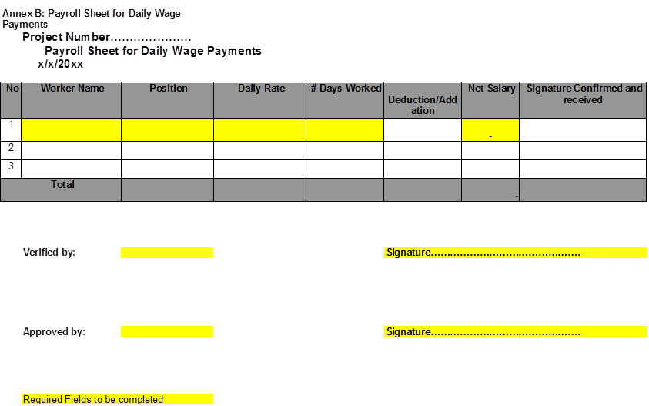

Annex 12 Financial report

Annex 13 Minutes from the preparatory 3rd and First Steering Committee meeting 4th May 2012

Acuerdos de la Reunión de Comité Directivo del Proyecto GEF-Humboldt - 3 y 4 de Mayo del 2012

- Se da por constituido el Comité Directivo del Proyecto GEF-Humboldt con todos sus miembros representantes y detallados en la página de firmas. Con la observación que llego un comunicación (5-4-CD/30) que informa la acreditación del Señor. Carlos Palomares Palomares como Representante del Ministerio de Producción – PRODUCE, Perú;

- El Comité Directivo acuerda modificar las siguientes actividades, quedando según la versión final del Plan Operativo Anual (19 meses) :
1.4.1; 1.1.5.1; 1.1.5.2; 2.1.1; 2. 1.3; 2.3.2; 2.3.3; 2.4.1; 2.4.3; 3.2.1; 3.1.1.; 3.1.3; 3.3.1; 4.1.3; 4.1.4; 4.1.7; 4.2.2; y 4.2.12. A demás se inscribe y apruebe nuevas actividades números: 1.1.5.2a+b; 1.4.3; 2.2.1; 2.1.3 (COF solamente); 2.3.3 (cambio nombre); 3.3.2 (cambio fecha después de Agosto 2013);

- El día 18 de mayo se enviará el Reporte de Incepción a todos los miembros del Comité Directivo;

- Toda Reunión de Trabajo Técnico merece una minuta para ser circulada a manera informativa. Estas minutas no están sujetas a aprobación, salvos los del Comité Directivo;

- El CD pide a PNUD Perú aclarar el tema de alquileres de espacio para el proyecto en el Complejo de las Naciones Unidas en Lima, Perú;

- Conferencias internacionales: Idealmente estas deben ser con cofinanciamiento. El participante debe dominar el idioma ingles y que calce con un tema(s) del proyecto. Los puntos focales de IFOP e IMARPE deben recoger las demandas, priorizarlas y enviar un formulario en el que se indique el nombre(s) de la persona(s), entidad a la que pertenece y a que actividad del proyecto aporta. Enviar a la UCR para la evaluación y procesamiento. Se incluye pueden incluir eventos que por temas educativos son bastante útiles para el proyecto;

- Actividad 4.1.4: Se ha elevado el monto del crucero por un total de USD 1,200,000USD con fondos GEF y Gobierno de Chile. El monto de GEF es de 600, 000 USD y a la contrapartida del Gobierno de Chile es de USD 600,000. Nota: Se consultará con UNOPS la validez de la procedimiento de compras del Gobierno de Chile en referencia a documentos enviados por SUBPESCA;

- CHILE y Perú: Aprueban el Plan de Trabajo por 19 meses en función a las actividades y solicitan afinar las finanzas en términos reales de los gastos de gestión y asesoría técnico para que favorezca la claridad del Plan de Actividades y así dar su aprobación final.

- La Unidad Coordinadora Regional (UCR) enviará el miércoles 9 de mayo del presente el POA y el cuadro de finanzas esclarecido. El día 18 IFOP e IMARPE se reunirán vía Skype para dar una última revisión a los documentos recibidos. Hora de Santiago 9am y Perú 8am. Cuando haya un consenso la UCR enviara una carta comunicando todo el CD.

Anexo 1 Nota aclaratoria sobre los costos de transacción relacionados con UNOPS Copenhague y UCR
Anexo 2 Plan de Trabajo 01.06.2012 a 31.12.2012
Anexo 3 Nombramiento representante del Ministerio de la Producción, Perú
Anexo 4 Agenda de trabajo (modificado durante la reunión del día 3 de mayo)
Anexo 5 Nota aclaratoria sobre los costos de la oficina del Proyecto en Lima

Página de Firmas
CHILE:
- Jorge Toro Da´Ponte - Instituto del Fomento Pesquero (IFOP) Co-Presidente

____________________________

- Beatriz Ramirez - Ministerio del Medio Ambiente

____________________________

- Antonio Palma - Servicio Nacional de Pesca (SERNAPESCA)

____________________________

- Julio Cordano - Ministerio de Relaciones Exteriores

____________________________

- Francisco Ponce – Sub Secretaria de Pesca (SUBPESCA)

____________________________
PERU:
- Carlos Palomares - Ministerio de la Producción Co-Presidente

____________________________

- Gabriel Quijandría –Ministerio del Ambiente

____________________________

- Nicolás Roncagliolo – Ministerio de Relaciones Exteriores

____________________________

- Pedro Gamboa - Servicio Nacional de Áreas Naturales Protegidas por el Estado (SERNANP)

____________________________

- Albertina Kameya - Instituto del Mar del Perú (IMARPE)

____________________________

PNUD:
- Raul Enrique O'Ryan Gallardo, PNUD

____________________________

http://www.minrel.gob.cl/prontus_minrel/site/artic/20091222/imag/FOTO_0220091222172644.jpg and http://www.scielo.cl/scielo.php?pid=S0718-560X2009000300020&script=sci_arttext
SUBPESCA has a co-funding commitment amounting to close to USD11 million dollars.
En el caso de un eventual apoyo del GEF, se utilizarán los indicadores M&E del GEF para este propósito.
Subsequently on 25th November the MFA-Peru changed this deadline to a further 10 days hence.
http://es.wikipedia.org/wiki/Agencia_Peruana_de_Cooperaci%C3%B3n_Internacional
This meeting did not take place as Jorge Samanez of APCI was not available.
MJA = Mr. Michael Joseph Akester
LLL = Ms. Lenka Lazo Ludeña
Hacer la consulta con Lenka Lazo en Lima
P11 = formato para aplicar para trabajos de la ONU – no es necesario para un trabajo de consultor
Si es una actividad general: “Taller de trabajo AMP Islas Juan Fernandez” que requiere insumos como papel A0 de ‘flip-chart’, marcadores, etc. se manda la lista a la UCR con anticipación.
De acuerdo a nuestra última experiencia de compra en Chile, a las compañías/organizaciones que no tienen RUT no se les puede emitir factura.
Por ejemplo si estamos refiriendo a servicios como el alquiler de una embarcación de un pescador artesanal y esta previsto 6 alquileres a USD500 cada uno hay que hacer un ‘award’ de USD3,000 en el siguiente categoría: 2500 a 5000 USD.
Fondos de contrapartida
CD: Comité Directivo
PNUD: Programa de las Naciones Unidas para el Desarrollo
GEF: Global Environmental Facility
UNOPS: United Nations Office for Project Services

